# **Abstract**

# **Résumé**

**Table of Contents :**

Abstract 2

Résumé 3

Introduction 6

1. The Martian environment 7

1.1. Interaction of the solar wind with the different bodies of the Solar System 7

**1.1.1.** **Solar wind** 7

**1.1.2.** **Four different classes of interaction** 9

1.2. The Martian obstacle 15

**1.2.1.** **Mars today** 15

**1.2.1.1.** **Atmosphere - Exosphere - Ionosphere: who is who?** 15

**1.2.1.2.** **The Martian magnetic field** 20

**1.2.2.** **The history of Mars (as known today)** 23

**1.2.2.1.** **A magnetic field history** 24

**1.2.2.2.** **A Mars’ volatile and climate history** 26

1.3. The interaction of the solar wind with Mars 29

**1.3.1.** **The steady-state interaction** 32

**1.3.1.1.** **The bow shock and the upstream region** 32

**1.3.1.2.** **The Magnetosheath** 35

**1.3.1.3.** **The Magnetic Pile-up Boundary and the Magnetic Pile-up Region** 36

**1.3.1.4.** **The ionopause and the Photo Electron Boundary** 37

**1.3.1.5.** **The Ionosphere** 38

**1.3.1.6.** **The wake and the magnetotail** 38

**1.3.2.** **Variation in the Martian interaction with the Sun** 41

**1.3.2.1.** **Magnetic topology** 41

**1.3.2.2.** **Pressure balance** 42

**1.3.2.3.** **Variability of the boundaries** 43

**1.3.3.** **Focus on the nightside ionosphere** 45

2. Instrumentation, data and analysis tools used 47

2.1. Exploration of Mars 47

**2.1.1.** **Mars Global Surveyor** 50

**2.1.1.1.** **Objectives** 50

**2.1.1.2.** **Orbitography** 51

**2.1.1.3.** **Instruments** 52

**2.1.1.4.** **Main discoveries** 53

**2.1.2.** **Mars Express** 55

**2.1.2.1.** **Objectives** 55

**2.1.2.2.** **Orbitography** 56

**2.1.2.3.** **Instruments** 57

**2.1.2.4.** **Main discoveries** 59

**2.1.3.** **MAVEN** 61

**2.1.3.1.** **Objectives** 61

**2.1.3.2.** **Orbitography** 61

**2.1.3.3.** **Instruments** 63

**2.1.3.4.** **Main discoveries** 65

2.2. Instrumentation 66

**2.2.1.** **Mars Global Surveyor** 66

**2.2.1.1.** **The magnetometer: MAG** 66

**2.2.1.2.** **The Electron Reflectometer: ER** 66

**2.2.2.** **Mars Express** 69

**2.2.2.1.** **Electron Reflectometer: ELS** 69

**2.2.2.2.** **The ion spectrometer: IMA** 70

**2.2.3.** **MAVEN** 71

**2.2.3.1.** **The ion spectrometer: STATIC** 72

**2.2.3.2.** **The Magnetometer: MAG** 73

**2.2.3.3.** **The Electron spectrometer: SWEA** 74

**2.2.3.4.** **The Langmuir probe: LPW** 77

**2.2.3.5.** **Contamination, effect of the Spacecraft potential** 77

2.3. Data coverage 77

2.4. Analysis tools 77

**2.4.1.** **AMDA and 3D view** 77

**2.4.2.** **CL** 77

2.5. Frames 78

2.6. Models 78

**2.6.1.** **Model of crustal magnetic field: the model of *Morschhauser et al.* [2014]** 78

3. Identification of suprathermal electron depletions in the nightside ionosphere 79

3.1. Discovery of electron depletions 79

3.2. Global properties of suprathermal electron depletions 81

3.3. Automatic detection of suprathermal electron depletion: criterion 82

**3.3.1.** **MAVEN** 82

**3.3.2.** **MEX** 84

**3.3.3.** **MGS** 85

3.4. Application of the criteria 87

3.5. Global properties of suprathermal electron depletions: statistical properties 89

4. Determination of the origins of suprathermal electron depletions 90

5. Physical processes: Interaction plasma/neutrals 91

Conclusions 92

Conclusions 93

Table of figures 94

Table of tables 96

Bibliography 97

# **Introduction**

# **The Martian environment**

Mars is a fascinating planet, sometimes called ‘twin planet of the Earth’ due to its neighborhood and its history. It is hence one of the most visited object of the solar system since humanity achieved escaping Earth’s gravity. However, the Martian environment, patterned by the interaction of Mars with the solar wind, is not yet fully understood. It lays between the Earth one, whose atmosphere is shielded below a strong internal magnetic field, and the Venus one, which has no proper magnetic field but a very dense atmosphere, and has something to deal with cometary ones.

The different types of interaction existing between the solar wind and the several objects of the solar system will be discussed in a first part (1.1). We will then focused on the nature of the Martian obstacle in the second part (1.2). Finally, the current knowledge of the interaction of Mars with the solar wind will be developed in a third part (1.3).

## **Interaction of the solar wind with the different bodies of the Solar System**

All the bodies present in the Solar System, from the biggest planets to the smallest dust particles, are immersed in the solar wind. All these objects interact with the solar wind, but each of these interactions is unique as each object has its own specificities. However, the interactions with the solar wind can be gathered into categories, which will be detailed (1.1.2) after a short description of the solar wind (1.1.1).

### **Solar wind**

The solar wind is a flow of ionized solar plasma carrying a frozen-in magnetic field - a remnant of the solar magnetic field - which streams outward through interplanetary space [*Kivelson and Russel*, 1995]. This ejection of plasma is due to the difference of gas pressure existing between the solar corona and the interplanetary space, which is huge enough to balance the solar gravity. The existence of the solar wind was conjectured in the 50s and it has directly been observed by space probes in the mid-60s.

The composition of this plasma is the same as the one of the solar corona: 95% of **hydrogen** ($H^{+}$), 4% of **helium** ($He^{++}$), and 1% of heavy ions. The solar wind is very **tenuous** ( $\sim 10 uma.cm^{-3}$ near the orbit of Mercury and $\sim 0.1 uma.cm^{-3}$ near the orbit of Pluto), **supersonic** ($\sim 250-800 km.s^{-1}$), and **dynamic**. It typically travels a Mars diameter in 15-20 seconds and changes on timescales as short as minutes. Embedded in this plasma is a weak magnetic field oriented in a direction nearly parallel to the ecliptic plane (the plane of the Earth’s orbit around the Sun). It is called the Interplanetary Magnetic Field (**IMF**). However, due to the radial movement of the particles and the rotation of the Sun, the magnetic field lines form the Parker spiral [*Parker*, 1958], as sketched in Figure 1‑1. Hence, the IMF reaches Mercury with an angle of ~20° with respect to the planet-Sun line, ~45° for the Earth, and ~56° for Mars [Brain et al., 2006].

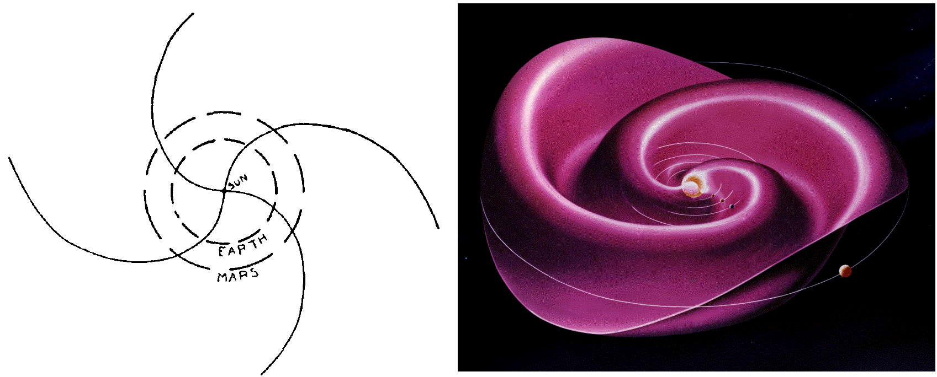

Figure 1. Illustration of the Parker spiral.

*On the left is the sketch from [Parker, 1958], representing the Parker spiral and the orbit of the Earth and Mars. On the right is a 3D representation of the Parker spiral with the orbit of Mercury, Venus, the Earth, Mars and Jupiter.*

As it expands into the solar system, the solar wind evolved in density, temperature, and the strength of its IMF, so that the incident plasma at Mars has properties intermediate between those experienced by inner and outer planets. Several properties of the solar wind at the average distance of the Earth [*Kivelson and Russel*, 1995], and of Mars [*Brain*, 2006; *Fränz et al.,* 2007], from the Sun are gathered in Table 1. The average distance of the Earth from the Sun is defined as 1 Astronomical Unity ($1 AU=150×{10}^{6} km)$. Mars is at an average distance of 1.5 AU from the Sun.

|  |  |  |
| --- | --- | --- |
| **Property** | **Earth orbit (1 AU)** | **Mars orbit (1.5 AU)** |
| **Proton density** | 6.6 $cm^{-3}$ | $$1-3 cm^{-3}$$ |
| **Electron density** | $$7.1 cm^{-3}$$ |
| $He^{++}$**density** | $$0.25 cm^{-3}$$ |
| **Flow speed** | $$450 km.s^{-1}$$ | $300-400 km.s^{-1}$ |
| **Proton temperature** | $$10 eV$$ | 10-20 eV |
| **Electron temperature** | $$12 eV$$ | 2-10 eV |
| **Magnetic field** | $$7 nT$$ | $$2-4 nT$$ |

Table 1. Observed properties of the solar wind at the orbit of the Earth [Kivelson and Russel, 1995] and at the orbit of Mars [Brain, 2006; Fränz et al., 2007]

The different bodies embedded in the solar wind are all obstacles on its course toward the limits of the solar system. The plasma flow is then modified in the vicinity of the planets, satellites or comets which slow down its progression.

### **Four different classes of interaction**

Though the different bodies present in the solar system possess various characteristics, it is possible to sort their interaction with the solar wind into different categories. These interactions depend mostly on the presence or absence of an atmosphere, and therefore of an ionosphere, and on the presence or absence of an intrinsic magnetic field strong enough to deflect the solar wind flow. These characteristics set which kind of obstacle interacts with the solar wind (solid body, ionosphere, intrinsic magnetic field…) and hence the kind of the resulting interaction. It exists many different way of sorting these interactions and the sorting presented below is one among the other. However, it permits to get a good idea of the different interactions and what make them different.

The four general classes presented here are the following: (1) magnetospheres, (2) cometary and Moon-like interactions (3) induced-magnetospheres, and (4) mini-magnetospheres. These different groups are showing up in the M-B diagram presented in Figure 1‑2 [*Barabash*, 2012]. On this figure is compared the total mass of the neutral gas present around an object (M) and the magnetic field (B) at this object. For the body lacking of an intrinsic magnetic field, B correspond to the value of the interplanetary magnetic field at the distance of the body from the Sun.

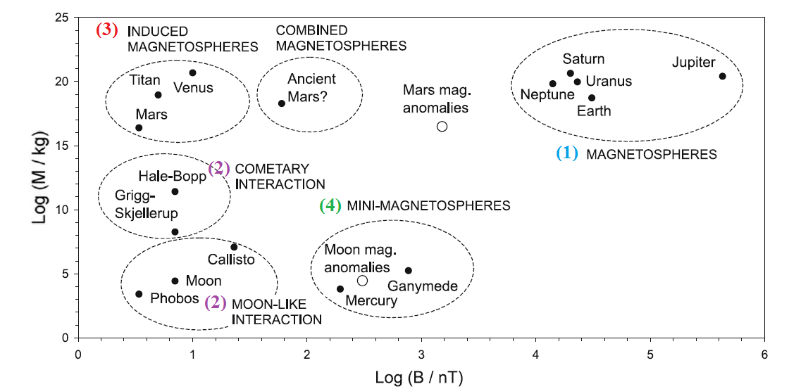

Figure 2. M-B diagram [Barabash et al., 2012].

*M corresponds to the total mass of the neutral gas present around an object and B corresponds to the magnetic field at this object.*

* (1) Magnetosphere (Saturn, Neptune, Uranus, Earth, Jupiter)

This is the most familiar interaction with the solar wind. The bodies concerned are those which own a strong intrinsic magnetic field. This planetary magnetic field provides here the effective obstacle to the solar wind plasma. A simplified sketch of the Earth magnetosphere is drawn on Figure 1‑3 [*Luhmann et al.*, 1991].

The solar wind pressure presses on the outer reaches of the magnetic field, distorting it into a blunt obstacle shape, and confining it to a magnetospheric cavity. As the solar wind is supersonic, this encounter creates a shock upstream the planet, called the **bow shock**. The solar wind is then slowed down and reach a subsonic speed in a region called the **magnetosheath**. The magnetosheath acts like a buffer region between the interplanetary medium where the solar wind plasma is dominant and the near planetary environment where the planetary plasma is dominant. Hence this transition region is filled with shocked, deflected, and high density solar wind plasma with its draped, frozen-in magnetic field.

As the solar wind is a conductive fluid, a current layer called the **magnetopause** exists to isolate the magnetic field of the planet from the IMF. The magnetopause is the outer boundary of what is called the **magnetosphere**, defined as the region of space in which the magnetic field lines have at least one end connected to the source of the internal field. Only a small amount of solar wind particles finally go through the magnetopause, particularly in the polar cornet, more or less sporadically.

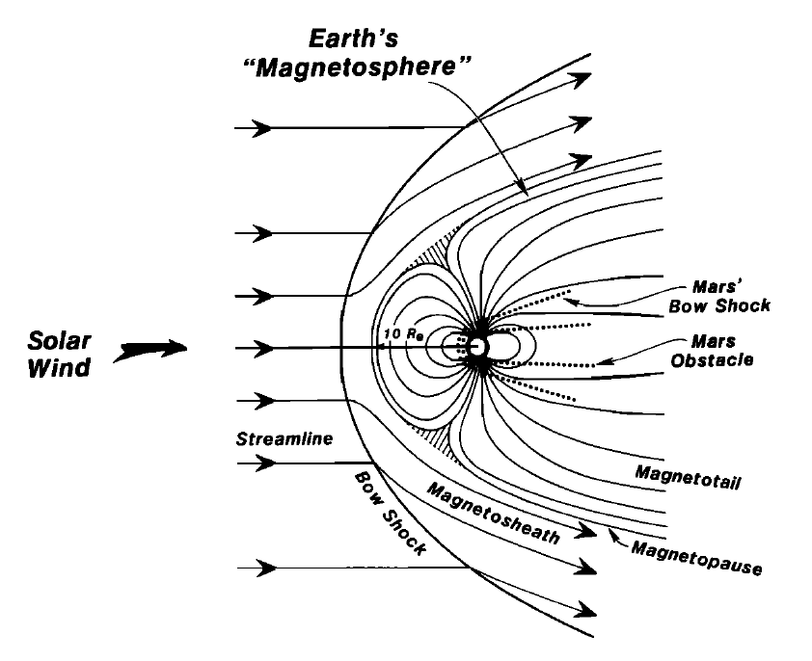

Figure 3. Illustration of the general features of the interaction of the solar wind with the Earth magnetic field [Luhmann et al., 1991]. Superimposed in dotted lines are the main features of the Mars-solar wind interaction. The sizes of the planet has been normalized for the purpose of comparison.

Though on the dayside the planetary magnetic field lines are compressed by the solar wind pressure, on the nightside they are pinched by the solar wind pressure into a long **magnetotail**. The magnetotail is composed of two lobes, of opposite polarity depending of the inner magnetic field polarity, extending in the antisolar direction. They are isolated from each other by a **plasma sheet**, at which the radial component of the magnetic field reverses.

* (2) Cometary and Moon-like interactions (Callisto, Moon, Phobos, comet)

The bodies concerned in this category do not possess an internal magnetic field nor a consistent atmosphere. In this case, the obstacle to the flow of the solar wind is an incompressible conducting body, such as an iron core or a salt-water ocean. The solar wind particles then travel without being disturbed until they reach the surface of the obstacle, where they are absorbed. This create a plasma-absorption wake left in the plasma behind the body, which is characteristic of this interaction. At the same time, the IMF diffuses into the low conducting outer layers of the obstacle at a rapid rate, so that it is barely perturbed from its upstream orientation. Contrary to different configurations, neither the magnetic field nor the particles accumulate on the dayside.

An illustration of this interaction at the Moon is presented on the left side of Figure 1‑4, from *Luhmann et al.*, [2004]. We clearly see that the IMF is hardly affected by the passage of the obstacle but that a wake cavity is formed downstream. In the case of the Moon, there is no bow shock upstream because the diversion of the magnetic field occurs inside the absorbing body.

The negligible gravity of the comets imply a different kind of interaction, dominated by the pick-up and mass-loading processes which will not be detailed here.

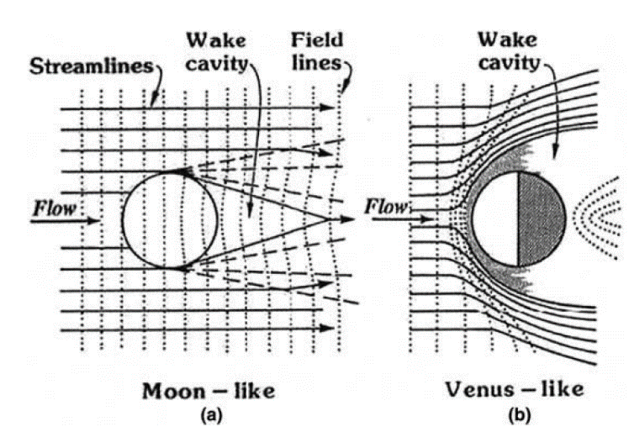

Figure 4. Illustration of two different interactions of the solar wind with unmagnetized planetary obstacles [Luhmann et al., 2004]. On the left, the Moon interacts only weakly with the solar wind, providing mainly an absorber. On the right, in the case of Venus, the presence of a substantial ionosphere produces a relatively impenetrable obstacle.

* (3) Induced-magnetosphere (Titan, Venus, Mars)

This class of interaction contains the bodies that does not possess an intrinsic magnetic field at large scale but that possesses an atmosphere. The word ‘induced’ used here refers to the general processes of creating an effective magnetic obstacle through plasma interactions [*Luhmann et al.,* 2004]. The induced magnetic fields include the field perturbations resulting from electromagnetic induction, but also from the flow interaction.

In this case, the atmosphere of the bodies is partially ionized by the ultraviolet solar photons which creates an ionosphere (see 1.2.1.1 for more details). The obstacle to the solar wind is then an electrically conducting, compressible ionospheric shell which balances the external plasma pressure at a boundary called **ionopause**. As in the case of the magnetospheres, the solar wind slows down upstream the obstacle and becomes subsonic when it cross the bow shock upstream the body. At the same time, the interplanetary magnetic field lines piled up in the front of the obstacle and draped around it, as shown on the right side of Figure 1‑4. The so-formed induced magnetosphere also includes a magnetosheath and an induced tail which is essentially the extension of the magnetosheath into the wake.

On Figure 1‑5 is shown a simplified scenario of the creation of an induced magnetosphere. The neutral environment of a planet is ionize through different processes by the ultraviolet solar photons. The so-formed ionosphere is a conductor. The incoming magnetic fields generate induced currents in the ionosphere that keep the IMF from penetrating through the body by generating a canceling field. This situation persists as long as the external magnetic field keeps changing its orientation and/or magnitude [Luhmann, 1995].

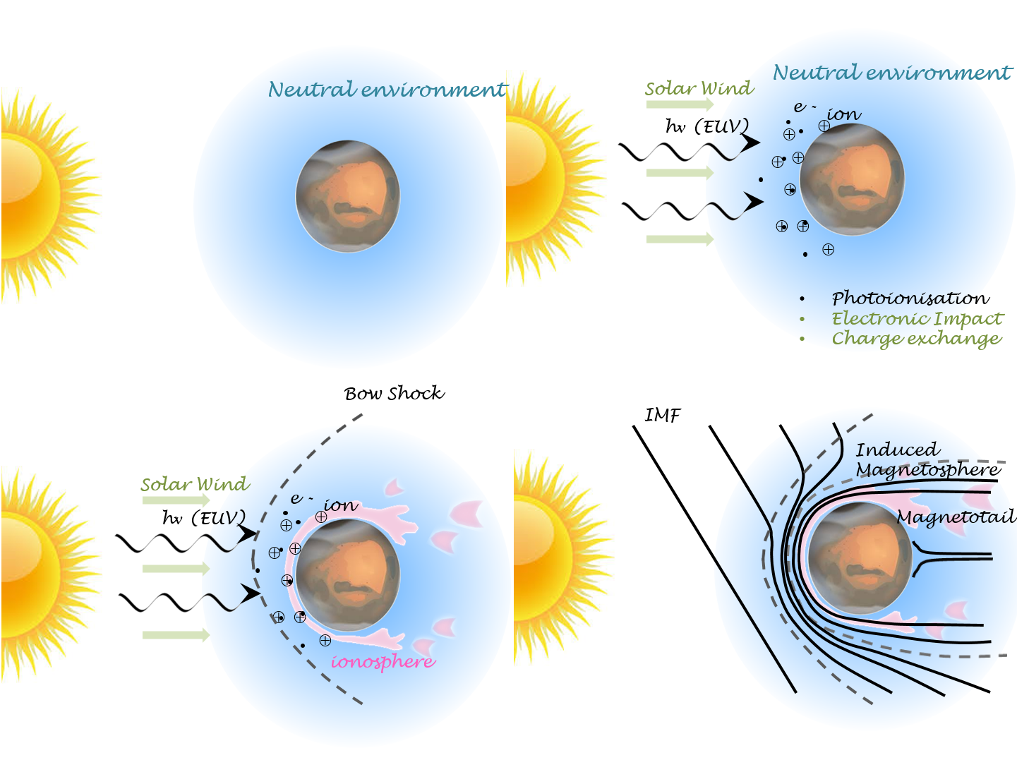

Figure 5. Illustration of the steps leading to the formation of an ionospheric obstacle in the solar wind flow. Adapted from Kivelson and Russel [1995].

* (4) Mini-magnetosphere (Ganymede, Mercury)

This last class gathered bodies with no significant atmosphere but with a magnetic field (intrinsic or remnant) 2 or 3 orders of magnitude weaker than in the magnetosphere class. This class appears like an intermediate case between bodies with low or no magnetic field and planet with strong magnetic field. Little is known about these magnetospheres and future missions, such as Bepi-Colombo, will help understanding this kind of interaction.

As observed on Figure 1‑2, the Martian interaction with the solar wind cannot be restricted to one category, due its magnetic and atmospheric history. The global interaction can be similar in some extend to those of induced magnetospheres, but the presence of strong crustal magnetic sources induces some complications.

## **The Martian obstacle**

Mars is the fourth planet of our solar system and the last telluric one. It orbits around the sun on an elliptic orbit with a maximum distance to the sun (Aphelion) of 1.67 AU and a minimum distance to the sun (Perihelion) of 1.38 AU, which imply an eccentricity of 0.0935, much higher than the Earth one (0.0167). Mars inclination on its orbital plane is $25,19°$, which is comparable to the Earth ($23,44$ °) and implies the presence of seasons.

The length of the day on Mars is quite comparable to the Earth one: $\sim 24h37min$, and the planet makes a revolution around the Sun in ~687 days, a little less than two Earth years. With an average radius of $3386,2 km$, Mars is twice as small as the Earth and the gravity at its surface is three times smaller. The temperature at its surface can vary from -3°C to -133°C.

### **Mars today**

Mars has been visited by more than twenty spacecraft - landers - rovers to date (see section 2.1 for more details). These in-situ measurements permit a better knowledge of the Martian object, its current atmosphere (1.2.1.1) and magnetic field (1.2.1.2), which both are important to understand the interaction of Mars with the Solar wind.

#### **Atmosphere - Exosphere - Ionosphere: who is who?**

**Atmosphere**

Based on the nomenclature used for the terrestrial atmosphere, the Martian atmosphere can be divided into several layers according to the mechanisms involved (turbulence, molecular diffusion, photoionization, heating by absorption of UV rays). Taking the collisional point of view, the atmosphere can be divided into two parts: the barosphere and the exosphere. These two layers are characterized by a dimensionless number, the number of Knudsen ($Kn$):

$$Kn=\frac{λ}{H}$$

The mean free path $λ$ can be defined as follow, in the case of a gas composed of a single species, where n is the density of the species, and $πσ^{2}$ the cross section :

$$λ=\frac{1}{πnσ^{2}\sqrt{2}}$$

The scale height **H** - corresponding in every point to the altitude to be raised for the pressure to be decreased by a factor of $e$- can be defined as follow:

$$H=\frac{k_{B}T}{Mg}$$

Where M is the mean molecular mass, g the local acceleration of gravity, $k_{B}$ the Boltzmann constant and T the medium temperature.

Regarding the Knudsen number, the barosphere and the exosphere can be defined as follow:

* The **barosphere** is a region of low Knudsen number ($Kn≪1)$. This is the inner part of the atmosphere, with the highest density. The dynamic is dominated by collisions between molecules and atoms, which result in a homogeneous, well-mixed layer.
* The **exosphere** is a region of high Knudsen number ($Kn≫1)$. It corresponds to the external layer of the atmosphere and hence the less dense. The dynamic is here dominated by external forces, especially gravitation. It is characterized by a very high Knudsen number, which mean that there are very few collisions. This layer is highly heterogeneous. The different species are separated according to their mass. The low mass species have higher scale height and will then be more abundant at higher altitude regarding heavier species whose density will decrease more quickly with altitude. The exosphere is an exchange area between the lower atmosphere and the interplanetary medium.

The transition between the collisional and non-collisional medium is called the **exobase**. It has been estimated at 250 km by *Anderson and Hord* [1971], after Mariner 6 and 7 observations.

The barosphere can be divided into two layers, regarding the mixing of the atmospheric components: the **homosphere** and **thermosphere**. The homosphere and thermosphere are separated by a layer called the **homopause** (located at ~125 km mean altitude on the dayside).

* The homosphere is the lower layer, characterized by atomic and molecular constituents which are well mixed by winds and dissipative turbulence [*Stewart,* 1987; *Bougher* 1995; *Bougher et al.*, 2000; 2009; 2014]. The relative proportion of each species stay quasi-constant, no matter the molecular mass. It is composed of the **troposphere** and of the **mesosphere**. The troposphere is the lowest layer of the atmosphere, which contain the majority of the atmospheric mass. It hardly absorbs any solar photons but is heated by the contact with the planetary surface. It extends until the **mesopause** (located at ~90-110 km), above which temperatures increase dramatically with altitude, largely due to solar EUV-UV heating.
* The thermosphere corresponds to the region where the atomic/molecular diffusion dominates. Individual species begin to separate according to their unique masses and scale heights. There is a depletion of the heaviest species when the altitude increases. The first in situ measurements obtained in the thermosphere were obtained by the Viking 1 and 2 entry probes in 1976 [*Nier and McElroy*, 1976; *Nier et al.*, 1976]. The measurements obtained along the descent of the lander highlights the presence of $CO_{2}, N_{2}, {}_{ }^{40}{Ar}, O_{2}, NO$ and maybe CO.

More recently, measurements made with the MAVEN spacecraft down to the homopause improve our knowledge of the composition of the atmosphere and its variation with altitude. On the left panel of Figure 1‑6 is plotted the neutral composition obtained during one orbit down to 133,8 km near the equator at noon, and on the right side, the average vertical neutral profiles obtained at 45° solar zenith angle [*Mahaffy et al.,* 2015]. We clearly see that the lower atmosphere is dominated by $CO_{2}$ whereas the higher atmosphere is dominated by O, with significant amount of $O_{2}, N_{2}$ and N.

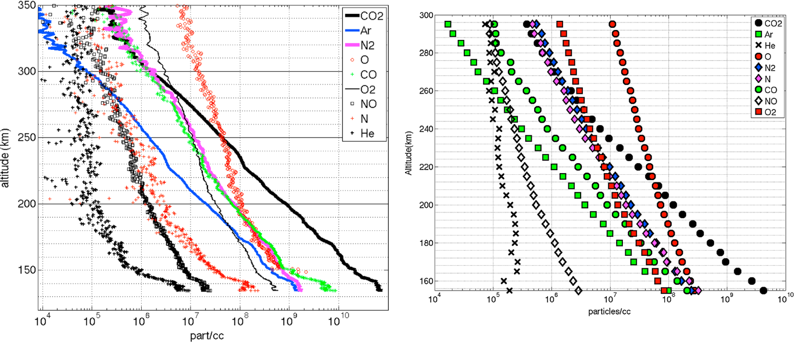

Figure 6. Neutral profiles obtained with the NGIMS instrument on MAVEN [Mahaffy et al., 2015].

*On the left is an example of the variation with altitude of nine atomic and molecular species during a passage down to 125 km. On the right is the average vertical profiles for nine upper atmosphere species at 45° solar zenith angle.*

The upper neutral atmospheric region includes the thermosphere and the exosphere (also sometimes referred to as the corona).The upper neutral atmosphere interact directly with the solar wind particles and radiations, modifying the plasma neighboring the planet and creating an **ionosphere**. While the thermosphere extends from ~100 to ~250 km altitude, the ionosphere extends from ~100 to ~400 km altitude. On Figure 1‑7 are plotted the ion profiles obtained by *Benna et al.,* [2015] during the first eight months of the MAVEN mission in 2014-2015. We can see that the dominant ion is ${ O}_{2}^{+}$ below 300 km, with a smaller but significant amount of $O^{+}$ and $CO_{2}^{+}$, depending on the altitude.

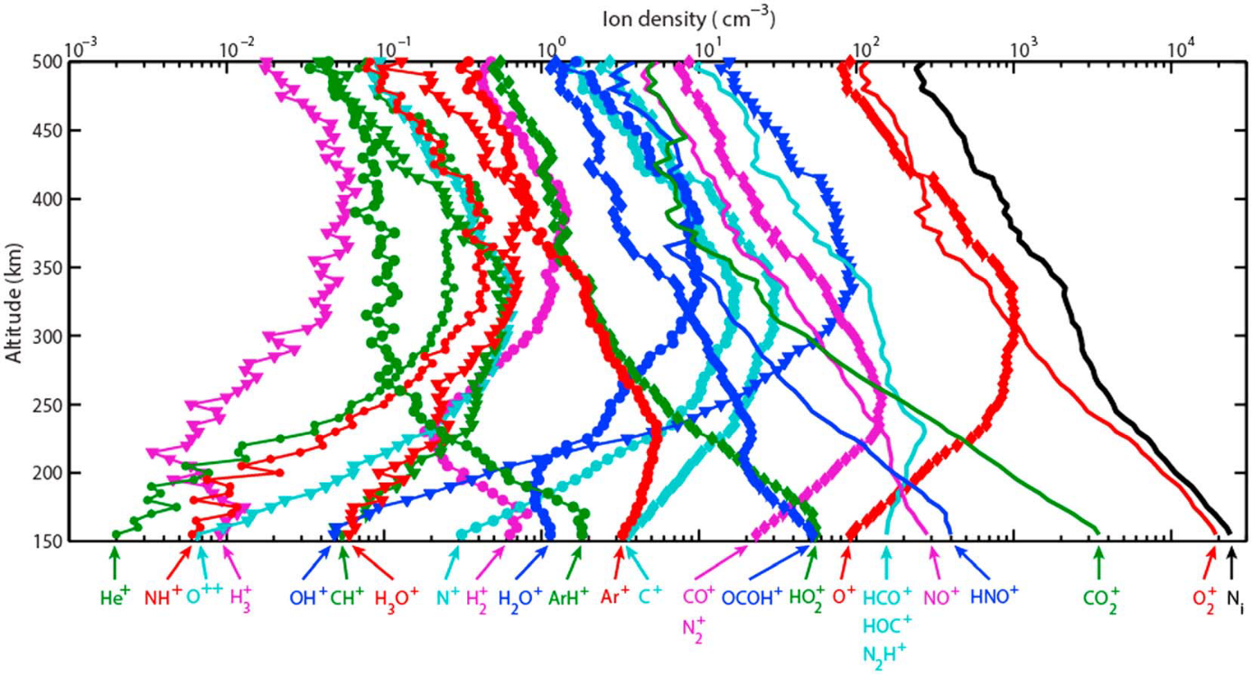

Figure 7. Altitude profiles of the averaged density of ionospheric ions measured by NGIMS at a solar zenith angle of 60° at altitudes between 150 and 500 km Benna et al. [2015]. The vertical profile of the total ion density $N_{i}$ is also plotted in black.

**Ionosphere**

The only necessary ingredients for creating an ionosphere are a neutral atmosphere and a source of ionization for the gases in that atmosphere. Sources of ionization include photons and energetic-particle “precipitation”. The process involving photons is called photoionization, and the other one is often called impact ionization. Photons come mainly from the sun. The ionizing particles can come from the galaxy (cosmic rays), the sun, or from the ionosphere itself. The only requirement for the photons and energetic particles is that their energy exceed the ionization potential or binding energy of a neutral-atmosphere atomic or molecular electron. In nature, atmospheric ionization usually is attributable to a mixture of these various sources, but one often dominates. In the case of Mars, the photoionization of oxygen and carbon dioxide are particularly important for creating its ionosphere.

Three ionization processes are predominant on Mars (but there are several other mechanisms which play an important role in the dynamic and the escape of the ionosphere, see section 1.2.2.2):

* Photoionization:

Solar photons arriving on Mars mainly interact with O and $CO_{2}$ by the following mechanism:

$$CO_{2}+hν→CO_{2}^{+}+e^{-}$$

$$O+hν→O^{+}+e^{-}$$

The cross sections corresponding to these two reactions are plotted on Figure 1‑8. They are both associated with an ionization threshold, $91,1 nm$ for oxygen and $89,9 nm$ for carbon dioxide. This means that only photons with lower wavelength can photoionize O and $CO_{2}$. It corresponds to solar photons in the “extreme” ultra-violet (EUV) and ultraviolet (UV) wavelength range. These photons with wavelengths from 10 to 100 nm produce at least the dayside ionosphere of Mars. Photoionization is the most important ionization process at Mars.

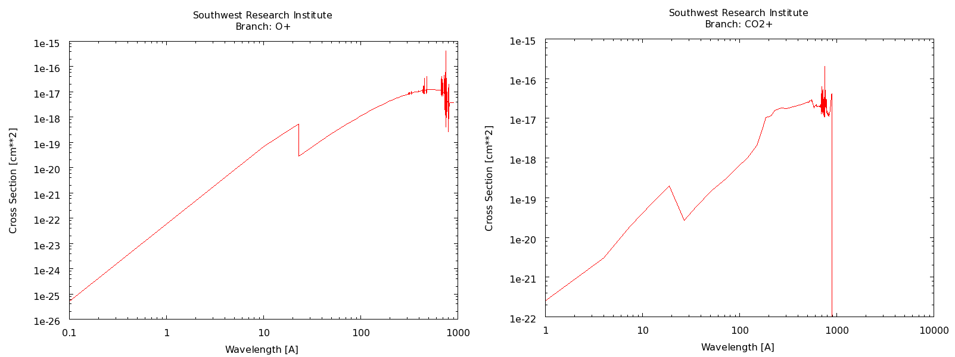

Figure 8. Cross section for the photoionization of atomic oxygen and carbon dioxide from Huebner et al., [1979, 1992, 2015].

* Ionization by electronic impact:

It corresponds to the interaction of electrons coming from the solar wind with the atmospheric neutrals which creates ions. [nightside]

$$e+M→M^{+}+e+e$$

* Charge exchange reactions

The plasma of the solar wind or of the induced magnetosphere interact with the neutrals of the high atmosphere. The ions can extract an electron from the neutrals and transfer them their positive charge. Following is an example of such charge exchange reaction:

$$CO_{2}^{+}+O→O^{+}+CO_{2}$$

The production rate of these ions is set by their cross section, the ionization frequency and the neutral density. The altitude profile of ion production shows a peak at some altitude, because the rate of ionization depends on both the neutral density (which decrease with height) and the incoming solar-radiation intensity (which increases with height).

#### **The Martian magnetic field**

The question of the Martian intrinsic magnetic fieldremained unanswered until the end of the 90s, when it was proved that at the present time, Mars does not possess any global magnetic field generated by an internal dynamo. The first observations of the Martian magnetic field in the near Martian environment had been made by the Mariner 4 spacecraft in 1965 when it passed within 13200 km of the planet. The lack of detectable magnetic field signature attributable to Mars led to the conclusion that the Martian magnetic moment could not exceed ${3×10}^{-4}$ that of Earth dipole moment, equivalent to an equatorial field of less than 100 nT [*Smith et al.,* 1965]. Additional measurements were made by Mars 2, 3 and 5 in the early 1970s and by Phobos 2 is 1989. Even the Phobos 2 spacecraft, which reached the lowest altitudes at 850 km from the surface, did not measure any magnetic field providing evidence of an intrinsic magnetic field. The scientific community was then divided between those claiming the presence of a small intrinsic dipole moment [*Dolginov and Zhuzgov*, 1991; *Slavin et al.,* 1991; *Verigin et al.,* 1991; *Möhlmann et al.,* 1991] and those claiming the absence of any intrinsic magnetic field [*Russell et al.,* 1995; *Gringauz et al.,* 1993].

Mars Global Surveyor (MGS) is the first spacecraft to obtain magnetic field observations beneath the ionosphere (~170 to 200 km) in 1997-1998. It provided 83 periapsis passes with altitudes between 100 and 170 km. This region is particularly interesting since it is shielded from the confounding effects of the solar wind interaction with Mars, its atmosphere and ionosphere. The induced magnetic fields resulting from this interaction can reach levels similar with those arising from a planetary field of internal origin (see 1.3.1.3 for example). *Acuña et al.* [1998] showed that on several orbits reaching the underside of the ionosphere, relatively weak field ($≤5nT$) was observed. They hence conclude that Mars does not possess a global intrinsic magnetic field on a large scale, and therefore no dynamo at present.

However, on some other orbits, like the one shown on Figure 1‑9, the magnetometer recorded large magnetic fields near the periapsis. It shows a magnetic signature which is not of global scale, as it would necessarily be if it was generated in the deep interior, for example by a dynamo. Instead, for this and many other examples, it was found that the spatial scale of the observed field was comparable to the altitude of observation. These signatures were restricted to a segment of the spacecraft trajectory that passes closely over the Mars crust. It was thus discovered that the magnetic field of Mars is dominated by intensely magnetized sources distributed, non-randomly, in its crust [Acuña et al., 1998, 1999].

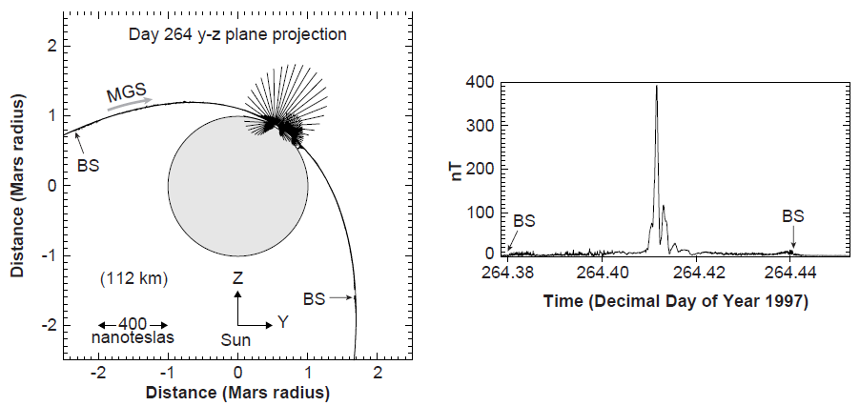

Figure 9. Illustration of the measurement of the crustal magnetic field by MGS [Acuña et al., 1998].

*On the left is the projection of the MGS spacecraft trajectory and observed magnetic field onto a plane perpendicular to the Mars orbit plane and the Mars-sun line for a specific periapsis. The field observed along the trajectory at 3-s intervals is represented by a scaled vector projection of B originating from the position of the spacecraft at such times. Field vectors are scaled to $400 nT = 1 R_{Mars}$. On the right is the magnitude of the observed magnetic field as a function of time for the interval of time represented in the left panel.*

Compiling the data obtained by MGS during two full Mars years of its 400 km-mapping altitude, *Connerney et al.*, [2005] presented a global map of the magnetic fields due to remnant magnetism in the crust of Mars. Figure 1‑10 is an updated version of this map [Connerney et al., 2015]. It is a global map of $∆Br$, essentially a $360×180$-pixel “image” of the filtered radial magnetic field, color contoured over two order of magnitude variation in signal amplitude. The map is superimposed on the Mars Orbiter Laser Altimeter shaded topography map.

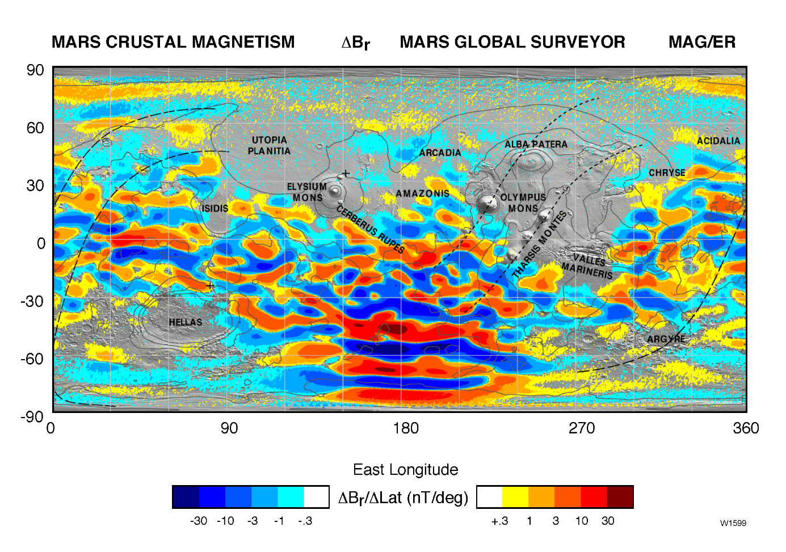

Figure 10. Map of the magnetic field of Mars observed by the Mars Global Surveyor satellite at a nominal 400 km altitude.

*Each pixel is colored according to the median value of the filtered radial magnetic field component observed within the ½° by ½° latitude/longitude range represented by the pixel. Contours of constant elevation (-4, -2, 0, 2, 4 km elevation) are superimposed (after Connerney et al., 2005).*

The crustal magnetic sources, mainly located in the southern hemisphere, can be considered as small dipoles located under the Martian crust. They form closed magnetic field loops, whose effect can extend up to 1500 km altitude. The crustal magnetic field can reach intensity exceeding 200 nT at 400 km in the Southern hemisphere [*Acuña et al.*, 2001]. The largest crustal magnetic field strength measured at Mars was ~1600 nT near 100 km altitude. This value can be compared to the strength of the Earth’s global field and anomalies measured at 400 km: 26000 nT and 10 nT respectively. Crustal fields extend above 120 km altitude over 70% of the surface, and even extend above 1000 km altitudes over the strongest southern source.

The Martian obstacle to the sun is then composed of the ionosphere, together with the crustal magnetic sources. Both forms magnetic fields that divert the plasma around the planet. Crustal magnetic fields contribute to the deflection in some regions of Mars (mainly in the Southern hemisphere), creating ‘mini-magnetospheres’. In other regions, the IMF carried by the solar wind induces currents (via Faraday’s Law) in the conducting ionosphere that generate magnetic fields (via Ampere’s Law). The shielding magnetic fields then deflect solar wind particles around the obstacle (via the Lorentz’s law).

The interaction of Mars with the Sun will be extensively discussed in section 1.3, after a brief incursion in the Martian history.

### **The history of Mars (as known today)**

Mars is currently an arid planet, with a thin atmosphere, having an atmospheric pressure of 636 Pa (0.006 bar), compared to the ${10}^{5}$ Pa (1 bar) atmospheric pressure we currently have on the Earth. However, several missions (see section 2.1) showed the presence on the Martian surface of geological features (riverbed, fluvial networks, hydrated minerals) revealing the ancient flowing of liquid water on Mars. Water was then stable at the surface of Mars several billion years ago. However, as it can be observed on the water phase diagram reminded on Figure 1‑11, the current temperature and pressure conditions at the surface of Mars prevent the presence of ‘permanent’ liquid water, even if transient liquid water has already been observed (*Martin-Torres et al.*, [2015] for example). The leading idea for explaining these observations is the occurrence of a different climate during these early periods, with a denser atmosphere, and warmer temperatures to sustain the flowing of liquid water at the surface of Mars. Warmer temperatures could be obtained by the presence of more greenhouse gases, such as $CO_{2}$.

Disappearance of liquid water at the surface of Mars is strongly linked to the disappearance of the atmosphere and a change in the climate and the inventory of volatiles through time.

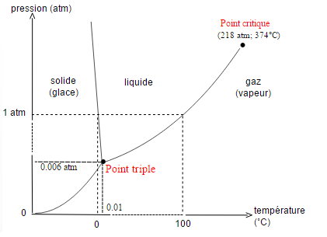

Figure 11. Phase diagram of water

#### **A magnetic field history**

The result obtained with the MGS spacecraft showed that Mars does not possess any global magnetic field at the present time, and therefore no dynamo at present. However, the presence of crustal magnetic sources strongly suggest that Mars have had a dynamo in the past, when the crust acquired intense remnant magnetization.

It is likely that a molten iron core formed early, after or during hot accretion, 4.5 or 4.6 billion years ago. A substantial global magnetic field may then had been generated for at least a few hundred million years by dynamo action in the core. During this time period, the planetary magnetic field must have been recorded in certain kind of rocks, as we can see it on Earth (Figure 1‑12).

Geological interlude

Igneous rocks, when they cool down, can acquire a thermoremanent magnetization from the Earth’s field thanks to some of their component, such as iron-titanium oxide minerals in basalt. When there temperature decrease below their Curie temperature, they record in their structure the orientation and magnitude of the ambient magnetic field. The record can then last for billion years, unless the rock is heated to temperature higher than its Curie temperature. The study of the remnant magnetic field on Earth permit to better understand the continental drift and the way oceanic ridges work (alternation of layers of opposite magnetization on each side of the ridges as the Earth dipole polarity reverse and the oceanic plateau moves forward).

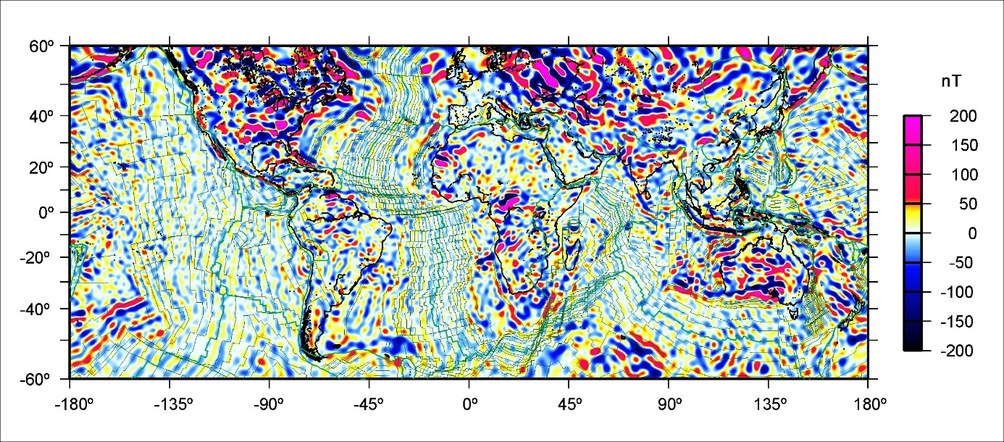

Figure 12. Vertical component of the MF6 model crustal magnetic field at the Earth surface, overlain with the isochrones of an ocean-age model inferred from independent marine and aeromagnetic data by Muller et al., [2007] and plate boundaries by Bird et al., [2003], http://geomag.org/models/MF6.html

Regarding the distribution of the Martian crustal magnetic field, which are mainly coincident with the oldest terrain, *Acuña et al.,* [1998; 1999] proposed that the dynamo stopped early in the Martian history, prior to the last great impact (~4 billion years ago). During this time, the entire crust acquired a magnetic imprint via crustal heating - implying the presence of an iron-rich magma (intrusive, impact or thermal event) - and cooling in the presence of a reversing dynamo [*Connerney et al.,* 2005]. This mechanism permitted the crust to acquire a permanent remnant field that record the orientation of the global Mars magnetic field at that epoch. The large erasure of this imprint occurred when the crust is melted above its Curie temperature (thermal demagnetization) when no more ambient magnetic field is present, as during the last great impact for example. This left the large unmagnetized basins in the crust. The extinction of the dynamo would then leave the anomalies that are not obliterate by subsequent thermal events as permanent record of the paleofield and crustal evolution. This view has been supported by more complete analysis on the large impact basins [*Lillis et al.,* 2008; 2013a]. It appears that dynamo generation of the global magnetic field was extinguished before the formation of Hellas and Utopia basins approximately 4.0-4.1 Ga. A review of the different mechanism supposed to be implied in the creation of the current Martian crustal magnetic field is reported in *Connerney et al.,* [2015].

Knowing that Mars had a substantial global magnetic field billions of years ago, the atmosphere may have been sheltered from the solar wind for a geologically significant period. In the dynamo era, Mars may have retained a warm and dense atmosphere. When the dynamo stopped, there was no more shelter from the solar wind and the planet lose its atmosphere.

#### **A Mars’ volatile and climate history**

As the atmosphere of Mars was not any more sheltered from the solar wind by a magnetic shield as the one of the Earth, it was directly subjected to atmospheric erosion. Atmospheric loss may have contributed significantly to the evolution of the Martian climate over time. At the first times of the Martian history, the main mechanisms of atmospheric erosion were [*Brain and Jakosky*, 1998]:

* Catastrophic degassing by meteoritic bombing: impact erosion;
* Hydrodynamic escaping. It occurs when a light species escapes in abundance to space (usually enabled by high solar EUV flux or another form of heating) and drags heavier species along with it through collisions;
* Absorption and storage in the regolith of the surface and sub-surface;
* Escape into space. It’s a result of a set of physical processes that provide particles in the thermosphere, ionosphere and exosphere with sufficient energy to escape the planet.

Hydrodynamic escape should have been significant for Mars during the first few hundred million years after its formation [*Zahnle and Kasting*, 1986]. When it ceased, impact erosion was a dominant loss mechanism, then decreasing as the impact flux declined over time [*Melosh and Vickery*, 1989]. The impact of these two escape processes on the atmosphere and climate of Mars are reviewed by *Jakosky and Phillips,* [2001]. The two remaining loss process were then exchange with the surface (as polar caps) and sub-surface (as carbonate deposits within the crust) and escape to space. As the first is largely reversible, escape to space permanently removes particles from the atmosphere. The latter is likely to have been the dominant permanent loss process over the last 3.8 billion years, and therefore a main contributor in the change of climate inferred to have occurred between present and 3.5-4.0 billion years ago.

Escape to space remove both neutral and ionized species from three atmospheric reservoirs: the thermosphere, the exosphere and the ionosphere, described in section 1.2.1.1. Most of the escape occurs between the homopause and the exobase, typically between 190 and 210 km [*Krasnopolsky et al.*, 1993]. A neutral or an ion escapes from Mars when it acquired the required escape velocity. The escape velocity $v_{L}$ is a ratio between the gravitational potential energy of a given particle and the kinetic energy required to overcome it, which does not depend on the mass of the particle. However, the necessary energy to reach this velocity is mass dependent.

$$v_{L}=\sqrt{\frac{2GM}{r}}$$

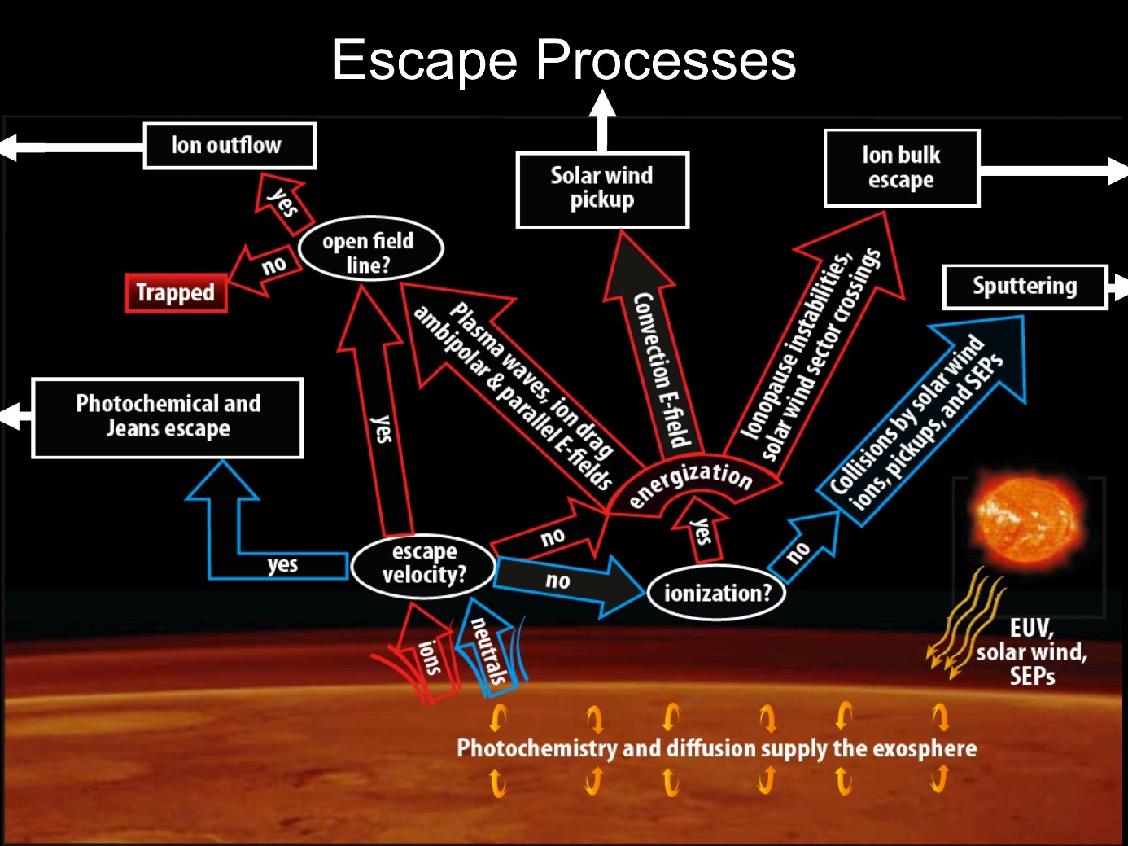

Figure 13. Schematic of contemporary escape processes (rectangular boxes) relevant for atmospheric neutrals and ions, presented in a ‘decision tree’. Solar inputs shown at the lower right contribute to the energization of atmospheric particles [Brain et al., 2014].

The different escape processes are gathered in Figure 1‑13. Three main escape processes have been identified for neutrals:

* **Jeans (or thermal) escape**: a portion of the thermal distribution for an atmospheric species exceeds the energy necessary for escape. Only species with small mass (H, D and He) can escape via this mechanism in significant quantity;
* **Photochemical escape**: exospheric chemical reactions (such as dissociative recombination of an ionized molecule with a nearby electron, resulting in two fast neutral atoms) provide atmospheric species with sufficient velocity to escape. Photochemical loss can be significant for O, N and C;
* **Atmospheric sputtering**: energetic incident particles (including ionospheric particles accelerated by the solar wind) can collide with particles of the thermosphere and ionosphere near the exobase and the momentum and energy exchange between particles carried out during the collision can lead to the ejection to space of the target particle. The incident particles can be solar wind protons or pickup ions.

When an atmospheric particle is ionized above the exobase, it can be accelerated, usually antisunward, by ambient electric fields. Most of the ions returned to the atmosphere by precipitation while a certain amount is expected to escape. The ion escape processes are:

* **Ion pickup**: an ionized neutral particle is accelerated away from the planet by a motional electric field ($E= -v×B$) induced by the solar wind plasma and its IMF [*Luhmann et al.*, 1991]. It occurs primarily for ionized exospheric neutrals;
* **Ion outflow**: acceleration of low energy particles out of the ionosphere via plasma heating and outward directing charge separation electric field;
* **Bulk escape**: any process for which coherent portions of the ionosphere are detached via magnetic and/or velocity shear processes and accelerated away from the planet.

Thanks to the spacecraft orbiting around Mars we can better understand the physical processes that drive escape today. This knowledge allows us to extrapolate to earlier conditions, when the drivers where enhanced and escape would have been more rapid.

escape down the tail and through a “polar plume”

## **The interaction of the solar wind with Mars**

The exact nature of the interaction of the solar wind with Mars has been elucidated only around twenty years ago with MGS and the setting that no intrinsic magnetic field was on Mars but several crustal magnetic field sources. Before MGS, the bow shock ant the magnetosheath had already been explored by Mariner 4, Mars 2, 3 and 5 and the tail had been observed by Phobos 2. Two models for the Martian interaction with the solar wind were opposed. On one hand, a model of magnetospheric interaction, proposed by *Dolginov et al.*, [1973] and *Gringauz et al.,* [1976], which claimed that the magnetic field of Mars controls the interaction of the solar wind with the planet. Their arguments were that they found more similitudes in the interaction of the solar wind with the Earth and Mars than between Mars and Venus, which was already known for not having any intrinsic magnetic field. Those conclusions were opposed to those of *Vaisberg et al.*, [1973] and *Russell et al.,* [1984] who proposed that the interaction with Mars was controlled by the Martian atmosphere, like the unmagnetized planet Venus. The different arguments are summarized by *Vaisberg* [1992].

The MGS magnetic measurements supported the proposition that the solar wind interacts with the extended atmosphere and electrically ionosphere of Mars, creating a magnetospheric cavity, but also with the small-scale crustal magnetic fields. This interaction hence contrasts with the plasma interactions at any other solar system bodies. The obstacle that faces the solar wind is a combination of a global atmospheric obstacle (like for Venus or the comets) punctuated by many smaller-scale obstacles formed by strong crustal magnetic fields (somehow similar to the Earth or the Moon).

The main features of the Martian global plasma interaction are summarized in carton form in Figure 1‑14. Solar wind particles, coming from the left, and the associated IMF, whose highly variable orientation is represented in yellow, induces magnetic field in the conducting Martian ionosphere. This induced magnetosphere-like interaction forms a variety of different plasma regimes and boundaries that can be distinguished using spacecraft particle and field measurements.

So as to show how the different regions and boundaries of the Martian environment are observed by plasma instruments, the data recorded by several instruments of the particle and field package of the MAVEN spacecraft during one orbit in October 2016 are plotted on Figure 1‑15. On the first panel is plotted the energy-time spectrogram of omnidirectional electron energy flux (JE) measured by SWEA. On the second and third panel are plotted the energy-time and mass-time spectrogram of omnidirectional ion energy flux (JE), respectively, measured by STATIC. On the fourth panel are the electron (**red**) and ion (**black**) density measured by SWEA and SWIA respectively. The density of SWIA is not trustworthy below the magnetosheath as it does not record ions with energy below a dozen of eV. On the fifth panel is plotted the in-situ magnitude of magnetic field (**black**) measured by MAG, superimposed with the calculated magnitude of the crustal magnetic field (**red**), from the model of *Morschhauser et al.* [2014] (see section for more details). Finally, the altitude and the position of the spacecraft regarding Mars are plotted on panel 6 and 7 (see section for more details about the frames). More details about the different instruments can be found in section. On this orbit, the spacecraft entered in the Martian induced magnetosphere on the dayside Southern hemisphere, then traveled toward the Northern hemisphere and the nightside it reached at ~17:15 UT. Figure 1‑14 and Figure 1‑15 will be used together in section 1.3.1 to describe the different regions and boundaries forming the Martian interaction with the Solar wind, from the incoming solar wind down to the ionosphere.

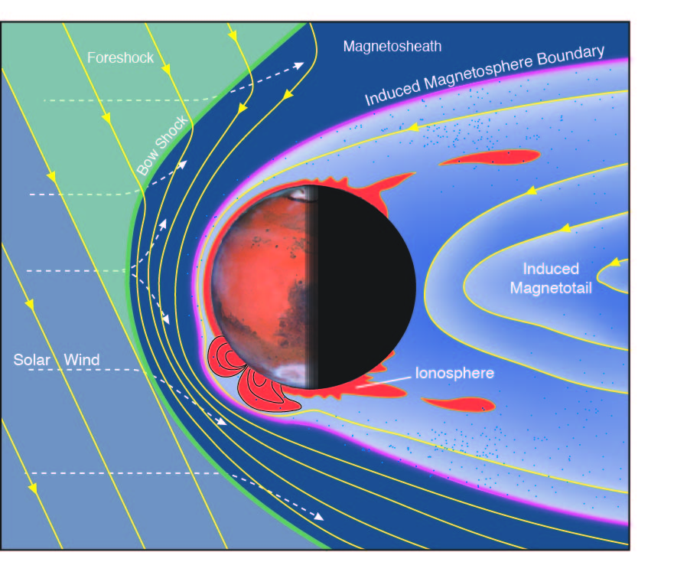

Figure 14. Schematic of the Martian plasma interaction regions [Brain et al., 2014].

*The solar wind carries with it the IMF (yellow) as it streams (dashed lines) toward the bow shock (green) upstream of Mars. Intense crustal magnetic field (orange) impose structure throughout localized regions of the upper atmosphere and ionosphere.*

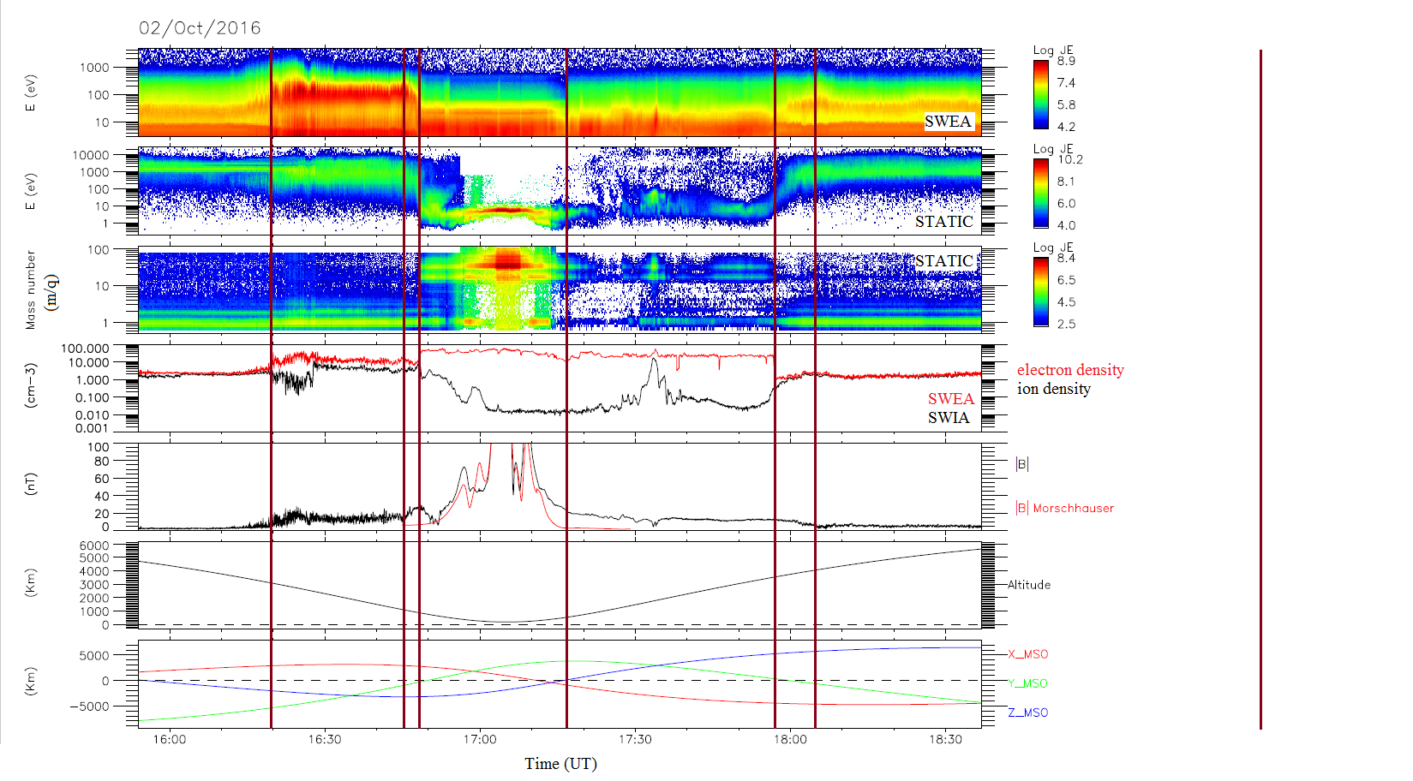

Figure 15. Example of a MAVEN passage in the plasma environment of Mars with a periapsis on the dayside.

Panel 1: SWEA energy-time spectrogram of omnidirectional electron energy flux. Panel 2: STATIC energy-time spectrogram of omnidirectional ion energy flux (C0 mode). Panel 3: STATIC mass-time spectrogram of omnidirectional ion energy flux (C6 mode). Panel 4: Electron density measured by SWEA (**red**) and ion density measured by SWIA (**black**). Panel 5: Magnetic field intensity (measured by MAG in **black** and calculated from the model of *Morschhauser et al.* [2014] in **red**) versus time. Panel 6: Altitude versus time. Panel 7: Coordinates of the spacecraft in the MSO frame (see section). The vertical lines

Models are also important tools for placing spacecraft measurements in context, and for probing cause and effect in the physics underlying the plasma interaction. Most of the models employ either Magneto-hydrodynamic (MHD) or hybrid assumptions. MHD models implement equations for the motion of electrically conducting fluid subject to electromagnetic forces, while hybrid models strive to include ion kinetic effects by tacking individual ion motion (still treating the electrons as a neutralizing fluid). The fluid model are particularly well suited for reproducing characteristics of the interaction region, while the hybrid model may better transcribe kinetic effects. Comparison of several models have been made by *Brain et al.,* [2010], *Kallio et al.,* [2011], and *Ledvina et al.,* [2008]. Individual model results will be discusses throughout this section, where appropriate.

We will first describe the solar wind interaction with Mars as a steady-state interaction (1.3.1). We will then discuss time-dependent effects on the location of the boundaries and the different regions (1.3.2). We will finish on a focus on the nightside ionosphere (1.3.3), which is the main region which has been studied throughout this PhD.

### **The steady-state interaction**

The characteristics of the solar wind interactions with weakly magnetized, or unmagnetized body, are in some regards similar to the flow about a magnetized planet [*Luhmann et al.*, 1992, *Brain 2006*], but for the lack of a global scale magnetosphere within which the motion of charged particles is governed by an intrinsic planetary magnetic field. At Mars, the disturbance caused by the presence of the planet is much smaller compared to the size of the planet that at the Earth (see Figure 1‑3). The distance of the obstacle “nose” at the Earth is ~10 Earth radii upstream while the nose of the obstacle at Mars is only a few hundred kilometers above the surface.

Due to the absence of magnetic obstacle at Mars, the solar wind interact directly with the upper atmosphere and ionosphere and induce a magnetosphere by the pile up of the IMF. The solar wind transitions from supersonic to subsonic as it crosses the bow shock (1.3.1.1) and enters into the magnetosheath (1.3.1.2). Few solar wind protons are observed downstream a boundary sometimes called the Magnetic Pile-up Boundary (MPB) (1.3.1.3). Below the MPB is the Magnetic Pileup Region (MPR). The Photo Electron Boundary (1.3.1.4) separates the planetary ionosphere (1.3.1.5) from the MPR. A two-lobed induced magnetotail (1.3.1.6) forms on the night side, with a current sheet carrying planetary ions between the two lobes [*Nagy et al.,* 2004 for a review of the distinct plasma boundaries and regions resulting from the interaction].

#### **The bow shock and the upstream region**

When the solar wind, which is supersonic, encounter on its way a conductive obstacle such as Mars, a bow shock is forming upstream of the planet (green line on Figure 1‑14). Due to the geometry of the planet, the shock is detached. The solar wind is then heated, deflected, and slowed when it passed the shock so that it becomes subsonic. On Figure 1‑15 the bow shock can be observed at ~16:20 UT on the inbound part of the orbit. This first boundary separated two regions:

- The upstream one which is characterized by solar wind plasma (mainly protons with an energy greater than 1000 eV), a low plasma density and temperature (the ion beam is rather narrow on panel 2), a low magnetic field (< 5nT), and a supersonic flow (not shown). The typical shape of the electron flux spectrogram in the solar wind is plotted in **red** in Figure 1‑16. The left part for energies below 10 eV should not be taken into account as it is due to the potential of the spacecraft (see section);

- The downstream one, called magnetosheath, which is characterized by a more intense magnetic field and density, a subsonic flow (not shown) and a higher temperature (the ion beam is larger on panel 2). The typical shape of the electron flux spectrogram in the magnetosheath is plotted in **dark red** in Figure 1‑16 and will be discussed in the next section.

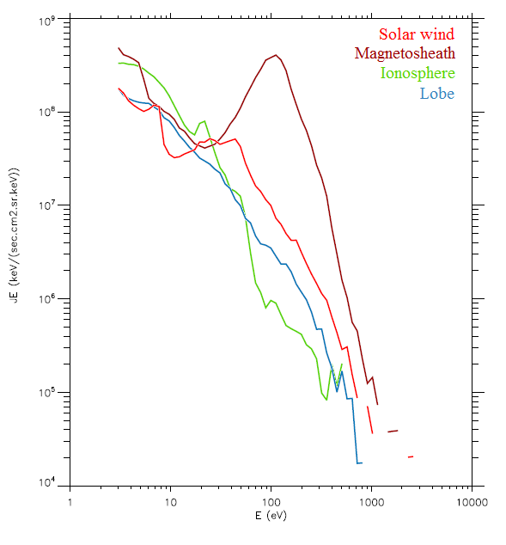

Figure 16. Electron energy spectra measured by SWEA in the **solar wind**, **magnetosheath**, **ionosphere** and the **lobe** on the orbit showed on Figure 1‑15.

Due to the low gravity of Mars and the absence of magnetic field, the bow shock is close to the surface of the planet (~2000 km at the subsolar point, ~5500 km at the terminator), so an important part of the exosphere is located well out of the shock and can interact directly with the incident solar wind. The interaction of Mars with the solar wind hence starts several planetary radii away from the planet, where the exospheric neutrals are ionized, mostly by photoionization and charge exchange. The resulting ions keep the same temperature as their neutral parents (a few eVs), but gain a small amount of energy during the process of photoionization. The new born ions, heavier but colder than the native ions of the solar wind, are accelerated by the electrical fields associated to the incoming flow, which tend to restore the thermodynamic equilibrium. These ions are ‘**pickup ions**’. As the solar flow approaches Mars, an increasing number of cold exospheric newborn ions are created and lead to a significant **massloading** of the solar wind [*Bertucci et al., 2011**]*, which decelerates the flow by ~5% [Kotova et al., 1997]. The term ‘mass-loading’ refers to a situation where slow-moving mass is added to a flowing plasma, decelerating it via conservation of momentum.

Thanks to the several shock crossing of MGS, the altitude of the shock has been observed to increase from the subsolar point away to the tail, and that it has roughly the shape of a hyperboloid of revolution. Calculation of the bow shock shape have been made by *Vignes et al.* [2000, 2002], based on MGS crossings, and *Trotignon et al.* [2006], based on MGS and Phobos data, and *Edberg et al.* [2008], based on MEX data. Comparison of the results of these three models are presented on Figure 1‑17 [*Edberg et al.,* 2008]. The bow shock is the outer boundary and the three fit are globally in good agreement, slightly less at the subsolar point.

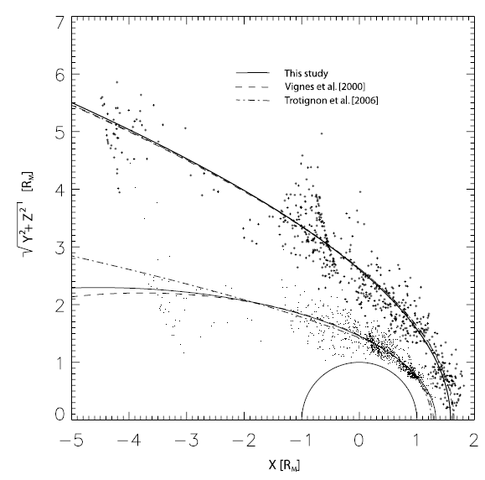

Figure 17. All MPB and bow shock crossings found from the pre-mapping phase of MGS plotted as dots and plus signs, respectively, in 4° aberrated cylindrical MSO coordinates [Edberg et al., 2008]. Also shown, as a comparison, are the best fit conic section from Edberg et al., [2008] (solid line), the best fit from Vignes et al., [2000] (dashed line), and the best fit from Trotignon et al. [2006] (dashed-dotted).

#### **The Magnetosheath**

After the crossing of the bow shock, we can on Figure 1‑15 that the spacecraft enter into a region with the same ion population as in the solar wind (mainly protons), at approximately the same energy, but with a much higher temperature. The electron and ion density are higher than in the solar wind and the magnetic field is also higher than in the solar wind but shows much more fluctuations. Moreover, if we observe the electron energy spectra of this region on Figure 1‑16 (**dark red** one), we can see that the electron population is at higher energy than in the solar wind, and is warmer. These characteristics are typical of the magnetosheath.

The magnetosheath is the region standing between the solar wind and the effective obstacle (dark blue region on Figure 1‑14). It acts like a buffer between a region dominated by the solar wind dynamic pressure and the planetary induced magnetosphere dominated by the planetary pressure. It is populated by shock-heated, dense and turbulent solar wind plasma. Indeed, the solar wind plasma is slowed to velocities lower than $100 km.s^{-1}$, compressed by up to several times its original density, and heated to temperature up to ~4 times higher than upstream. The flow is also deflected from its original antisunward motion. The flow continues to slow as it travels deeper into the magnetosheath.

As the plasma slows, the magnetic field increases, by up to ~4 times the upstream value. The magnetic field is compressed, distorted and “**draped**” as the plasma in which it is embedded is compressed and diverted around the obstacle. The understanding of the draping of magnetic field lines around a planet is based on the work of *Alfvèn et al.,* [1957] who first talk about this phenomenon. Indeed, as Mars is a conductive obstacle, the IMF cannot penetrate inside the planet. As the IMF is frozen in the solar wind plasma, when the plasma is slowed down upstream the planet, the magnetic field lines pile-up upstream the planet. However, as the IMF continues to be convected by the unperturbed solar wind flow around the planet, the magnetic field lines bend around the planet to form the magnetotail downstream. The IMF is wrapping around Mars.

In summary, the magnetosheath is characterized by shock-heated, dense and turbulent solar wind plasma and by a huge variability both in the field magnitude and direction. We can observe it on the outbound part of the orbit on Figure 1‑15 between ~16:30 UT and ~16:45 UT and on the outbound bound from ~18:05 UT to the end of the plot. On both case, the dominant ions are protons with high energy and temperature (wide beam) and the quite low magnetic field is highly fluctuating. This characteristics are more visible on the inbound, which is located on the dayside than on the outbound, which is located in the tail.

#### **The Magnetic Pile-up Boundary and the Magnetic Pile-up Region**

The region which separates the magnetosheath from the ionosphere is still controversial. It has proven difficult to determine whether there is a single outer boundary of the induced magnetosphere or several that are physically distinct. In the two following section we discuss about several of the boundaries commonly used to describe this region.

As the spacecraft plunges deeper in the magnetosheath in Figure 1‑15, we can see around 16:45 UT that the energy of the electrons and of the ions begins to fall, at the same time as the magnetic field begin to strongly increase. These lower boundary of the magnetosheath is usually called the Magnetic Piled-up Boundary (MPB) [*Bertucci et al.*, 2004] and is represented as the purple line on Figure 1‑14.

The MPB is a controversial boundary, which has also been called the Induced Magnetosphere Boundary [Brain et al., 2014], Induced Magnetopause, planetopause [*Riedler et al.*, 1989], magnetopause [*Rosenbauer et al.,* 1989; *Lundin et al*., 1989], protonopause [*Sauer et al.*, 1994], or the ion composition boundary [*Breus et al.*, 1991], depending on the observed parameters. The chosen name of the boundary, MPB, arbitrarily emphasizes the behavior of the magnetic field. The other names emphasizing other plasma components, or an instrument- neutral designation, would also have be correct, but after long, and surely animated, discussions, the MPB terminology has been adopted [*Nagy et al.,* 2004].

Despite the different names and plasma signatures associated with this boundary, it seems clear that it results from the interaction of the shocked solar wind with planetary heavy ions. The MPB clearly separates two very different regions:

* The magnetosheath with low amplitude and turbulent magnetic fields;
* A region of high piled-up fields, the Magnetic Pile-up Region (**MPR**), where the solar wind magnetic field is piled up and draped around the ionosphere. The MPR marks the transition between plasma dominated by ions of solar wind origin (mainly protons) and plasma dominated by ions of planetary origin (mainly $O^{+}$ and $O_{2}^{+}$). The two types of ions are usually distinguished regarding the ion mass spectrometry (third panel).

Several sharp changes of the plasma and field parameters can be observed at the MPB like: the rotation of the magnetic field direction, a strong and sharp jump observed on the magnetic field amplitude (the draped IMF at Mars typically reaches strengths of 30-60 nT) and a decrease in magnetic field turbulence, an increase in the field draping, a strong reduction of the field’s directional variability, a strong drop of the suprathermal electron fluxes (energies > 10eV) by often more than one order of magnitude [*Acuña et al.,* 1998; *Bertucci et al.,* 2003]. There is also a drastic change of ion composition: the proton density decreases, commensurate with an increase of planetary ions density. A sharp increase in electron density, and a decrease in the electron temperature can also be observed. Several of these features can be observed on Figure 1‑15. However, not all the characteristics are observed at each crossing so that it is not yet understood which signatures help to form or maintain MPB and which result from its existence.

As for the bow shock, the MPB is usually approximated by a paraboloid of revolution about the planet-Sun line. The shape has been fit using Phobos data [*Trotignon et al.*, 1996], MGS data, [*Vignes et al.*, 2000], a combination of Phobos and MGS data [*Trotignon et al.*, 2006], and MEX data [*Edberg et al.,* 2008]. The last three models are plotted on Figure 1‑17. They are in rough agreement except for the far nightside. From the model fit, the MPB is situated at ~850 km altitudes near the subsolar point, and ~1500 km near the terminator.

#### **The ionopause and the Photo Electron Boundary**

Between the MPR and the ionosphere is a boundary, sometimes called Ionopause, sometimes called Photo Electron Boundary (**PEB**) and which delimit the magnetospheric cavity almost void of solar wind plasma which is formed around Mars. The Ionopause name is inherited from Venus, where it corresponds to the upper boundary of the ionosphere. It is defined as the location where ionospheric electron density increases rapidly or as the location where ionospheric thermal pressure is balanced by the magnetic pressure in the induced magnetosphere [*Phillips et al.,* 1988]. At Mars, the ionospheric thermal pressure is typically insufficient to balance magnetic pressure and so the field penetrates into the ionosphere, dominating the pressure there [*Dubinin et al.*, 2008a] (pressure balance will be discussed in more details in section 1.3.2.2).

The PEB is considered as the boundary above which magnetosheath-like solar wind electrons are located and below which ionospheric photoelectrons are located [*Mitchell et al.,* 2001]. The PEB can be observed as the location between regions where photoelectrons are evident and where they are not. [*Nagy et al.*, 2001].

On Figure 1‑15 the Ionopause/PEB can be observed mainly on the electron spectrogram, where the electron flux at energies greater than 100 eV decreases dramatically and a line at 20-30 eV begins to be observed (sign of the presence of photoelectrons) and on the ion spectrogram, where the ion energy drops from ~1000 eV to less than 10 eV, and planetary ions begin to be observed. The decrease in the magnetic field value that can be observed just below the Ionopause/PEB is also a typical feature of this boundary.

In most case, the PEB and the Ionopause coincide but it is still not clear if the Ionopause and the PEB are collocated or not. The average Ionopause altitude is almost constant on the dayside, around 450 km, and increases near the terminator.

#### **The Ionosphere**

The lowest region that can be observed on Figure 1‑15 (at the periapsis), is the ionosphere. It is represented in orange on Figure 1‑14. The ionosphere is a region of low energy planetary plasma, with relatively cold, heavy ions. It can be easily detected thanks to the spectral lines of photoelectrons on the electron spectrometer. The photoionization of atmospheric $CO_{2}$ and atomic O produces electrons with specific energies (two peaks at 21-24 eV and 27 eV) [*Mitchell et al.*, 2000]. However, the individual peak cannot be resolved by SWEA and on the electron spectra corresponding the ionosphere on Figure 1‑16, we only see one peak at ~20 eV. The presence of photoelectron is then use as a tracer of the ionosphere [*Mitchell et al.,* 2000; 2001; *Dubinin et al.,* 2006; *Frahm et al.*, 2007 and Garnier et al., coming soon]. The ionosphere is also characterized by a decrease of the flux of electrons having an energy greater than ~30 eV. This decrease can reach one order of magnitude for ~100 eV electrons [Mitchell et al., 2001].

#### **The wake and the magnetotail**

If we follow the MAVEN spacecraft going away from its periapsis on Figure 1‑15, it exits the ionosphere at ~17:15 UT and enter a new region on the nightside of Mars. It corresponds to the lobes of the induced magnetotail (Figure 1‑14). The IMF magnetic field lines draped around Mars extend well downstream in the anti-sunward direction, and form the magnetotail by analogy with the magnetotail that forms downstream of a magnetic planet. A magnetic planet imposes a geometry and polarity on the field in its magnetotail, whereas the magnetotail formed downstream an unmagnetized body changes direction in response to changes in the direction of the IMF. *Yeroshenko et al.* [1990] found that the magnetic field in the magnetotail can be organized into two tail lobes with ‘to’ and ‘away’ from Sun directions of the magnetic field (two opposite polarities), separated by a thin magnetic neutral sheet. The plasma sheet consists primarily of planetary ions which are accelerated up to keV energies by the magnetic field tensions [*Dubinin et al.,* 1993]. Well-defined current sheets are sometimes evident as low as ~400 km. The magnetic field in the tail is weak (~10 nT), though it is still stronger than the unperturbed IMF.

The two lobes of the magnetotail can be observed on Figure 1‑15 from ~17:15 UT to ~17:55 UT with the current sheet at ~17:35 UT. The magnetic field is quite steady in the lobes, apart from the current sheet passage, where there is a drop in the amplitude of the magnetic field and an inversion of the three components of the magnetic field (not shown). The presence of planetary ions can also be observed so as a little enhancement in the electron energy. The boundaries separating the wake from the magnetosheath could be called wake boundary, as an extension of the MPB to the nightside.

[description simulation Dong]

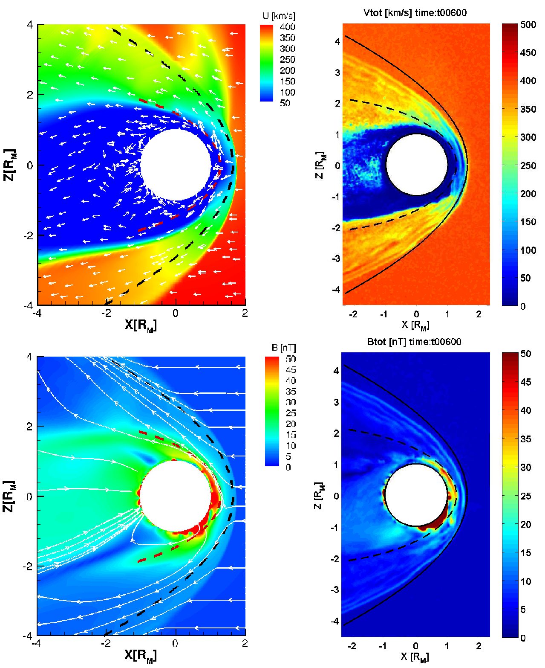

Figure 18. Plasma and magnetic field environment of Mars according to the multi-fluid magnetohydrodynamic simulation of Dong et al., [2014]. Upper left panel is a meridian plane projection of the magnitude (color) and direction (arrows) of plasma velocity near Mars. Lower left panel shows the simulated magnetic field lines and magnetic field magnitude (colors) in meridian plane direction. Large field magnitudes very near the planet’s surface are due to strong crustal magnetic fields, especially in the Southern hemisphere. However, strong fields due to the solar wind interaction with Mars are also observed at high altitude on the dayside. Right panels illustrate flow velocity (upper) and magnetic field magnitude (lower) in greater detail and unencumbered by flow and field vectors.

### **Variation in the Martian interaction with the Sun**

The description of the Martian magnetosphere proposed in section 1.3.1 is a steady-state description, which does not take into account neither the presence of crustal magnetic field nor the variation of the external drivers (such as the direction of the IMF or the EUV flux).

#### **Magnetic topology**

Due to the presence of crustal magnetic sources, the magnetic field lines in the vicinity of Mars can be of three kind [*Nagy et al.*, 2004; *Bertucci et al.,* 2003; *Brain et al.*, 2007], gathered on the left side of Figure 1‑19:

* **Closed**: magnetic field lines are connected at both end to the crust (a configuration);
* **Open**: one end of the magnetic field line is connected to the crust and the other end to the IMF (b configuration);
* **Draped/Unconnected**: both ends of the magnetic field lines are unconnected to the crust and connected to the IMF (c and d configuration).

The closed magnetic field lines are due to the presence of crustal magnetic sources in the Martian crust. If the magnetic field is strong enough, as in the Southern hemisphere, the closed magnetic field lines should shield the upper atmosphere from magnetized charged particles and from intrusion of the magnetosheath plasma. There is hence formation of regions that act in many respects like small-scale version of the terrestrial dayside magnetosphere [*Fränz et al.*, 2006], as plotted on the right side of Figure 1‑19.

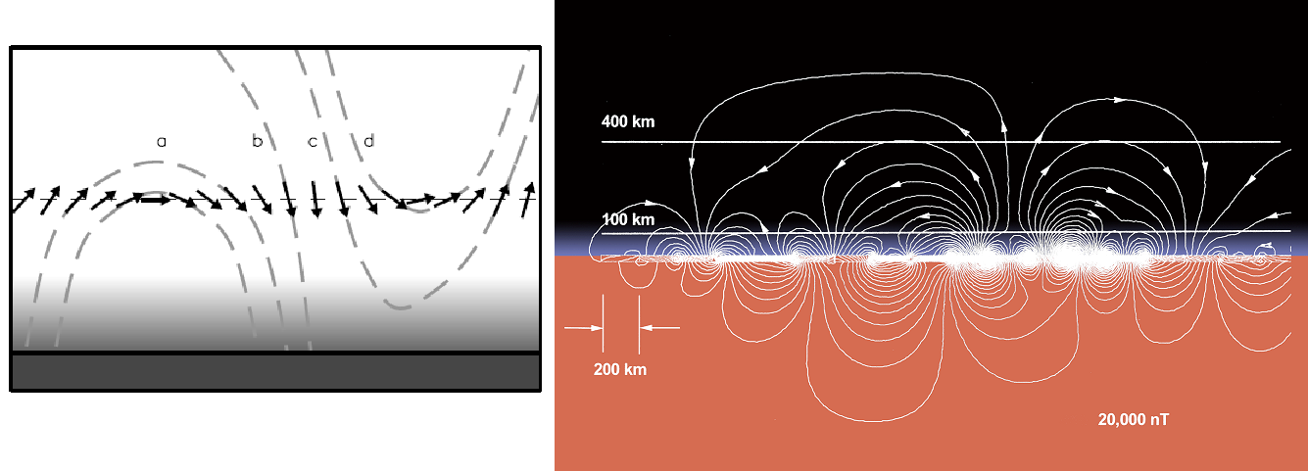

Figure 19. Left. Possible magnetic field topologies [Brain et al., 2007]. The Mars Global Surveyor Magnetometer and Electron Reflectometer (MGS MAG/ER) measures the local vector magnetic field near 400 km altitudes (arrows). Electron pitch angle distributions can be used to help identify whether the field angle is closed (curve a), open (curve b) or draped (curve c) in the ionosphere/atmosphere, or draped above the ionosphere/atmosphere (curve d). Right. Plane projection of the magnetic field geometry above the intensely magnetized southern highlands [Connerney et al., 2015] based on the crustal magnetic field model of Connerney et al. [1999]. This figure illustrates the field geometry that would be encountered during periapsis passes along a line of constant longitude (near 150° East) and centered at 50°S. Similar ‘mini-magnetosphere’ may be encountered above much of the magnetized crust, depending on spacecraft altitude and solar wind conditions.

Open field lines can be found at the edge of closed crustal magnetic field lines, and form cusp-like regions, analogous to terrestrial magnetospheric cusp regions. Such regions can provide a conduit for energy and particle exchange between the solar wind and the ionosphere [*Krymskii et al.*, 2002]. Open field lines between closed field lines can be confused with the signature of current sheets. Indeed, *Halekas et al.,* [2006] showed that the non-uniform geographic distribution of the current sheet at 400 km in the nightside suggests that crustal fields may play some role in their presence at low altitude. This interpretation has been supported by simulations [*Ma et al.,* 2002].

These three topology have been encountered at Mars and can be detected thanks the electron pitch angle distribution: PAD. The electron pitch angle corresponds to the angle between the electron velocity and the magnetic field vectors. These distribution have been mapped geographically at 400 km by *Brain et al.,* [2007] and on a wider range of altitude by *Xu et al.*, [2016]. The results of these studies will be discussed in more details in section.

#### **Pressure balance**

The total pressure at any location in the Martian system should be conserved. Upstream from the planet the solar wind is dominated by dynamic pressure ($\sim {ρv}^{2}$). The thermal plasma pressure (~*nkT*) becomes dominant in the magnetosheath. The dominant pressure term in the MPR is the magnetic pressure (~*B2/2μ0*) from induced magnetic field. In the ionosphere the plasma pressure (~nkT) become dominant.

Each boundary in the interaction of Mars with the Sun is the result of an equilibrium of pressure.

/!\ à compléter

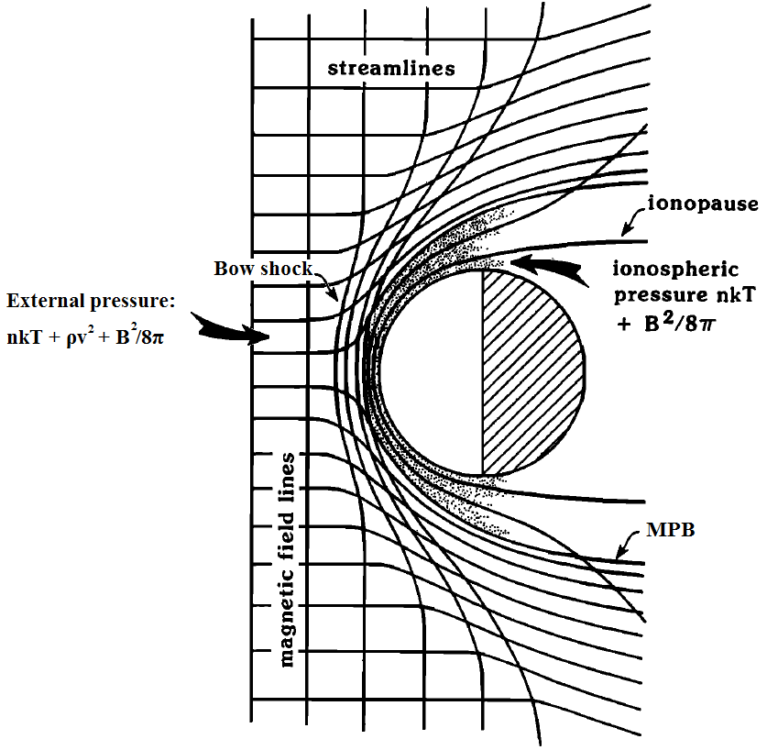

Figure 20. Illustration (not to scale) of how the interplanetary magnetic field may penetrate into the Martian ionosphere (stippled). The stream lines of plasma flow are those that are diverted around the planetary obstacle, while the cross-flow lines are magnetic field lines.

#### **Variability of the boundaries**

The location of the different boundaries and hence the extension of the different regions depend on the intensity of the external drivers (solar wind plasma, solar UV photon flux, upstream pressure and IMF direction), but also the internal drivers in the case of Mars (crustal magnetic sources and their orientation with respect to the sun).

**Influence of the crustal magnetic sources**

The orientation of Mars with respect to the Sun would not be a major factor in controlling variability in its plasma environment if it lacked crustal magnetic fields. However, the crustal fields rotate with the planet every ~24h. They are strong enough to influence the altitude of all the major plasma boundaries on timescales associated with Mars’ rotation [*Brain et al.*, 2003, 2006].

As the crustal field add magnetic pressure to the Martian system at ionospheric altitude, that helps to counter the pressure of the solar wind. Crustal fields replace the need for induced ionospheric shielding currents in some locations. The pressure from the crustal magnetic fields alters the shape of the obstacle to the solar wind, perturbing various plasma boundaries upward locally [*Crider*, 2004; *Fränz et al.*, 2006], as illustrated on Figure 1‑14. As the crustal fields influence the location of all main plasma boundaries at Mars, their influence on the bow shock is relatively weak [Mitchell et al., 2001; Crider et al., 2002; Edberg et al., 2009; Duru et al., 2010]

**Influence of the Solar EUV Photon flux**

The solar EUV flux determines the ionospheric thermal pressure, which ultimately balances the incident pressure of the solar wind. The altitude of the MPB and of the bow shock have been successfully correlated with EUV flux [*Edberg et al.*, 2009], though attempts to correlate the Ionopause/PEB with EUV flux have been unsuccessful [*Mitchell et al.,* 2001].

**Influence of the solar cycle**

As the EUV flux is more important during solar maximum, one can think that the solar cycle have an impact on the position of the different boundaries of the Martian environment. However, *Modolo et al.*, [2005] simulations showed that the position of the bow shock and the MPB hardly depend on the solar cycle, according to the observations made by *Vignes et al.* [2000]. Minor differences have to be noted on the density between minimum and maximum activity, except on the nightside where the plasma density at the maximum of the solar cycle is six times more important than at the minimum. This is mostly due to the variation in the production of planetary ions.

**Influence of the IMF direction**

Variation in the direction of the IMF change considerably the position and the shape of the MPB. Indeed, the shape of the bow shock is asymmetric with respect to the IMF direction [Acuña et al., 1998, Dubinin et al., 1998, Vignes et al., 2002]. Hybrid simulation by *Modolo et al.*, [2012], using time-dependent input conditions demonstrated that a rotation of the IMF causes the entire interaction region to rotate in response, with a ‘lag’ of as much as two minutes in some regions.

**Influence of the parameters of the solar wind flow**

The solar wind density and velocity determine the incident dynamic pressure at Mars. Since there is a pressure balance throughout the dayside interaction region, the density and velocity play a large role in determining the size and position of the different plasma boundaries, the plasma temperature in the magnetosheath, and the strength of the magnetic field in the induced magnetosphere [Brain et al., 2014].

The position and the shape of the MPB is partially affected by the speed of the solar wind [Modolo et al., 2005].

Simulations are especially well-suited to study the effects and relative importance of the individual drivers. See for example: *Brecht and Ledvina* [2006]; *Harnett and Winglee* [2006]; *Modolo et al.*, [2006]; *Ma and Nagy* [2007]; *Kallio et al.*, [2008]; *Fang et al.*, [2010]; [*Najib et al.*, 2011]](#_Bibliography)*.*

[ajout simulation]

### **Focus on the nightside ionosphere**

The ionosphere is mainly due to photoionization of atmospheric oxygen and carbon dioxide. As the recombination of the electron and ions resulting from this interaction back into neutrals is rapid and there is no nightside photoproduction, the ionosphere is generally a daytime phenomenon. However, photoelectrons are also observed in the nightside hemisphere [*Frahm et al.*, 2006]. The nightside Martian ionosphere is maintained by transport processes from the dayside (e.g., horizontal transport of photoelectrons from dayside to nightside along draped magnetic field lines [*Ulusen and Linscott*, 2008; *Fränz et al.*, 2010], as well as by production processes such as electron impact ionization of precipitating magnetosheath electrons [Fillingim et al., 2010; Lillis et al., 2011; Lillis and Brain, 2013b].

On Figure 1‑21 is plotted an orbit of MAVEN in February 2015, during which the periapsis is on the nightside. The different boundaries described in section 1.3.1 are highlighted by the vertical lines. The spacecraft enter the bow shock at ~06:50 UT, on the dayside Southern hemisphere. Then it travels in the magnetosheath until ~06:10 UT where it crosses the MPB and then the Ionopause/PEB at ~06:15 UT. Then, the spacecraft stays in the ionosphere until ~07:00 UT. However, at ~06:25 UT, the spacecraft passes the terminator and carries on in the nightside. On this example, the spacecraft observes the dayside ionosphere as well as the nightside ionosphere.

We can observe between ~06:30 UT and ~06:35 UT a typical structure of the nightside ionosphere: the **suprathermal electron depletions** (which may be equally called electron depletions hereinafter). We can observe it on the first and the fourth panel. During the event, the electron flux at all energies above 3 eV (the limit of the SWEA instrument), decrease by more than three order of magnitude. At the same time, a sharp drop in the electron density is measured.

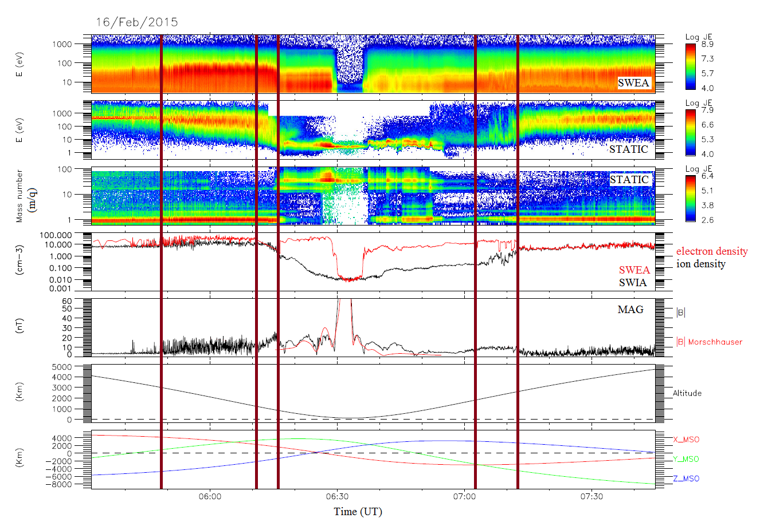

Figure 21. Example of a MAVEN passage in the plasma environment of Mars with a periapsis on the nightside.

Panel 1: SWEA energy-time spectrogram of omnidirectional electron energy flux. Panel 2: STATIC energy-time spectrogram of omnidirectional ion energy flux (C0 mode). Panel 3: STATIC mass-time spectrogram of omnidirectional ion energy flux (C6 mode). Panel 4: Electron density measured by SWEA (**red**) and ion density measured by SWIA (**black**). Panel 5: Magnetic field intensity (measured by MAG in **black** and calculated from the model of *Morschhauser et al.* [2014] in **red**) versus time. Panel 6: Altitude versus time. Panel 7: Coordinates of the spacecraft in the MSO frame (see section). The vertical lines

The study of this structure thanks to different spacecraft has been the main objective of this PhD.

[motivation et plan]

# **Instrumentation, data and analysis tools used**

/!\ à compléter

## **Exploration of Mars**

The launch of space vehicles to explore Mars started in 1960 with the launch of **Marsnik 1** by the Soviet Union. Unfortunately, the exploration of Mars only begun four years later, on July 14-15, 1965, with the first Martian flyby made by the NASA spacecraft **Mariner 4**. Indeed, the Martian exploration has experienced a high failure rate, especially at its beginnings, from 1960 to 1971. Only five missions on the nineteen sent succeeded. This eagerness to explore Mars was motivated by its spatial proximity and by its past, when Mars may have looked like the Earth. Hence, the main objectives of the missions to Mars, past or future, are to determine if it has ever sheltered life, to understand the process and the evolution of the Martian weather, to understand the origins and the evolution of the Martian geology and finally to prepare the human exploration of Mars.

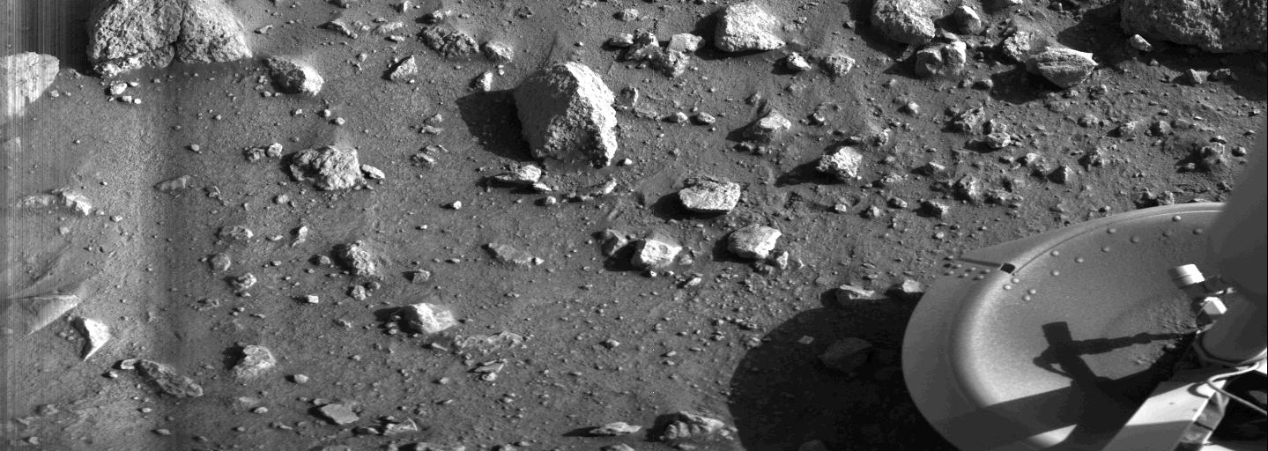

Figure 22. First photograph made by the lander Viking 1 of the Martian surface

On November 14, 1971, the NASA spacecraft **Mariner 9** became the first spacecraft to orbit another planet when it achieved its orbit insertion around Mars. The Soviets finally reached the Martian surface in 1971. **Mars 2** crashed on the surface on November 27, and **Mars 3** landed successfully on the surface on December 2 but ceased transmission within 15 seconds. In July 1976, The NASA lander **Viking 1** offered us the first photograph ever taken from the surface of Mars (Figure 22). The two lander Viking 1 and Viking 2 took also the first in-situ measurement of the atmosphere during their descent toward the surface.

Since then about twenty orbiters, landers and rovers have reached the red planet, even if error of units sometimes make them crash. In 2017, the operational Martian fleet is composed of two scientific rovers rolling on its surface: **Curiosity** of the Mars Science Laboratory mission (NASA) and **Opportunity** of the Mars Exploration Rover mission (NASA) along with six orbiters surveying the planet: **Mars Odyssey** (NASA), **Mars Express** (ESA), **Mars Reconnaissance Orbiter** (NASA), **Mars Orbiter Mission** (Indian Space Research Organization), **MAVEN** (NASA) and the **ExoMars Trace Gas Orbiter** (ESA).

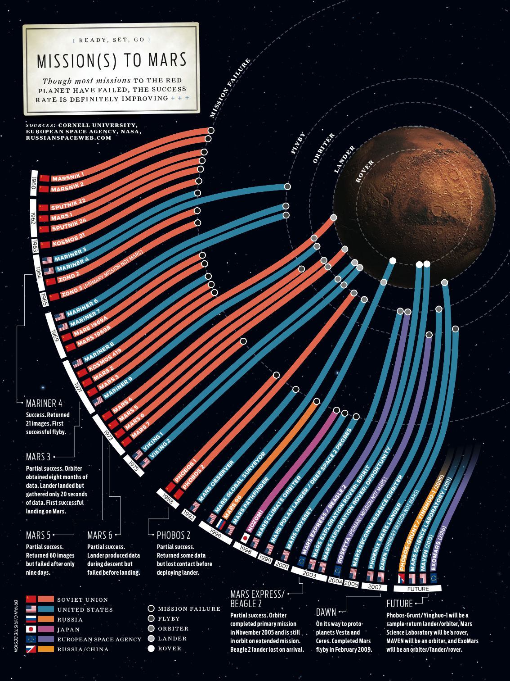

Figure 23. Summary of all the missions ever sent toward Mars.

*The Russian mission* ***Phobos-Grunt*** *failed its launch and stayed in a low Earth orbit. The NASA* ***Mars Science Laboratory*** *successfully landed on Mars and is still rolling on its surface. The NASA* ***MAVEN*** *spacecraft successfully orbits around Mars since 2014. The European* ***ExoMars*** *mission partially succeed. The orbiter achieved its insertion around Mars but the* ***Schiaparelli*** *lander failed its landing. Next missions are: NASA lander* ***InSight****, ESA rover* ***ExoMars*** *and NASA rover* ***Mars2020****.*

### **Mars Global Surveyor**

After the success of the Viking program, about twenty years have passed with no successful American mission to Mars but many questions about the origin and history of Mars remained unanswered. The **Mars Global Surveyor** (MGS) spacecraft has been launched on November 7, 1996 from Cape Canaveral Air Force Station (Florida, USA), four years after the loss of contact with the previous mission spacecraft: **Mars Observer** (several days before its insertion around Mars).

#### **Objectives**

MGS is the first mission of the NASA Mars Surveyor Program. The objectives of this program are to understand the current and past climates of Mars, the geological and geophysical evolution of the planet and whether life could have started and evolved on Mars [*Albee et al.,* 2001]. The primary objectives specific to the MGS mission are the following:

* Characterize the surface morphology at high spatial resolution to quantify surface features and geological process;
* Determine the composition, distribution and thermophysical properties of surface minerals, rocks and ices;
* Determine the global topography, geodetic figure, and gravitational field;
* Establish the nature of the magnetic field and map the crustal remnant field;
* Monitor global weather and thermal structure of the atmosphere;
* Study surface-atmosphere interaction by monitoring surface features, polar caps, polar thermal balance, atmospheric dust, and condensate clouds over a seasonal cycle.

Several secondary objectives had been set during the extensions of the mission:

* Provides multiple years of on-orbit relay communications capability for Mars lander and atmospheric vehicles;
* Long-term weather and surface monitoring;
* Support landing site selection through acquisition of high-resolution imaging for the 2007 Phoenix lander and the 2011 Curiosity rover

#### **Orbitography**

The MGS mission had been designed to be a global mapping mission which investigated the entire planet, from its interior to its surface, through its atmosphere, up to its ionosphere. These constraints leads to the definition of a low-altitude, near-circular, near polar, Sun-synchronous mapping orbit with a short repeat cycle. The selected characteristics were then: a “frozen orbit” with a period of 117.65 min, an inclination of 92.96°, an average altitude of 378 km varying from 368 to 438 km above the surface and a local time set at 1400/0200 LT.

The amount of propellants needed to reach this mapping orbit was too large to be launched. Hence, after Mars orbital insertion, an aerobreaking phase - during which the spacecraft would reach low altitudes at its periapsis - had been planned to use the atmospheric drag on the spacecraft to slow it so as to reach its low-altitude mapping orbit. Such a technique was challenging as it had never been done before and few was known about the structure and dynamics of the Martian atmosphere.

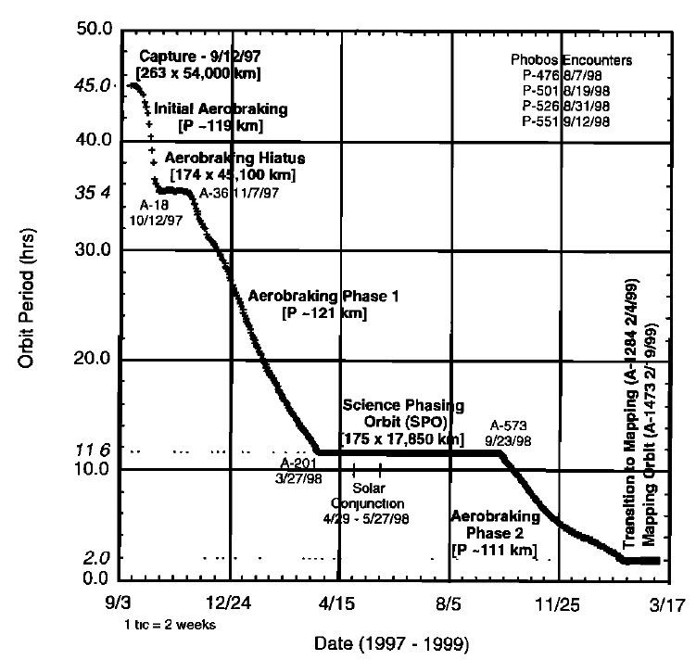

Figure 24. MGS orbit period during its aerobreaking phase. [Albee et al., 2001]

After its launch on November 1996, the MGS spacecraft travelled 11 months before reaching Mars on September 11, 1997 and being inserted in a highly elliptical orbit of 45 hours period. On its third orbit, MGS initiated the aerobreaking phase, operating repeated dips into the upper atmosphere (down to 105 km altitude) with its solar panel in a V configuration to slow the spacecraft. The solar panels’ surface were then the main sources of kinetic energy dissipation by friction with the atmosphere.

According to the initial planning, the spacecraft would have reached its mapping orbit in the spring of 1998. However, at the periapsis of the fifteenth orbit on October 8, 1997, the spacecraft experienced excessive flexing of one of its solar panel. Indeed, a failure during the deployment of this solar panel in early cruise resulted in a bad locking in its proper position. When the pressure increased on this solar panel during the dips in the low atmosphere, this problem became critical for the integrity of the whole mission. The orbit was quickly raised so as to decrease the pressure on the solar panel, which interrupted temporarily the aerobreaking phase as it was initially planned. On November 7, 1997 the aerobreaking phase was resumed, with reduced pressure on the panels. As this pressure was reduced by a factor of 3 regarding the original plan, it delayed the entry into the circular-mapping orbit for one Earth-year.

MGS finally reached its mapping orbit on February 19, 1999 (Figure 24), after 17 months into orbit. It was the first time a spacecraft deployed aerobreaking techniques to reach its working orbit. Even if the incident on the fifteenth orbit delayed the beginning of the mapping phase, it allowed the acquisition of an unexpected amount of data in the ionosphere as the number of elliptical orbit and the local time range explored had widely increased.

The MGS mapping mission was initiated on March 9, 1999. In the nominal mapping mode the spacecraft was continuously nadir-pointed, enabling the instruments to acquire and record data on a continuous basis. The nominal mapping mission end on February 1, 2001. It was extended several time until the end of 2006. MGS then became silent, due to a battery failure. The MGS mission officially ended in January 2007.

#### **Instruments**

After the failure of the Mars Observer mission, four of its science instruments retooled the MGS spacecraft. The aim of the instrument suite was to study Mars in its entirety, meaning at the same time its surface, interior and atmosphere. To meet the scientific objectives of the mission they had to both acquire high-quality data and maximize the data returned within the constraints of the mission. Four instruments and a radio science investigation have been operated onboard MGS, the configuration of which is shown on Figure 25:

* MOC (Mars Orbiter Camera)

MOC is a high resolution camera which aim was to map the whole Martian surface [*Malin et al.*, 1992]. It produced a daily wide-angle image of Mars to provide a continuous record of Martian weather but it could also take narrow-angle pictures to observe object as small as 0.5m.

* MOLA (Mars Orbiter Laser Altimeter)

MOLA is a laser altimeter which aim was to characterize the topology and the gravitational field of Mars [*Zuber et al.,* 1992]. It measured the height of the Martian surface features like mountains or valleys with a precision of ~30 cm in the vertical dimension.

* TES (Thermal Emission Spectrometer)

TES is a thermal emission spectrometer which aim was to study the atmosphere and map the mineral composition of the surface thanks to infrared spectroscopy [*Christensen et al.,* 1992]. The use of infrared wavelength was chosen so as to scan the heat emitted from the surface of the planet.

* MAG/ER (Magnetometer/ Electron Reflectometer)

The MAG/ER experiment was composed of two magnetometers (MAG) which measured the orientation and the magnitude of the magnetic field in order to better understand the interior of the planet and hence its history and evolution, and an electron spectrometer (ER) which measure the distribution function of the electrons having an energy between 10 eV and 20 keV [*Acuña et al.*, 1992].

* Radio Science (Gravity Field Experiment)

The radio science investigation used data provided by the spacecraft telecommunications system, high-gain antenna and onboard ultra-stable oscillator to map variations in the gravity field and to determine the atmospheric pressure at specific locations.

#### **Main discoveries**

The use of MOLA data permit the production of a high resolution map of the shape and topography of Mars [*Smith et al.*, 2001]. It showed that a difference of 30 km exists between the lowest point in Hellas to the top of Olympus Mons. It also revealed that Mars is flattened by ~20 km at the poles due to the rotation of the planet and that the North Pole is ~6 km lower than the South Pole. Pictures taken by MOLA also permit the identification of pathways for the flow of past water, the height of clouds, and the first direct global measurement of the amount and distribution of condensed carbon dioxide.

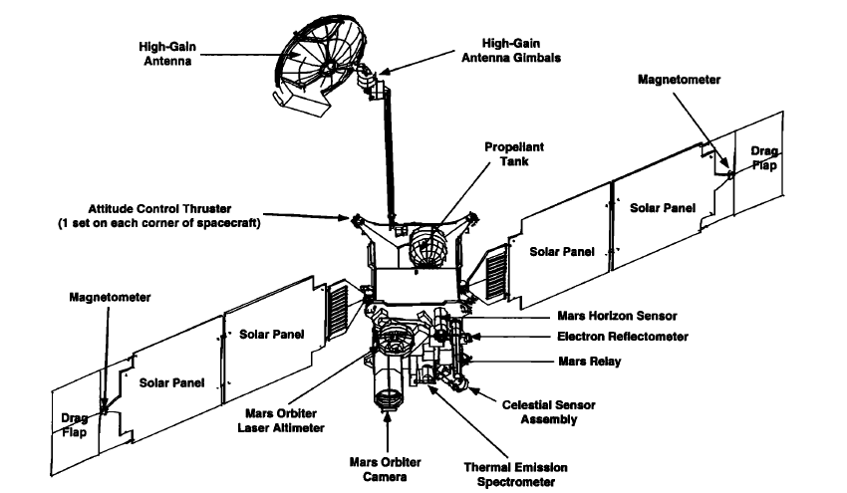

Figure 25. Global view of the MGS spacecraft showing the main components and instruments [Albee et al., 2001]

Visible imaging (MOC) and infrared spectral mapping (TES) provide information about the nature of the surface and processes operating on the surface. Thus, the TES data permitted the discovery of new mineralogical and topographic evidence suggesting Mars had abundant water and thermal activity in its early history. They also indicated evidence of an ancient hydrothermal system, implying stable liquid water at or near the surface, and hence implying that a thicker atmosphere existed in Mars’ early history. MOC meanwhile had been used to characterize the properties of the currently active fluids involved in the gullies identified on Mars. It suggested the presence of a current source of liquid water, similar to an aquifer near the planet surface.

During the circularization phase, MAG/ER observations showed that the Martian magnetic field is not globally generated in the planet’s core [*Acuña et al.,* 1998], but is localized in specific areas of the ancient crust [*Acuña et al*., 1999]. These anomalies demonstrate that Mars had once an internal dynamo which ceased operation early in geologic time. This discovery formed the basis of a new model of interaction between the solar wind and Mars.

### **Mars Express**

**Mars Express** (MEX) is the first mission launched by the European Space Agency (ESA) to explore another planet of the solar system. It has been so called due to the short duration of its design and construction compared to similar missions. The MEX probe is composed of an orbiter and a lander called Beagle 2, named after Charles Darwin’s ship. It has been launched on June 2, 2003 from the Baikonur Cosmodrome (Kazakhstan).

#### **Objectives**

As MGS, MEX is dedicated to the study of the planet’s interior, subsurface, surface and atmosphere. However, the combination of the MEX orbiter and of the Beagle 2 lander would have permit unprecedented orbital and in-situ measurements. The scientific objectives of MEX try to fulfill in part the scientific goals of the lost Russian **Mars 96** mission, and added two related new issues [*Chicarro et al.,* 2004]: the current inventory of ice or liquid water in the Martian crust, and possible traces of past or present biological activity on the planet.

The main scientific objectives of the orbiter were:

* Imaging the entire surface with a high-resolution of ~10m/pixel and selecting areas at super resolution (2m/pixel);
* Global infrared mineralogical mapping of the surface at 100m resolution;
* Radar sounding of the sub-surface structure down to the permafrost (depth of a few kilometers);
* Determining the global atmospheric circulation and mapping the atmospheric composition;
* Determining the interaction of the atmosphere with the surface and the solar wind;
* Collecting information about the atmosphere, ionosphere, surface and interior through radio science.

The Beagle 2 lander was designed to perform exobiology and geochemistry research on its landing site [*Pullan et al.,* 2004]. Its ultimate goal was to detect extinct or extant life on Mars. However, a more reachable objective was to establish the conditions that were suitable for the emergence and evolution of life. It was designed to perform in situ geological, mineralogical and geochemical analysis of rocks and soils, study the Martian environment (weather and climate) through chemical analysis of the atmosphere, perform in situ isotopic dating, etc.

#### **Orbitography**

The year 2003 has not been chosen by chance to launch MEX. This specific year enabled the maximum launch mass, a situation that only happen once every sixteen years. This enable the launcher to bring Beagle 2, which would not have been possible otherwise. The design of the orbit of the MEX orbiter was set by the objectives of the mission (among others covering the poles) and at the beginning of the mission, by the landing site of Beagle 2. Indeed, for the first 6 months the orbiter needed to fly over the lander site in the Isidis Planitia area. The working orbit chosen is a highly-elliptical quasi-polar orbit, with a periapsis at 250 km and an apoapsis at 10 142 km, an inclination of 86.35° and a 6.75h period.

After its launch in June 2003, the interplanetary journey only last 6 months (which also explain the denomination of Mars Express) and the spacecraft was captured into Mars orbit on December 25, 2003. Five days before insertion, the Beagle 2 descent capsule was ejected while the orbiter was still on a Mars collision course. From its hyperbolic trajectory, Beagle 2 was supposed to entered and descended through the atmosphere in about five minutes. However, nobody ever knew what happened to Beagle 2, no signal was ever received from the Martian surface. The orbiter has continued its mission alone, moving to its operational near polar orbit in January 2004. Since then, it performs successfully measurements and is still operational at the present time. Its periapsis has varied from 245 to 365 km over the years and it is slowly precessing.

On Figure 26 is plotted the orbit of MGS and MEX on March 10, 2005 in the ($X_{MSO}$; $Y_{MSO}$) plane. The Sun is on the right side of the scene. The orbit of Phobos (circular at ~9300 km) has been superimposed to give a scale.

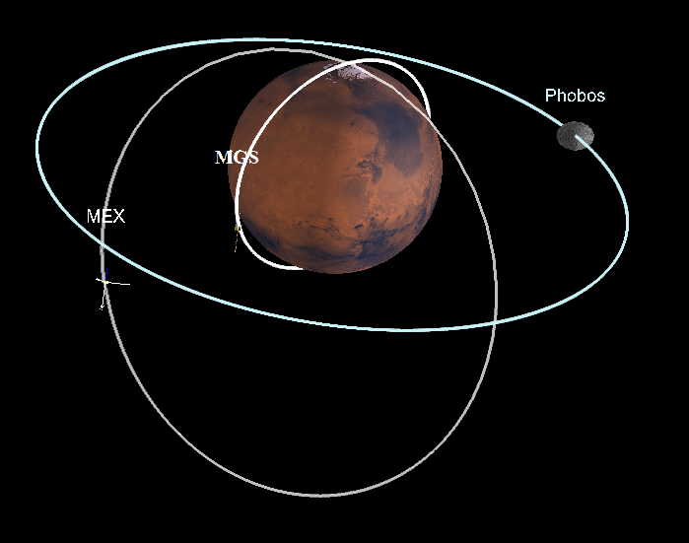

Figure 26. Orbit of MGS, MEX and Phobos on March 10, 2005 in the ($X_{MSO}$; $Y_{MSO}$) plane. Created with 3D view.

#### **Instruments**

The Mars Express orbiter payload is composed of 6 instruments, some of them reusing directly the designs used for the failed Russian mission **Mars 96**, and a radio-science experiment that requires no additional hardware. These instruments can be sorted in two categories: HRSC, OMEGA and MARSIS are observing the solid planet (surface and subsurface) whereas PFS, SPICAM and ASPERA are studying the atmosphere and the Martian environment. Their location on the spacecraft are showed on Figure 27.

* HRSC (High Resolution Stereo Camera)

The main goal of the HRSC camera is to imaging the entire planet in full color with a high spatial resolution (about 10 meters per pixel in stereo with different phase angle) [*Neukum et al.,* 2004]. A super resolution of 2 meters per pixel can also be used on specific features.

* OMEGA (Observatoire pour la Minéralogie, l’Eau, les Glaces et l’Activité)

OMEGA is a visible and near-IR mapping spectrometer [*Bibring et al.*, 2004] which can cover the planet at medium resolution (1-5 km) at altitudes between 1000 km and 4000 km but can also take higher resolution snapshot of selected areas. This enable the study of time and space distributions of atmospheric species, aerosols and dust particles in the atmosphere.

* MARSIS (Mars Advanced Radar for Subsurface and Ionosphere Sounding)

MARSIS is a subsurface radar sounder and altimeter [*Picardi et al.,* 2004] which map the sub-surface structures to depth of a few kilometers. The instrument is composed of two booms of 20 m each which can send low frequency radio waves toward the planet. Its main objective is to map the distribution of water down to 3-5m in the crust.

* PFS (Planetary Fourier Spectrometer)

The PFS instrument is a double-pendulum infrared spectrometer [*Formisano et al.,* 2005] which covers the wavelength range of 1.2-5µm and 5-45µm with a spatial resolution of 10-20 km. It can measure the vertical pressure and temperature profile of $CO_{2}$, which is the more abundant constituent of the atmosphere, and of some other minor constituents such as $H_{2}O, CO, CH_{4}$, etc.

* SPICAM (Studying the Global Structure and Composition of the Martian Atmosphere)

SPICAM is a UV and IR spectrometer complementary to the PFS instrument [*Bertaux et al.,* 2004]. It is focusing on atmospheric photochemistry, density-temperature structure of the atmosphere (0-150 km), upper atmosphere-ionosphere escape processes and interaction with the solar wind.

* ASPERA (Analyser of Space Plasmas and Energetic Ions for Mars Express)

The ASPERA instrument measures ions, electrons and energetic neutral atoms at different locations along the spacecraft’s orbit [*Barabash et al.,* 2004]. It is focused on the study of the interaction of the Martian atmosphere with the solar wind and the interplanetary medium and on characterizing the plasma environment of Mars.

* MaRS (Mars Radio Science)

The MaRs experiment [*Pätzold et al.,* 2004] is performing radio sounding experiment of the neutral atmosphere and of the ionosphere to provide vertical density, pressure and temperature profiles but also insights into the internal gravity anomalies and the surface roughness.

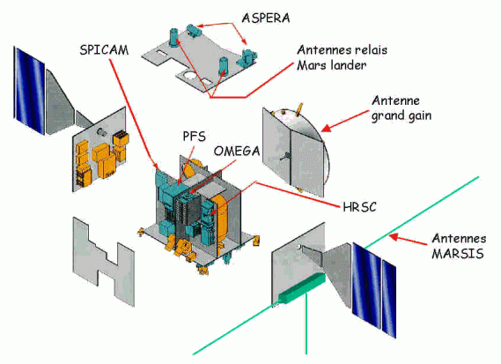

Figure 27. Exploded view of the MEX orbiter, revealing the arrangement of the scientific instruments.

#### **Main discoveries**

The MEX orbiter has provided for now more than twelve years of spectacular 3D pictures of the canyons, polar caps or impact crater like the one of the Gale crater in which Curiosity is currently working (Figure 28). The orbiter also carried out the mapping of Phobos with a high resolution, enable the determination of its mass and of its low density (1.86 $g.cm^{-3}$).

The OMEGA spectrometer detected for the first time hydrated minerals (phyllosilicate or hydrated sulfate) which proved that water was present on Mars’ surface for a period long enough for these minerals to be formed. OMEGA data also revealed the composition of the Southern polar cap: 85% of $CO_{2}$ ice and 15% of $H_{2}O$ ice. The HRCS camera showed that there is still volcanism on Mars and that the Olympus Mons the Tharsis’ volcano were still in activity several million years ago.

In 2004, the FPS spectrometer may have detected the presence of methane in the atmosphere. As its lifetime is short (440 years), it would implies the presence of mechanisms creating methane on Mars. The SPICAM data permitted the discovery of localized polar aurorae, which are located over regions with strong crustal magnetic field. MEX also made the first direct observation of the formation of carbon dioxide clouds, and determine they are observed on average at an altitude of 80 km.

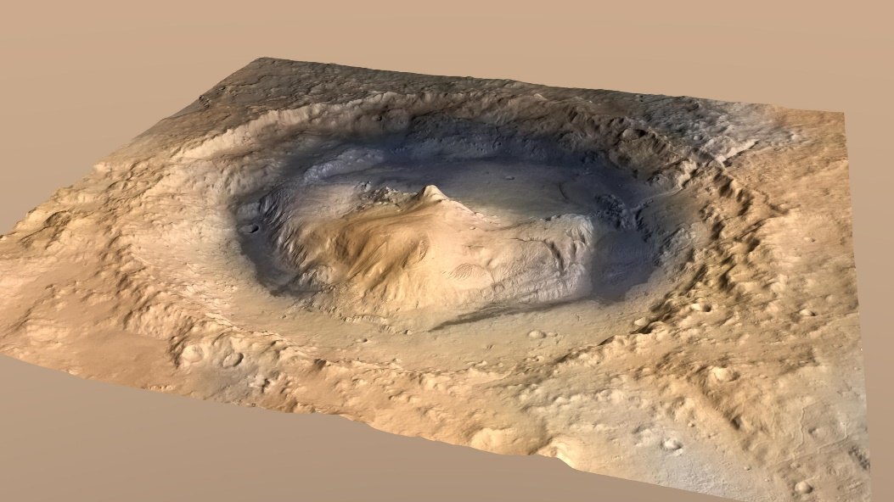

Figure 28. 3D picture of the Gale crater obtained with HRSC

Closer to the problematic of this PhD, the different spacecraft and lander which reached Mars before MAVEN made significate discoveries on the Martian plasma environment which permit the understanding we have today (section 1). Selected key results on the plasma environment made over nearly five decades are gathered in Table 2.

Table 2. Spacecraft mission to Mars that have provided measurements relevant for describing the plasma environment of Mars [Brain et al., 2014].

|  |  |  |
| --- | --- | --- |
| **Mission** | **Dates** | **Selected Key Results** |
| Mariner 4, 6, 7, 9 | 1965-1972 | * Detected bow shock and magnetosheath * First ionospheric density profiles |
| Mars 2, 3, 5 | 1971-1974 | * Measured bow shock, sheath, and inner magnetosphere |
| Viking 1, 2 | 1976 | * *In situ* ionospheric profiles (density, composition, temperature) |
| Phobos 2 | 1989 | * First sampling of central wake * Measured escaping ions |
| Mars Global Surveyor | 1997-2006 | * Discovered crustal fields * Sampled ionosphere down to / below main peak |
| Mars Odyssey & Mars Reconnaissance Orbiter | 2001-present | * Ionospheric density profiles |
| Mars Express | 2004-present | * Discovered localized aurora * Detected ionopause * Confirmed pressure balance near Mars |
| Rosetta | 2007 | * Distant bow shock crossing |

### **MAVEN**

The Mars Atmosphere and Volatile Evolution (MAVEN) mission is the latest mission sent by the United States to study the red planet. Contrary to the MGS and MEX mission, MAVEN took the bias to focus its study on the Martian upper atmosphere. It has been sent from Cape Canaveral Air Force Station (Florida, USA) on November 18, 2014.

#### **Objectives**

Thanks to previous Martian missions such as MGS or MEX, strong observational evidences support the idea that escape of gas from the Martian atmosphere to space has occurred, nowadays and since the early history of the planet (section1.2.2.2). The MAVEN spacecraft is designed to measure the structure, the composition and the variability of the Martian upper atmosphere and its interaction with the Sun and the solar wind, and the resulting loss of gas from the top of the atmosphere to space [*Jakosky et al.,* 2015]. Its main objectives are:

* Measuring the composition and structure of the upper atmosphere and ionosphere today, and determine the processes responsible for controlling them (dependence on geographical location, remnant magnetic field and external conditions). Extrapolating back in time to understand what the upper atmosphere would have looked like under the conditions in the early solar system history;
* Measuring the loss rate of gas from the top of the atmosphere to space, and determine the processes responsible for controlling them;
* Determining properties and characteristics that will allow us to extrapolate backwards in time to determine the integrated loss to space over the four-billion-year history recorded in the geological record.

#### **Orbitography**

After its launch in November 2013, the MAVEN spacecraft spent ten months in its interplanetary journey and finally reached Mars on September 21, 2014 (Figure 29). It was successfully inserted into a 35 hours elliptical orbit. The MOI was followed by a five weeks transition phase during which propulsive manoeuvers to get into the science mapping orbit have been operated, the science booms have been deployed and the instruments have been tested and calibrated. Once the science mapping orbit have been reached, the Science phase began on November 16, 2014.

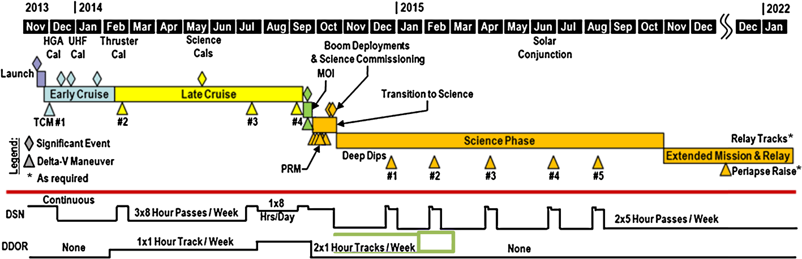

Figure 29. Overall timeline of MAVEN mission, from launch through end of primary mission and into a possible extended mission [Jakosky et al., 2015]

In order to fulfil the objectives of the mission, the spacecraft has been placed on a highly elliptical orbit, with a nominal periapsis at 150 km, and an apoapsis of 6220 km, which means a period of 4.5 hours. The periapsis is chosen on each orbit to be within the atmospheric density range of 0.05-0.15 $kg.km^{-3}$. Its altitude then varies around 150 km depending on the season, the location and the surface elevation. The periapsis is periodically lowered down to 125 km (density corridor 1.5-3.0 kg/km3) for five-day periods known as “deep-dips” [*Bougher et al.,* 2015]. This altitude, though higher than the one reach by MGS during its first aerobreaking phase, is in the vicinity of the homopause, which separate the upper atmosphere from the well-mixed lower atmosphere. “Deep-dips” are only operated on selected time to limit the drag on the spacecraft that could alter the orbit (as in the aerobreaking technique) and to minimize the risk of high-voltage arcing that could alter some of the instruments.

The orbital inclination of 75° has been chosen together with the apoapsis altitude and the orbital period to provide an appropriate precession rate of the orbit in both local time and latitude of the periapsis (Figure 30).

The primary mission lasted one Earth-year and the mission is now extended a second time through September 2018. At the end of its science phase, the MAVEN spacecraft will be able to act as a data relay for rovers or landers like Spirit, Opportunity and Curiosity, a relay to Mars Reconnaissance Orbiter and Mars Odyssey.

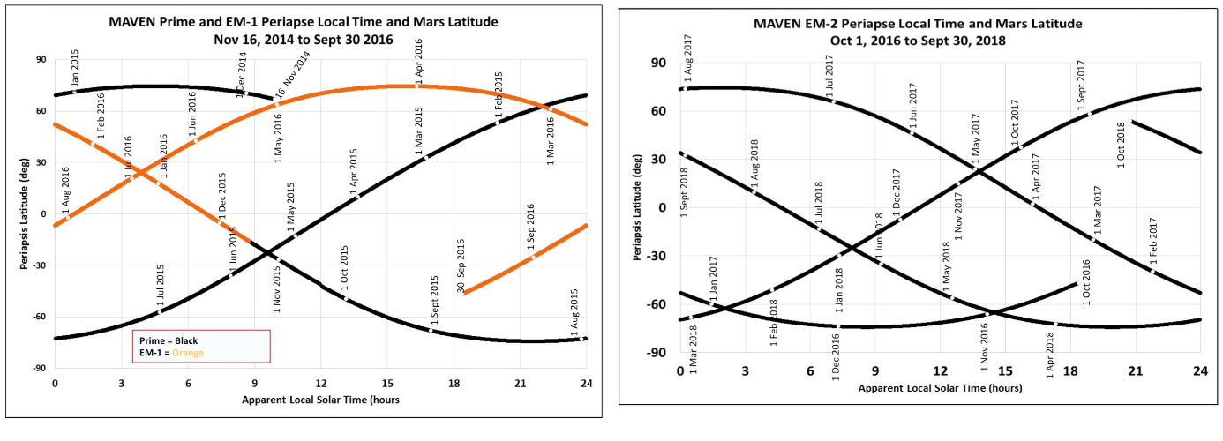

Figure 30. Precession of the MAVEN orbit for the primary mission and the first extension (left) and for the second extension (right). Location of the spacecraft at periapsis is shown as in geographical coordinates [Jakosky et al., 2016].

On Figure 31 is plotted the orbit of MAVEN and MEX on March 10, 2016 in the ($X_{MSO}$; $Y_{MSO}$) plane. The Sun is on the right side of the scene. The orbit of Phobos (circular at ~9300 km) has been superimposed to give a scale.

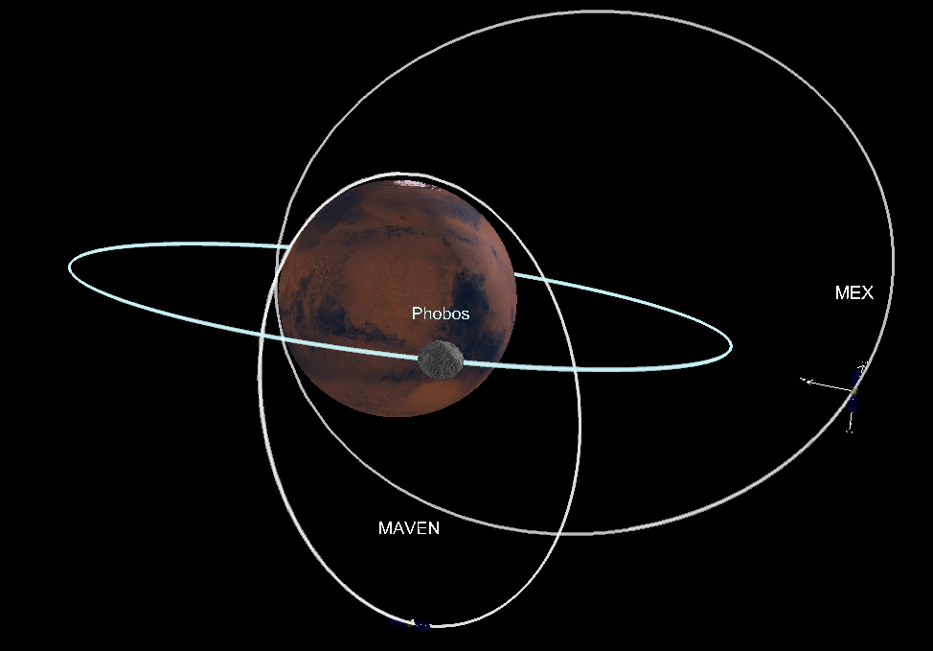

Figure 31. Orbit of MAVEN, MEX and Phobos on March 10, 2016 in the ($X_{MSO}$; $Y_{MSO}$) plane. Created with 3D view.

#### **Instruments**

The MAVEN spacecraft carries onboard a complete suite of plasma and field instruments, plus an ultraviolet spectrometer and a neutral spectrometer. Three instruments (NGIMS, IUVS and STATIC) are located on an Articulated Payload Platform (APP) which allows them to be oriented in space independent of the spacecraft orientation (Figure 32).

* STATIC (Supra-Thermal And Thermal Ion Composition analyzer)

The STATIC instrument [*McFadden et al.*, 2015] measures the velocity distributions, the temperature and the mass composition of suprathermal and thermal ions. As to fulfill the MAVEN objectives it is essential to measure loss of ions down to the escape velocity, the STATIC instrument is designed to measure the ion energy down to 0.5 eV;

* SEP (Solar Energetic Particle)

The SEP instrument [*Larson et al.*, 2015] measures the energy spectrum and angular distribution of solar energetic electrons (30 keV-1 MeV) and ions (30 keV-12 MeV);

* SWIA (Solar Wind Ion Analyzer)

The SWIA experiment [*Halekas et al.,* 2013] measures the energy and angular distributions of solar wind and magnetosheath ions;

* LPW (Langmuir Probe and Waves)

The LPW instruments [*Andersson et al.*, 2015] measures the electron density and temperature, and electric field waves in the Martian environment.

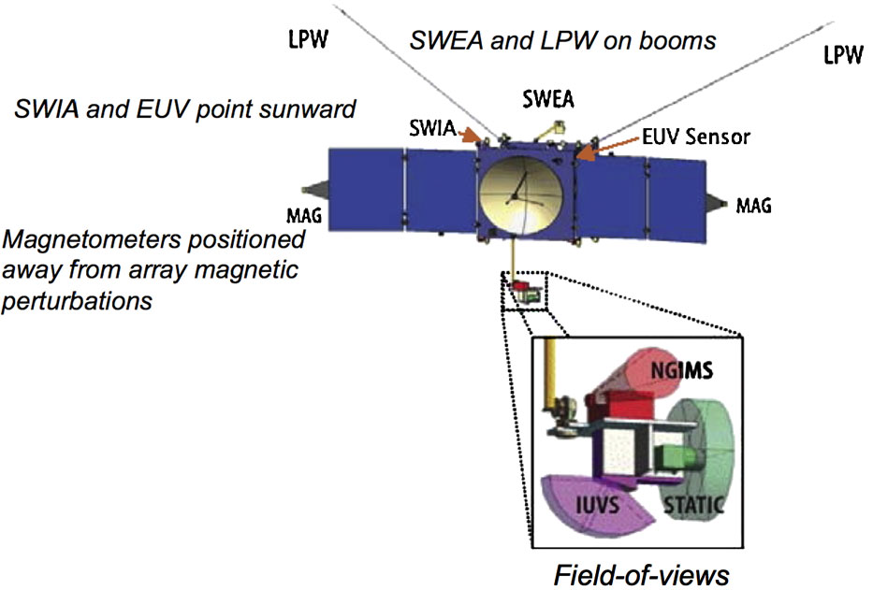

Figure 32. Instrument accommodation. It shows the locations of the science instruments on the body of the spacecraft and on the APP [Jakosky et al., 2015].

* EUV (Extreme Ultraviolet monitor)

The EUV monitor [*Eparvier et al.*, 2015] provides additional measurements for determining the solar EUV input to the Mars atmosphere, from photodiode measurements and from the LPW photoelectron saturation current.

* MAG (Magnetometer)

MAG is a dual vector fluxgate magnetometer [*Connerney et al.*, 2015] which measures the intensity and direction of the magnetic field along the spacecraft orbit. It than covers the interplanetary, induced magnetospheric, ionospheric and crustal magnetic field.

* IUVS (Imaging Ultraviolet Spectrometer)

The IUVS experiment [*McClintock et al.,* 2014] is a remote-sensing instrument that measured UV spectra with four modes: limb scans near periapsis, planetary mapping, coronal mapping and stellar occultations.

* NGIMS (Neutral Gas and Ion Mass Spectrometer)

The NGIMS experiment [*Mahaffy et al.,* 2014] makes in-situ measurements of the neutral composition, isotopic ratios and scale height temperature of the major gas species and thermal ions in the Martian upper atmosphere.

#### **Main discoveries**

/!\ à remplir

## **Instrumentation**

Data from three spacecraft have been analyzed during this PhD: MGS, MEX and MAVEN. This made it possible to take advantage of the different plasma instrument suite and of the different spatial and temporal coverage offered by the three missions. Each of the three spacecraft carried onboard its own specific suite of instruments. We here focus on several of their plasma instruments and detail their characteristics.

### **Mars Global Surveyor**

The MGS magnetic field experiment was composed of a dual system of triaxial fluxgate magnetometers (MAG) which measured the “in situ” ambient field, and of an electron reflectometer (ER) sensor [*Acuña et al.,* 1992] which determine the parameters of the local electron distribution function. MGS did not carry an ion spectrometer.

#### **The magnetometer: MAG**

MAG was able to detect ambient magnetic fields from $± 4 nT$ to $± 65 536 nT$. The use of two magnetometers allows a real-time estimation of the spacecraft-generated magnetic field and provide redundancy for the measurements of the in-situ magnetic field. The sensors are mounted remote from the spacecraft body at the end of the solar panels (~5m away from the spacecraft body). Magnetometer sensors are best accommodated far away from the body of the spacecraft, to minimize the relative contribution of spacecraft generated magnetic fields, taking much advantage of the $1/r^{3}$ diminution of a magnetic source with distance from the source.

An example of MAG measurement has been shown on Figure 9 and a comparison between MAG and ER measurements are proposed on Figure 35.

#### **The Electron Reflectometer: ER**

ER is a non-redundant hemispherical imaging electrostatic analyzer followed by a microchannel plate (MCP) and a resistive imaging anode. It has been developed by the Space Science Laboratory (Berkeley, USA) in collaboration with the Centre d’Etude Spatiale des Rayonnements (Toulouse, France). The analyzer is composed of two concentric hemispheres (Figure 33): the outer hemisphere is connected to the spacecraft ground, and the inner hemisphere potential is adjustable to deflect incoming electrons within a specified energy range onto the MCP. Each electron hitting the MCP produces a cloud of electrons, which hit the anode. The relative signal level at each end of the anode is measured to determine where the electronic cloud landed on the anode. As the analyzer focused on a disk called the plane of the field of view (FOV), this information enable to trace back the position of the initial incoming electron (the operation of an electron reflectometer will be explained in more details in section 2.2.3.3).

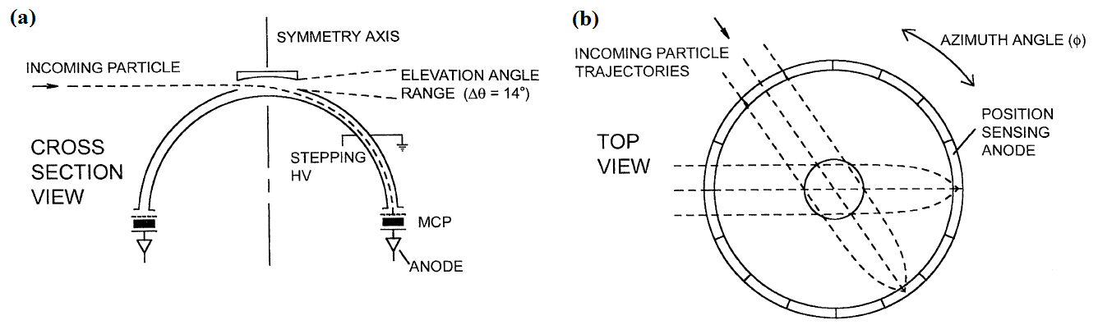

Figure 33. Schematic of the Electron Reflectometer showing the concentric hemispherical deflection plates, the microchannel plate (MCP) and the position-sensing resistive anode. Adapted from Mitchell et al. [2001].

The ER field of view is of 360° $×$ 14° and is divided into sixteen 22.5° $×$ 14° sectors. During a 2 to 48 seconds integration time, the analyzer images a slice of the electron distribution function that falls within the analyzer’s energy acceptance and FOV. The energy acceptance, divided into 30 logarithmically spaced energy channels ranging from 10 eV to 20 keV with an energy resolution of $\frac{δE}{E}=25\%$ (full width at half maximum), is selected by applying a deflection voltage to the inner hemisphere of the analyzer. All these characteristics are recorded in Table 3 so that they can be compared with those of MEX and MAVEN instruments.

The background count rate (due to noise in the electronics and cosmic rays) is $\sim 10 count.s^{-1}$ at all energies [*Mitchell et al.*, 2001]. The corresponding instrument background in the electron flux is displayed on Figure 34. Among all the energy channels available, the three channels which collected the majority of the flux were 90-148 eV, 148-245 eV and 245-400 eV.

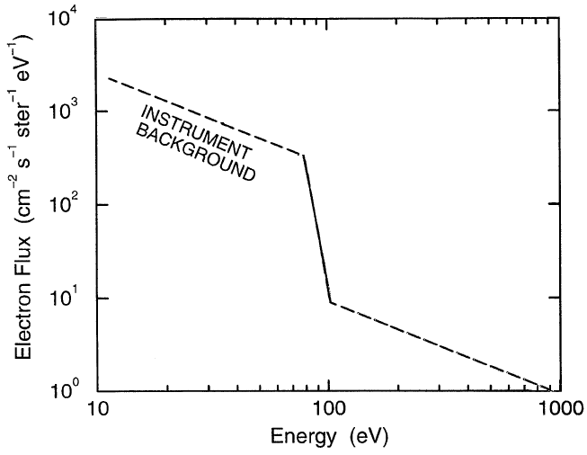

Figure 34. Electron energy spectra corresponding to the instrument background. Adapted from Mitchell et al. [2001].

On Figure 35 are plotted the electron spectrogram measured by ER and the magnitude of the magnetic field recorded by MAG on MGS on a specific orbit [adapted from *Acuña et al.,* 1998].

[à remplir]

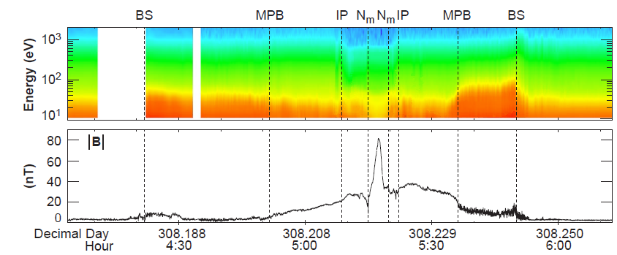

Figure 35. Electron and magnetic field observed by MGS. Panel 1: Electron fluxes (in units of $cm^{-2}s^{-1}sr^{-1}eV^{-1}$) measured by ER are shown as a color spectrogram. Panel 2: Magnetic field amplitude measured by MAG. Vertical lines indicate the position of the bow shock (BS), of the MPB, of the ionopause (IP), and of the ionospheric main peak ($N_{m}$). Adapted from [Acuña et al., 1998].

### **Mars Express**

The ASPERA-3 experiment is composed of four instruments including the Electron Spectrometer (ELS) and the Ion Mass Analyzer (IMA) [*Barabash et al.,* 2004]. Three instruments, among which ELS, are mounting on a scanning platform, providing a $4π$ coverage. IMA is technically a separated unit, connected by a cable to the ASPERA-3 main unit (Figure 36). Mars Express does not carry a magnetometer.

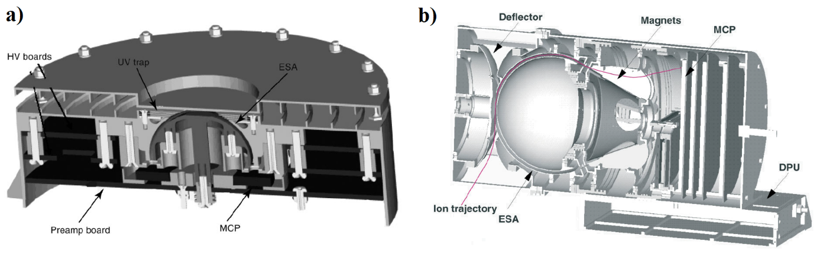

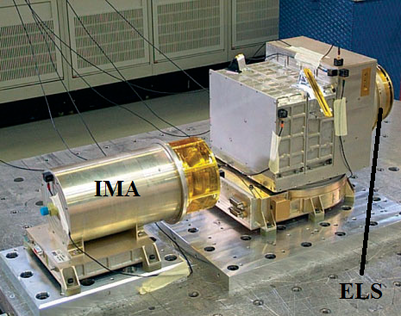

Figure 36. a) The ELS sensor b) Cross section of the IMA sensor c) The ASPERA-3 mechanical model during vibration testing [adapted from Barabash et al., 2004].

#### **Electron Reflectometer: ELS**

The ELS instrument is an electron sensor of a very compact design (only 300g compared to 2.2 kg for IMA). It is composed of a standard spherical top-hat electrostatic analyzer and a collimator system. It uses the same mechanisms as ER to image the electron distribution. During a 4 second integration time (maximum time resolution), the instrument can measure the electron fluxes in the energy range 0.001 – 20 keV/q in 128 logarithmically-spaced energy channels with an energy resolution of $\frac{δE}{E}=8\%$ (which is the best energy resolution among the electron spectrometers of the three spacecraft). ELS has a field of view of 360° $×$ 10° divided into sixteen sectors of 22.5° $×$ 10°, corresponding to the sixteen anodes placed behind the MCP. As ELS is mounted on the scanning platform, the full $4π$ angular distribution of electrons is measured during each platform scan with a selectable scan time of 32, 64 or 128s. The characteristics of ELS are gathered in Table 3.

In general, ELS has been operated in four different modes (*Frahm et al.*, [2006] and *Hall et al.*, [2016]):

- Default/Survey mode: Full energy range across 128 log-spaced energy steps with a four second cadence;

- Linear mode: Reduced energy range of 1 - 127 eV across 128 linearly spaced energy steps, also with a four second cadence;

-1s mode: Reduced energy range of 10 - 160 eV across 32 log-spaced energy steps with a one second cadence;

- 32 Hz mode: single energy channel (variable energy), with a cadence of 32 Hz.

The default mode is the most commonly used, operating more than 96% of the time from 2004 to 2014. The linear mode is utilized about once a month and the 32 Hz mode is rarely used. The 1s mode is sporadically used, but when operated, it lasts for several orbits. Over the course of the spacecraft in the induced magnetosphere, there is no change of mode within the same orbit. Regarding the use of the different modes, we will only use in the following data recorded in the Default/Survey mode.

#### **The ion spectrometer: IMA**

IMA is an ion mass composition sensor. Particles enter the instrument through the outer grid. A deflection system is located behind the grid to divert particles coming from between 45° and 135° with respect to the symmetry axis into the electrostatic analyzer (ESA). Ions which are within a swept energy pass band pass the ESA. They are then deflected in a cylindrical magnetic field set up by permanent magnets. The field deflects lighter ions more than heavy ions away from the center of the analyzer. The ions finally hit an MCP and are detected by an anode system. Ions are simultaneously analyzed for direction and mass per charge. The mass range and mass resolution can be chosen by modifying the magnet assembly. A system of 32 concentric rings behind the MCP measures the radial impact position (representing the ion mass) and 16 sector anodes measure the azimuthal impact position (representing ion entrance angle).

IMA has a field of view of $360° ×90°$. Electrostatic sweeping performs elevation coverage ($±45°$). It can provide 3D ion fluxes in the energy range 0.01-30 keV/q, with an energy resolution o*f $\frac{δE}{E}=7\%$*  , for the main ion components: $H^{+}$, $He^{++}$, $He^{+}$, $O^{+}$, and for the group of molecular ions: 20-80 amu/q. Its time resolution for full 3D is 32s. The characteristics of IMA are gathered on Table 3.

On Figure 37 is plotted…

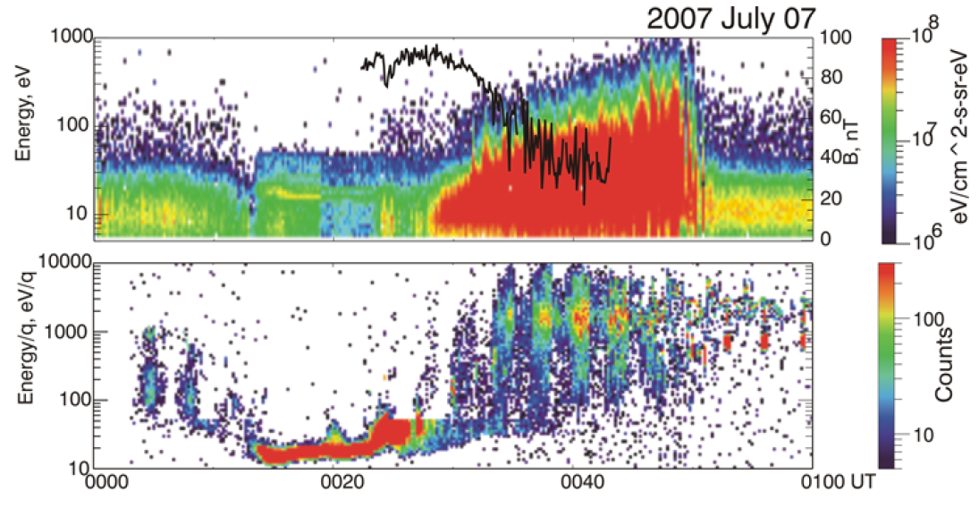

Figure 37. Panel 1: Energy-time spectrogram of the electron fluxes with the imposed curve of the magnetic field value. Panel 2: Energy-time spectrogram of the ion fluxes. Two different ion populations (solar wind and planetary plasmas) are mixed in the magnetic barrier region. Adapted from Dubinin et al. [2008b].

### **MAVEN**

The MAVEN particles and fields package is composed of seven instruments, including an ion spectrometer (STATIC), an electron spectrometer (SWEA), a Langmuir probe (LPW) and two magnetometers (MAG), presented on Figure 38.

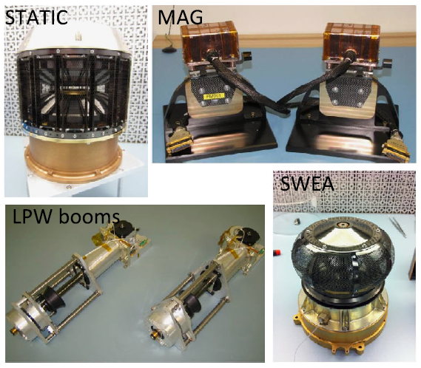

Figure 38. MAVEN science instruments. Adapted from Jakosky et al. [2015].

#### **The ion spectrometer: STATIC**

The STATIC instrument consists of a toroidal “top hat” electrostatic analyzer with a nominal 360° $×$ 6° field of view, followed by a time-of-flight velocity analyzer with 22.5° resolution in the detection plane. The energy analyzer also includes electrostatic deflectors at the entrance which expand the nominal FOV to 360° $×$ 90°. The instrument is designed to resolve ion energy per charge (E/q), direction and velocity per charge. Knowing the charge state of the ions (nearly all ions at Mars are singly charged except solar wind alphas), these measurements lead to the velocity distributions and mass composition of suprathermal and thermal ions over an energy range of 0.1 eV to 30 keV with an energy resolution of $\frac{δE}{E}=16\%$ and a base time resolution of 4 seconds [*McFadden et al.*, 2015]. It is able to resolve major ions: $H^{+},He^{++},He^{+},O^{+},O_{2}^{+}$ and $CO_{2}^{+}$. STATIC is mounted on the APP to orient differently its FOV according to the position of the spacecraft on its orbit. The characteristics of STATIC are gathered in Table 3.

STATIC is operated in several different modes, depending on the region or phenomenon of interest. These modes mainly differ on the time resolution, the number of energy and mass channels used, the integration on the deflectors and/or anodes sectors. We here only use two of them: C0 (time resolution of 4s, omnidirectional, 64 energy channels, 2 mass channels) for the time-energy spectrogram and C6 (time resolution of 4s, omnidirectional, 32 energy channels, 64 mass channels) for the time-mass spectrogram.

On Figure 39 is plotted …

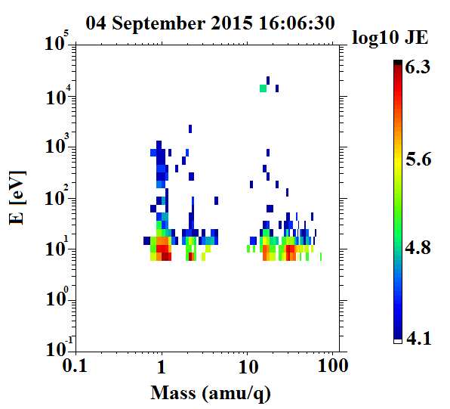

Figure 39.

#### **The Magnetometer: MAG**

MAG consists of two identical independent triaxial fluxgate magnetometer sensors which can measure the magnitude and direction of the ambient magnetic field from $±$ 0.06 to $±$ 65 536 nT [*Connerney et al.,* 2015] with a resolution of 0.008 nT in the most sensitive dynamic range and an accuracy of better than 0.05%. Both magnetometers sample the ambient magnetic field at an intrinsic sample rate of 32 samples/sec. The two sensors are mounted on the ends of the solar arrays on small extensions (0.66m in length), placing them approximately at 5.6m from the center of the spacecraft body. The characteristics of MAG are gathered in Table 3.

A spacecraft magnetic control program was implemented to provide a magnetically clean environment for the magnetic sensors and occasional spacecraft maneuvers have been planned to characterize spacecraft fields and/or instrument offsets in flight.

On Figure 40 is plotted …

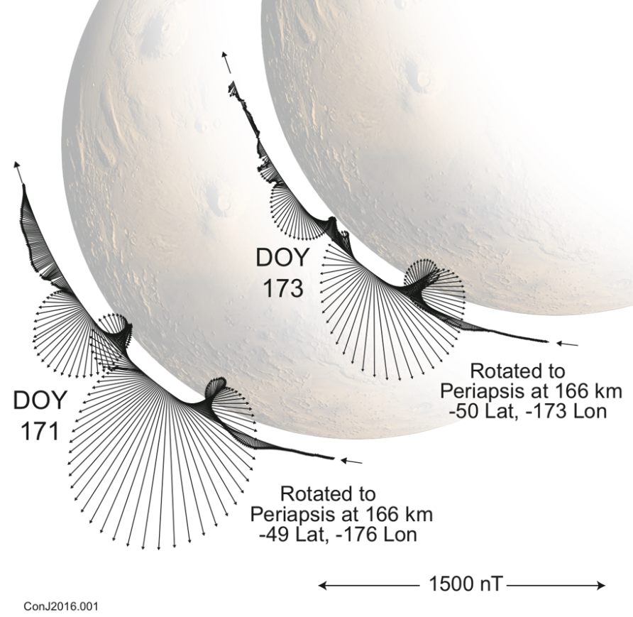

Figure 40.

#### **The Electron spectrometer: SWEA**

As ER on MGS and ELS on MEX, SWEA is a symmetric, hemispheric electrostatic analyzer with deflectors [*Mitchell et al.*, 2016]. It is designed to measure the energy and angular distributions of both solar wind electrons (core and halo populations) and ionospheric photoelectrons in the Martian environment, but also magnetosheath shock-energized electrons, tail lobe and auroral electrons. The instrument is a collaboration between the Space Sciences Laboratory at the University of California, Berkeley (UCB-SSL) and the Institut de Recherche en Astrophysique et Planétologie (IRAP) in Toulouse, France. SWEA design is closely based on an instrument sharing the same name currently operating on the STEREO spacecraft [*Sauvaud et al.*, 2008]. For MAVEN, IRAP provided the analyzer and front-end electronics (MCP, anode, preamplifiers and high voltage power supply), while UCB-SSL provided the low voltage power supply and digital electronics.

To fulfil its objectives and measure the energy and angular distributions of solar wind electrons, auroral electrons and ionospheric primary photoelectrons (Figure 16), the energy range chosen is 3 to 4600 eV. The instrument works by measuring the electron flux in consecutive given energy range. The pooling of all these measurements gives the distribution function of the electrons.

SWEA is roughly composed of two deflectors, followed by two concentric hemispheres leading to the electron detector (MCPs + anodes), as shown in Figure 41. SWEA selects electrons within a specified energy range by placing a potential difference, $∆V_{A}$, between the two concentric hemispheres. Electrons within this energy range are transmitted through the hemispheres to the exit grid to be counted, while those outside the range impact the walls and are scattered and absorbed. The center energy of transmitted electrons is proportional to $∆V_{A}$ through the following expression:

$$E_{0}=\frac{R_{0}}{2d}q∆V_{A}$$

where $R_{0}$ is the average radius of the two concentric hemispheres and d the distance between these two hemispheres. An energy spectrum is obtained by sweeping $∆V_{A}$ from 750 to 0.5 eV, which correspond – given the geometry of the instrument – to an energy range of 4600 to 3 eV. The energy resolution of SWEA is $\frac{δE}{E}=17\%$. The different characteristics of SWEA are gathered in Table 3.

As only a small fraction of scattered electrons reach the exit grid, they are accelerated by a 300-V potential onto a pair of MCPs mounted head to tail so as to maximize the amplification. The signal is amplify through this process by a factor of $\sim {10}^{6}$. The resulting electron cloud lands on a charge collecting anode that is segmented into 16 equal sized sectors. An incident parallel electron beam is focused by the hemispheres to a point on the anode providing a 22.5° azimuth resolution.

The field of view of the concentric hemispheres is 360° $×$ 7°. As MAVEN is not a spinning spacecraft but a three-axis stabilized spacecraft, it uses the deflectors to sweep the field of view above and below the aperture center plane. Deflection is achieved by placing a potential on either the upper or lower deflector, which bends the electron trajectories through an angle before reaching the aperture center plane and entering the hemispheres. The analyzer geometry limits the maximum deflection range to $±60°$. This full deflection is achieved up to an energy of 2 keV, resulting in an overall FOV of 360° $×$ 120°, which represent 87% of the sky. At higher energies, the deflection range decreases with energy, reaching $±26°$ at 4.6 keV.

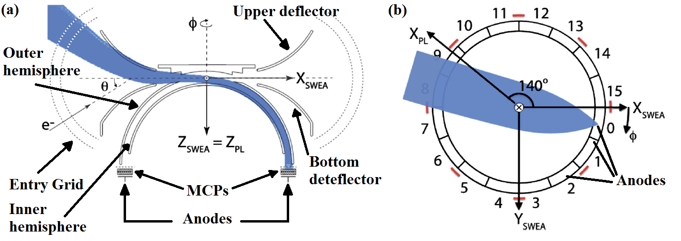

Figure 41. Left: Cross-sectional view of SWEA, defining the instrument frame regarding the payload (PL) frame. Right: Top view of the anodes. Simulated electron trajectories (blue) are shown for a deflection of $θ=-45°$. Adapted from [Mitchell et al., 2016]

The instrument is mounted at the end of a 1.5-meter boom, at which distance the spacecraft blocks 8% of the instrument’s FOV. Its final field of view is then 360° $×$ 120°. It spans 80% of the sky with $\sim 20°$ resolution. The position of SWEA regarding the spacecraft as well as the two different FOV depending on the energy are presented on Figure 42. SWEA has a 2-second measurements cadence which confers it a spatial resolution of 8 km.

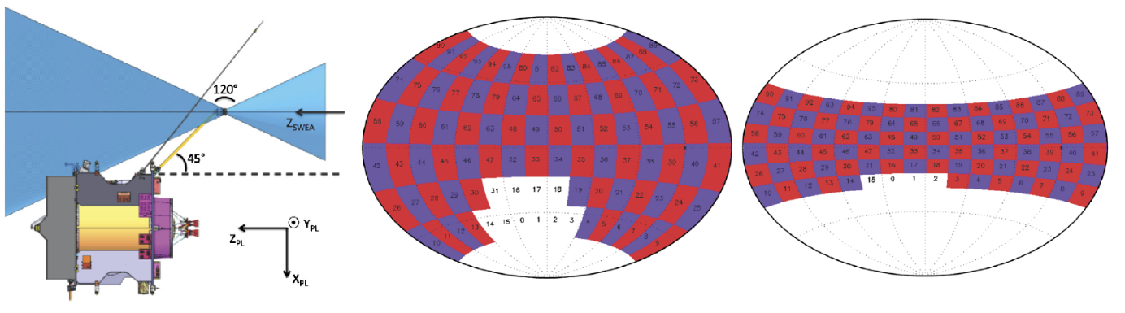

Figure 42. Left: SWEA is on the end of a 1.5-meter boom, with its symmetry axis ($Z_{SWEA}$) aligned with the spacecraft Z axis ($Z_{PL}$). SWEA has a FOV (blue shading indicates the instruments blind spots). Middle: SWEA’s field of view at all energies below 2 keV, mapped in SWEA coordinates over the full sky with an Aitoff projection. The FOV is subdivided into 96 angular bins (16 azimuths 6 deflections). SWEA’s blind spots are two oppositely directed cones. Ten of the angular bin, shown in white, are blocked by the spacecraft. Right: SWEA’s field of view at an energy of 4.6 keV. At this energy, four angular bins are blocked by the spacecraft. Adapted from [Mitchell et al., 2016]



#### **The Langmuir probe: LPW**

LPW is designed to measure the temperature and density of thermal ionospheric electrons, which have temperatures ($T_{e}$) ranging from 0.05 to 5 eV [*Andersson et al.,* 2015], as well as the spacecraft potential.

LPW is designed to measure the electron density and temperature in the ionosphere of Mars and to measure spectral power density of waves in Mars’ ionosphere, including one component of the electric field.

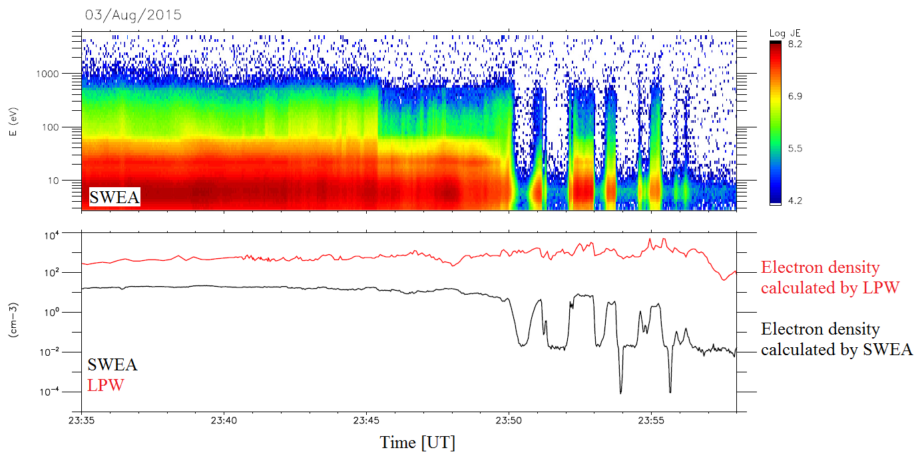

|  |  |  |  |  |
| --- | --- | --- | --- | --- |
| **Instrument Type** | **Quantity** | **MGS** | **MEX** | **MAVEN** |
| **Magnetometer** | Magnitude range | 4 – 65536 nT | none | 0.06 - 65536 nT |
| **Electron spectrometer** | Energy range | 10 – 20000 eV | 1 – 20000 eV | 3 – 4600 eV |
| Energy resolution | 25% | 8% | 17% |
| **Ion spectrometer** | Energy range | none | 10-30000 eV/q | 0.1-30000 eV/q |
| Energy resolution | 7% | 16% |
| Mass range | 1, 2, 4, 8, 16 and >20 m/q | $$H^{+}, He^{++}, He^{+}, O^{+},$$ $$O_{2}^{+} and CO_{2}^{+}$$ |
| **Langmuir probe** | Temperature | none | none | 0.05 to 5 eV |

Table 3. Summary of the characteristics of the magnetometer, electron spectrometer, ion spectrometer and Langmuir probe onboard MGS, MEX and MAVEN [Steckiewicz et al., 2016].

#### **Contamination, effect of the Spacecraft potential**

## **Data coverage**

## **Analysis tools**

### **AMDA and 3D view**

### **CL**

## **Frames**

Two dynamic reference frames are used in this manuscript: the **Mars-centric Solar Orbital** (MSO) and the $IAU_{Mars}$. After setting their definitions in section 2.5.1 and 2.5.2, we will discuss the definition of the altitude (section 2.5.3) and of the nightside (section 2.5.4) used throughout this PhD.

### **The Mars-centric Solar Orbital (MSO) frame**

The MSO coordinates are defined as follows: the origin is the center of Mars, the X axis points from the center of Mars to the Sun, Y points opposite to Mars’ orbital angular velocity and Z completes the right-handed set so that the frame rotates slowly as Mars orbits the Sun. All the ephemerides used in this manuscript are expressed in the MSO coordinates.

### **The $IAU_{Mars}$ frame**

The $IAU_{Mars}$ frame is defined with respect to the Martian latitude and longitude. The zero longitude is defined by a small crater of 0.5m diameter called “Airy-0”. The setting of the (longitude; latitude) coordinate system regarding the relief can be observed on Figure 10. Only the positive East longitude convention is used in this manuscript.

The $IAU_{Mars}$ coordinates are defined as follows: the origin is the center of Mars, the X axis points from the center of Mars to 0° East longitude, 0° Latitude, Y points from the center of Mars to +90° East Longitude, 0° Latitude and Z completes the right-handed set (+90° Latitude = rotation axis = north pole). The frame therefore rotates with the solid body.

From the $IAU_{Mars}$ coordinates can be defined a planetocentric spherical coordinate system: the radial component $r$ which point outward the planet, the azimuthal component $θ$ and the zenithal component $φ$ which are parallel to the surface of the planet. This system is mainly used for the magnetic field.

### **Definition of the altitude**

The altitude is the distance from a point to a reference surface. There are different reference surfaces, so there are different definitions of altitude.

The simplest reference surface is a sphere with Mars’ volumetric mean radius of $3389.51 km$. This leads to areocentric coordinates. This definition is the most used in this manuscript. However, another definition, more precise, will be used in section 5. In this approach, we use the IAU 2000 Mars ellipsoid (oblate spheroid), which leads to areodetic coordinates. In this case the radius at the equator is $R_{equator}=3396.19 km$ and the radius at the poles is $R_{pole}=3376.20 km$.

### **Definition of the nightside**

The local time (LT) corresponds to the angle (in hours) between the line linking the orthogonal projection of the spacecraft on the Martian equatorial plane to the center of Mars, and the line linking the center of Mars to the center of the Sun. The local time is between 00h00 and 24h00. This definition is represented on Figure. Dawn corresponds to 06h00, Noon to 12h00, Dusk to 18h00 and Midnight to 00h00. The local time is computed as follow:

$$LT\left(h\right)=\arctan\left(\frac{y_{MSO}}{x_{MSO}}\right)*\frac{12}{π}+12$$

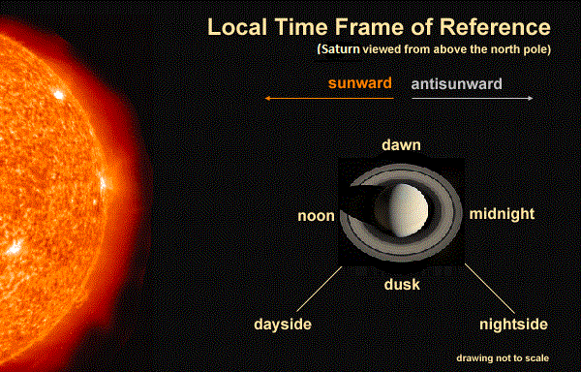

The solar zenith angle (SZA) correspond to the angle between the line linking the spacecraft to the center of Mars, and the line between the center of Mars and the center of the Sun. The SZA is between 0° and 180° and defined as fellow:

$$SZA\left(°\right)=\operatorname{acos}\left(\frac{x}{r}\right)*\frac{180}{π}$$

These two parameters are complementary as the local time does not take into account the altitude of the spacecraft and the SZA does not make any difference between the dusk and the dawn side.

The nightside can be defined different ways. The more coarsely, we can define it as:

$$X_{MSO}<0$$

This definition also corresponds to $LT ∈\left[00:00;06:00\right]∪[18:00;24:00]$.

However, the real border between sunlit and dark sides (called terminator) occurs at different SZA for different altitudes. A better definition then should be to define the nightside as:

$$SZA>90+\operatorname{acos}\left(\frac{R_{Mars}}{r}\right)$$

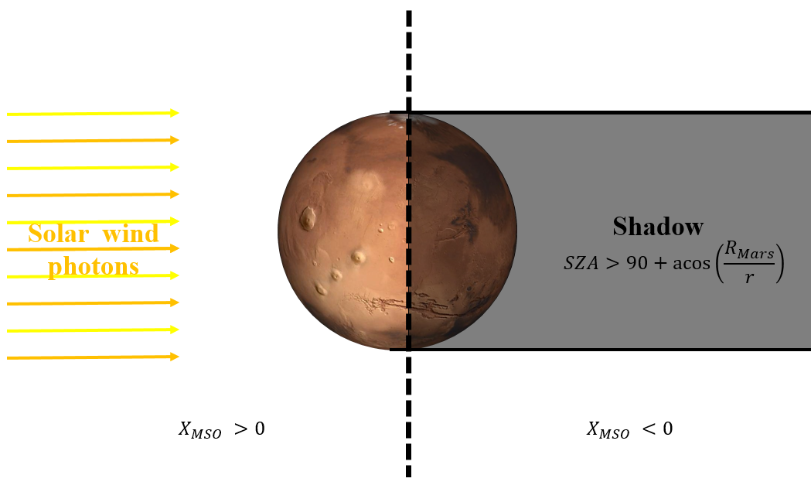

## **Models**

### **Model of crustal magnetic field: the model of *Morschhauser et al.* [2014]**

# **Identification of suprathermal electron depletions in the nightside ionosphere**



## **Discovery of electron depletions**

Hence if an electron depletion is observed in the nightside, it can be to some extent in the illuminated terminator region.

Martian suprathermal electron depletions have been observed to date by three spacecraft: MGS, MEX, and MAVEN. The last two are still in good operating condition at the time of writing. Figures 1, 2 and 3 display plasma observations of these structures made chronologically by MGS, MEX, and MAVEN respectively and are described next in more details. The improved performances of the plasma instrument suite over the different missions allow now for a more accurate understanding of electron depletions.

Figure 1 shows an example of electron depletions observed by MGS on April 26, 2005. The first panel is the ER energy-time spectrogram of omnidirectional electron flux and the second panel is the ER electron flux summed over all the observed energies. The blacked out regions in the third panel delineate the electron depletions automatically detected by criterion (3), when the electron flux drops by more than two orders of magnitude at all observed energies. This criterion is described in more details in section 3.3. The fourth panel is the magnitude of the magnetic field measured by MAG (black profile) superimposed with the magnitude of the crustal magnetic field calculated from the model of *Morschhauser et al.* [2014] (blue profile) (hereinafter referred as the Morschhauser model). Thus the first three depletions (between 18:05 and 18:15) are located over weak crustal field regions whereas the two last (between 18:25 and 18:30) are located over a modest crustal magnetic field source ($\sim$ 25 nT at 400 km altitude). On the last bottom right panel is plotted the orbital trajectory of MGS in a cylindrically symmetric MSO coordinates frame. The depletions are highlighted in red and are all located on the nightside.

As shown in this example, the electron flux measured by ER inside the electron depletions is barely above the background level (see Figure 10 of *Mitchell et al.* [2001] for a detailed description of the background level) at all energies observed which lead *Mitchell et al.* [2001] to designate them as “plasma voids”.

Figure 2 shows an example of electron depletions observed by MEX on June 23, 2012. The first panel is the ELS energy-time spectrogram of omnidirectional electron counts per second and the second panel is the ELS omnidirectional electron counts per second summed over all the available energies. Note that ELS’s geometric factor is approximately fixed, so that counts are proportional to electron flux. The blacked out regions in the third panel delineate the electron depletions automatically detected by criterion (2), when the electron count drops abruptly by more than two orders of magnitude at all the considered energies and thus reaches the background noise level ($\sim$ 40 c/s $)$. This criterion is described in more details in section 3.2. The fourth panel is the energy-time spectrogram of the omnidirectional heavy ions counts per second (m/q >20) measured by IMA. There are few light ions detected (not shown) but we can see that electron depletions are filled with heavy ions (mainly $O_{2}^{+}$ and ${CO}_{2}^{+}$ at this altitude in the nightside [*Krasnopolsky,* 2002]) having an energy E/q of a dozen of eV. Hence we cannot name these structures “plasma voids” anymore but still “electron plasma voids”. As there is no magnetometer onboard MEX we plot on the fifth panel the magnitude of the crustal magnetic field calculated from the model of Morschhauser as a guide. As for the MGS case, the three electron depletions are located above a medium crustal magnetic area (35 nT at 500 km altitude). On the last bottom right panel is plotted the orbital trajectory of MEX in a cylindrically symmetric MSO coordinates frame. The depletions are highlighted in red and are all located on the nightside.

Figure 3 shows an example of an electron depletion observed with MAVEN on July 11, 2015. The first panel is the SWEA energy-time spectrogram of omnidirectional electron energy flux (also referred to as JE in figure 3). Similarly to the examples shown for MEX and MGS, the blacked out regions in the third panel delineate the electron depletions automatically detected by criterion (1), when the electron flux at all the considered energies drops abruptly by more than two orders of magnitude. This criterion is described in more details in section 3.1. However, we can see that there is a remaining electron population at approximately 6-7 eV which could not be observed by MGS due to its energy range and by MEX probably due to higher negative spacecraft potential. Moreover, the third panel shows the density calculated from SWEA data in black and the density from LPW in red. Note that during this time interval the quality flag of the LPW density and of the spacecraft potential used for the calculation of the density from SWEA data is always greater than 50 except for 16:37:55 (in the ionosphere) and 16:45:20 (at the end of the depletion) which means that these data are reliable [*L. Andersson*, private communication]. Due to instrumental limits the density calculated with SWEA data is restricted to electrons with energies greater than 3 eV (see Table 1), whereas the density calculated with LPW includes lower-energy electrons, which explains the difference observed between the two densities (in particular in the ionosphere where the plasma is essentially cold). The characteristic drop in the suprathermal electron flux is very clear in the SWEA density during the electron depletion, whereas there is no drop in LPW density, i.e. in thermal electron density, which even increases slightly.

On panels 4 and 5 are plotted the STATIC energy-time spectrogram of omnidirectional ion energy flux and the STATIC mass-time spectrogram of omnidirectional ion energy flux. Thus the electron depletion is mainly filled with $O_{2}^{+}$ at 3 eV. This is consistent with the expected ionosphere composition at this altitude and with the energy corresponding to the ram velocity given by the spacecraft to cold ${ O}_{2}^{+}$. Hence, the depletions are not entirely void of plasma, as suggested in the MEX example. Only suprathermal electrons with energies greater than 10 eV are depleted, which justifies the name “suprathermal electron depletions” given by *Steckiewicz et al.* [2015].

The sixth panel shows the magnetic field intensity measured by MAG (black profile) superimposed with the intensity of the crustal magnetic field calculated from the model of Morschhauser (red profile). In this example, the depletions are observed above a moderate crustal magnetic source (50 nT at 125 km). As for MGS and MEX, on the last bottom right panel is plotted the orbital trajectory of MEX in a cylindrically symmetric MSO coordinates frame. The depletions are highlighted in red and are all located on the nightside.

## **Global properties of suprathermal electron depletions**

## **Automatic detection of suprathermal electron depletion: criterion**

Electron depletions can be observed by MGS, MEX and MAVEN respectively on ER, ELS and SWEA spectrograms. We present here the three criteria, adapted to each set of data, used to automatically detect electron depletions. The starting point of the definition of these criteria is the criterion developed for the MAVEN/SWEA data and published in *Steckiewicz et al.* [2015]. We thus first explain how this criterion is used for MAVEN before adapting it to MEX and MGS and their own specificities. The application of these three criteria explained in section 3.4 leads to three catalogs of electron depletions used in the next sections to compare the electron depletions distributions as observed by the three spacecraft.

### **MAVEN**

For SWEA data we use the criterion given in equation (1):

$$\frac{1}{3}\sum_{i=1}^{3}{\begin{aligned}\frac{CR\left(E_{i}\right)}{<CR\left(E_{i}\right), 1h>} \\ \end{aligned}} < 0.01 (1)$$

It is based on electron count rates (CR) from SWEA observations and relies on three energy channels $(E_{1}=4.26 eV, E_{2}=98.93 eV and E_{3}=111.16 eV)$. The numerator gives the count rate at an energy of $E_{i}$ (per time step), whereas the denominator gives the mean count rate at the same energy over a one hour period centered on the current time step. This simple criterion thus gives an idea of how the electron flux is at the current time step compared to average conditions. An electron depletion is detected if a ratio of two orders of magnitude is identified.

These three channels have been chosen after looking at the electron spectrum inside the electron depletions. As seen in Figure 3, inside the electron depletions there is a remaining electron population peaked at 6 eV and hardly any electrons above 10 eV. Hence we chose an energy channel below 6 eV, and two above to give more weight to depletions of high energies electrons and to avoid a significant influence by the 6 eV electrons due to spacecraft charging. Usually, the spacecraft potential in the nightside ionosphere is approximately -2 V. This implies a little modification in the energies detected which are reduced by the same amount. These small potentials have no significant impact on the criterion results. However, some strong spacecraft charging events (as in Figure) can bring the spacecraft potential to a dozen of volts. The electron flux detected at 6 eV during these events is then much lower than the mean electron flux calculated over one hour and an electron depletion can be detected. A few cases have been found during the time period under study and have been removed by hand. The sampling time step used for the criterion is the same as the measurement cadence of the SWEA instrument: 4s. Consequently the electron depletions detected last at least 4s which corresponds to a maximum of 16 km traveled by the spacecraft when at the periapsis.

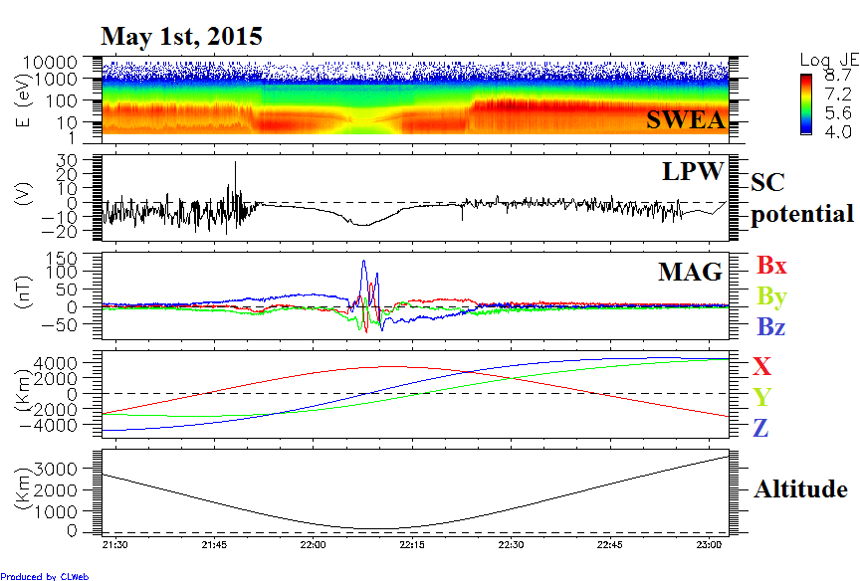

### **MEX**

Based on our experience with MAVEN data, we adapted criterion (1) to MEX ELS data to obtain criterion (2). In this case we use the three following energy channels: $E_{1}=21.20 eV$ (for low energies), $E_{2}=95.04 eV and E_{3}=103.25 eV$ (for high energies). Thus by taking a minimum energy above 20 eV we prevent most of the spacecraft charging effects to impact results of criterion (2) (see *Fränz et al.* [2006] and *Hall et al*. [2016] for more details concerning spacecraft charging impacts on ELS spectrograms). We also modify the threshold ratio from 1% to 2% based on the observations of ELS data. The sampling time step used for the criterion is the same as the measurements cadence of the ELS instrument when operated in its default survey mode: 4s. Consequently, the electron depletions detected last at least 4s which corresponds to a maximum of 17 km in the spacecraft orbital direction when at periapsis.

$$\frac{1}{3}\sum_{i=1}^{3}{\begin{aligned}\frac{CR\left(E_{i}\right)}{<CR\left(E_{i}\right), 1h>} \\ \end{aligned}} < 0.02 (2)$$

### **MGS**

In the case of MGS, a criterion based on three energy channels (one low, two high) does not work well, probably due to the energy resolution of 25%. Hence, we decided to compare the measured omnidirectional flux summed over all the available energies [11 eV; 16 127 eV] every two seconds with the same product averaged over two orbits (4 hours). An electron depletion is detected if this ratio is less than 1% which corresponds to a drop of two orders of magnitude in the electron flux. The MGS criterion is described in equation (3) with a similar form to equations (1) and (2). Consequently, the electron depletions detected size is at least 7 km in the orbital direction.

Among the energy range [11 eV; 16 127 eV], the three channels which collected the majority of the flux were 90-148 eV, 148-245 eV and 245-400 eV. Electron depletions thus show up in those three most reliable energy channels which are far too high energy to be affected by any spacecraft charging which would almost always be less than $\sim 20 eV$. Hence, the way criterion (3) have been defined make it little sensitive to spacecraft charging.

$$\frac{Flux\left( \left[11 eV;16 127 eV\right] \right)}{<\left(Flux\left( \left[11 eV;16 127 eV\right] \right),4h\right)>}<0.01 (3)$$

## **Application of the criteria**

MGS

For the study of the electron depletions observed with MGS we only focus on the data obtained during the circular mapping orbit phase at an altitude of $\sim$ 400 km. The dataset covers the time period from March 10, 1999 to October 11, 2006 which represents more than 42 000 orbits. Such statistics average all the effects of external drivers on electron depletions so that we only see the general behavior of the electron depletions. As the MGS orbit was circular at 400 km, electron depletions can potentially be observed during each orbit. This dataset covers the entire surface of Mars but only the 02:00 a.m. local time sector. ER data have a time resolution of 2s which corresponds to $\sim$ 7 km traveled by the spacecraft.

The example proposed on Figure 1 illustrates how the criterion detects the electron depletions in agreement with the ER spectrogram. However we can notice that all the decreases that can be observed on panel 2 are not detected as electron depletions. This is due to the threshold of 1% chosen. The application of this criterion resulted in a time table of 11 6278 electron depletions which means that, as for MAVEN and MEX, several electron depletions can be detected during a single orbit as in the example shown on Figure 1. Almost all these electron depletions have been detected in the nightside, except few (less than 100) isolated cases. A median value of four depletions observed per orbit has been obtained, as it was found for MAVEN events (Table 2). The median number of depletions per orbit for MEX data is a slightly higher but remains similar to both MAVEN and MGS which confirms that the occurrence of the electron depletions is stable during the three periods and consistent among the three spacecraft.

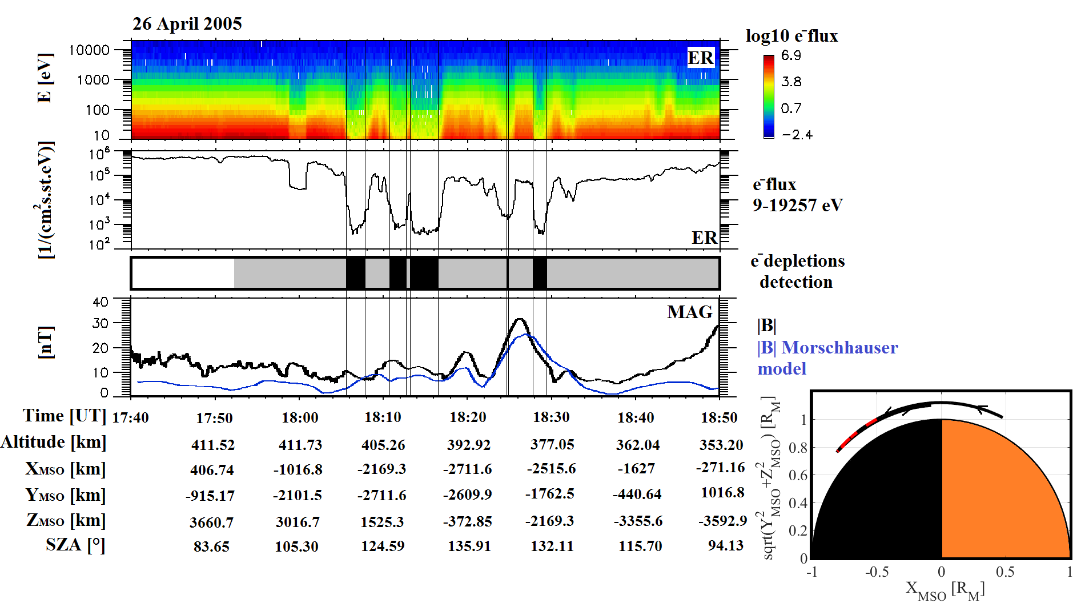

**Figure 1**. Example of electron depletion observed by MGS on April 26, 2005. First panel: ER energy-time spectrogram of omnidirectional electron flux. Second panel: ER omnidirectional electron flux summed over all energies available [11-16127 eV]. Third panel: Detection of electron depletions by criterion (3) (black boxes). See section 3 for more details. The shadow corresponds to the nightside. Fourth panel: Magnetic field intensity (measured by MAG in black and calculated from the model of Morschhauser in blue). Fifth panel (bottom right): MGS orbital trajectory in a cylindrically symmetric MSO coordinates frame. The location of the electron depletions detected are highlighted in red.

MEX

The time period under study for MEX data is from March 1, 2004 to December 31, 2014, which is similar to the one studied by *Hall et al.* [2016]. This corresponds to approximately 14 072 orbits. However we only applied criterion (2) on time intervals longer than one hour when ELS was working in the Survey mode, which corresponds to 9 983 time intervals. The time period under study is long enough to allow the periapsis to cover the whole surface of Mars between latitudes of -86° and +86° and all the local times in the nightside thanks to the precessing orbit of MEX.

The application of this criterion with no restriction on the altitude nor on the nightside resulted in a time table of 17 592 electron depletions. The example proposed on Figure 2 illustrates how the criterion detects the electron depletions in agreement with the ELS spectrogram. Those depletions are detected from 245 km to $\sim$ 10 000 km both on the nightside and on the dayside (for a small amount of cases). Globally, the depletions have been detected as in the MAVEN case during specific time periods when the periapsis went across the nightside at low enough altitudes. However, most of the depletions observed on the dayside and at altitudes above 1 000 km have to be considered with caution (since they include very short data gaps and the lobes - the region located on either side of the plasma sheet with reduced particle fluxes - that cannot be easily excluded). We therefore chose to only consider for the next studies depletions observed in the nightside below 900 km, which is consistent with our MAVEN results and enables the two studies to be compared. With these restrictions, 14 517 depletions have been found on 2 197 orbits, which implies a strong presence of spikes in MEX data as in the example on Figure 2. A median value of five depletions observed per orbit have been found.

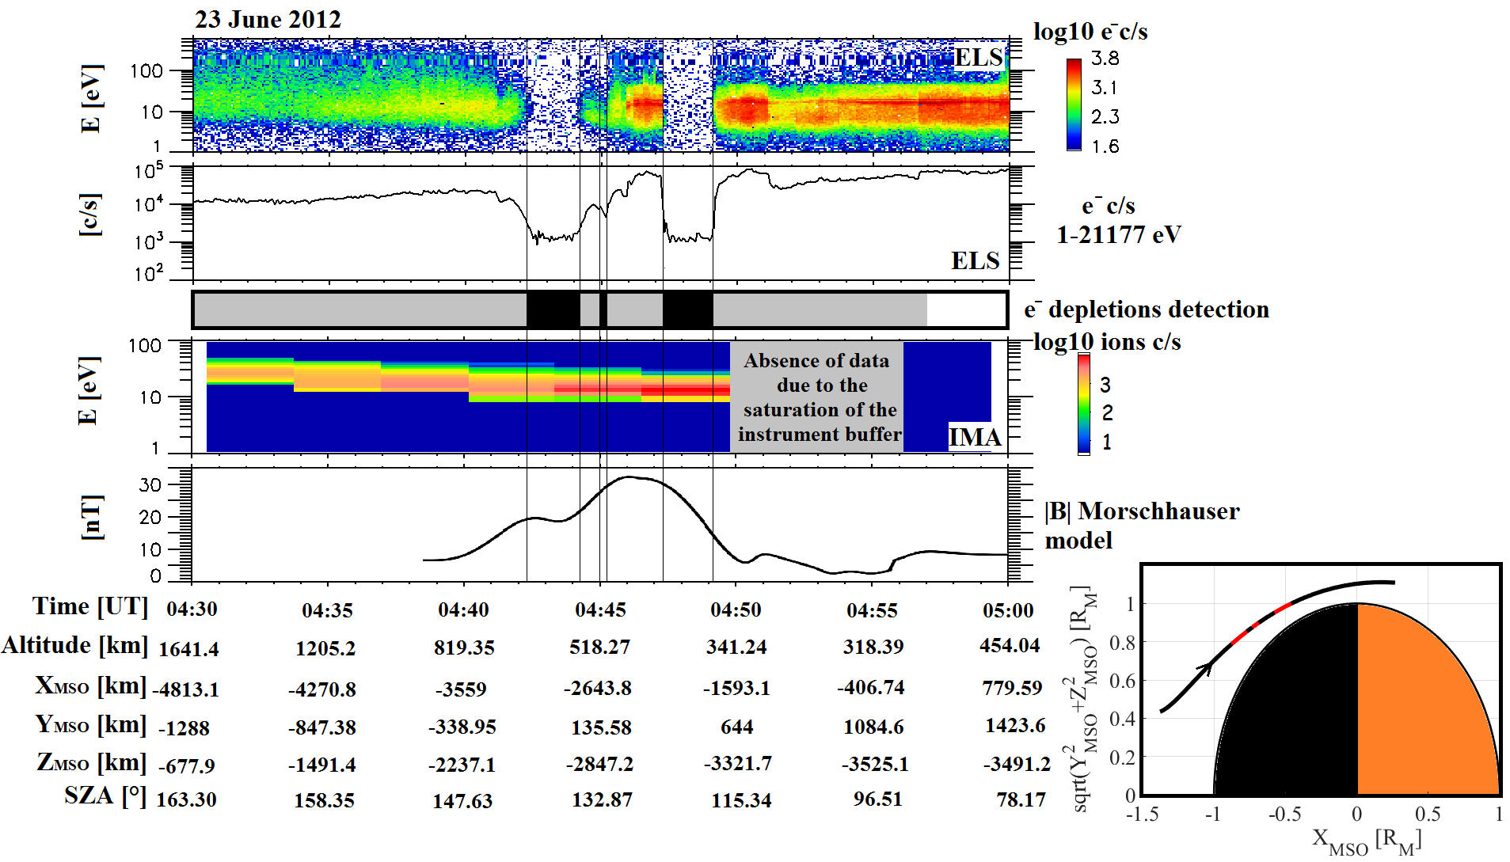

**Figure 2**. Example of electron depletion observed by MEX on June 23, 2012. First panel: ELS energy-time spectrogram of omnidirectional electron counts per second. Second panel: ELS electron counts per second summed over all the energies available (1-21177 eV). Third panel: Detection of electron depletions by criterion (2) (black boxes). See section 3 for more details. The shadow corresponds to the nightside. Fourth panel: IMA energy-time spectrogram of omnidirectional heavy ions counts per second (m/q>20). Fifth panel: Magnetic field intensity calculated from the Morschhauser model. Sixth panel (bottom right): MEX orbital trajectory in a cylindrically symmetric MSO coordinates frame. The location of the electron depletions detected are highlighted in red.

MAVEN

The criterion specified in equation (1) worked well for electron depletions in the Northern hemisphere as shown in *Steckiewicz et al.* [2015], it is thus also used here in the Southern hemisphere. The example proposed on Figure 3 illustrates how the criterion detects the electron depletions in agreement with the SWEA spectrogram. Criterion (1) has been applied from October 7, 2014 to November 25, 2015 with no restriction on the nightside nor on the altitude, which corresponds to more than 2 000 orbits.

During this time interval electron depletions have only been detected during two specific periods when the spacecraft reaches low altitudes (<900 km) in the nightside. Although MAVEN reached higher altitudes in the induced magnetosphere, criterion (1) detected no depletion above 900 km nor on the dayside. These two periods can be described in terms of aerographic coverage as following:

- from October 2014 to April 2015 during which the periapsis was above the Northern hemisphere;

- from May 2015 to November 2015 during which the periapsis was above the Southern hemisphere.

Both of these time periods did not cover the equatorial region and not all local times due to orbital limitations. Over the next few years of the MAVEN mission, the spacecraft will have covered the entire surface of Mars, all local times and solar zenith angles. The application of this criterion to the time interval under study resulted in a dataset of 1742 electron depletions identified above the Northern hemisphere and 1956 ones identified above the Southern hemisphere. We thus detected a lot of electron depletions per orbit. A median value of four depletions observed per orbit have been found. In terms of altitude distribution, the electron depletions detected are observed from 110 km up to 900 km altitude above the strongest crustal magnetic sources. The altitude distribution will be investigated in more details in section 5.

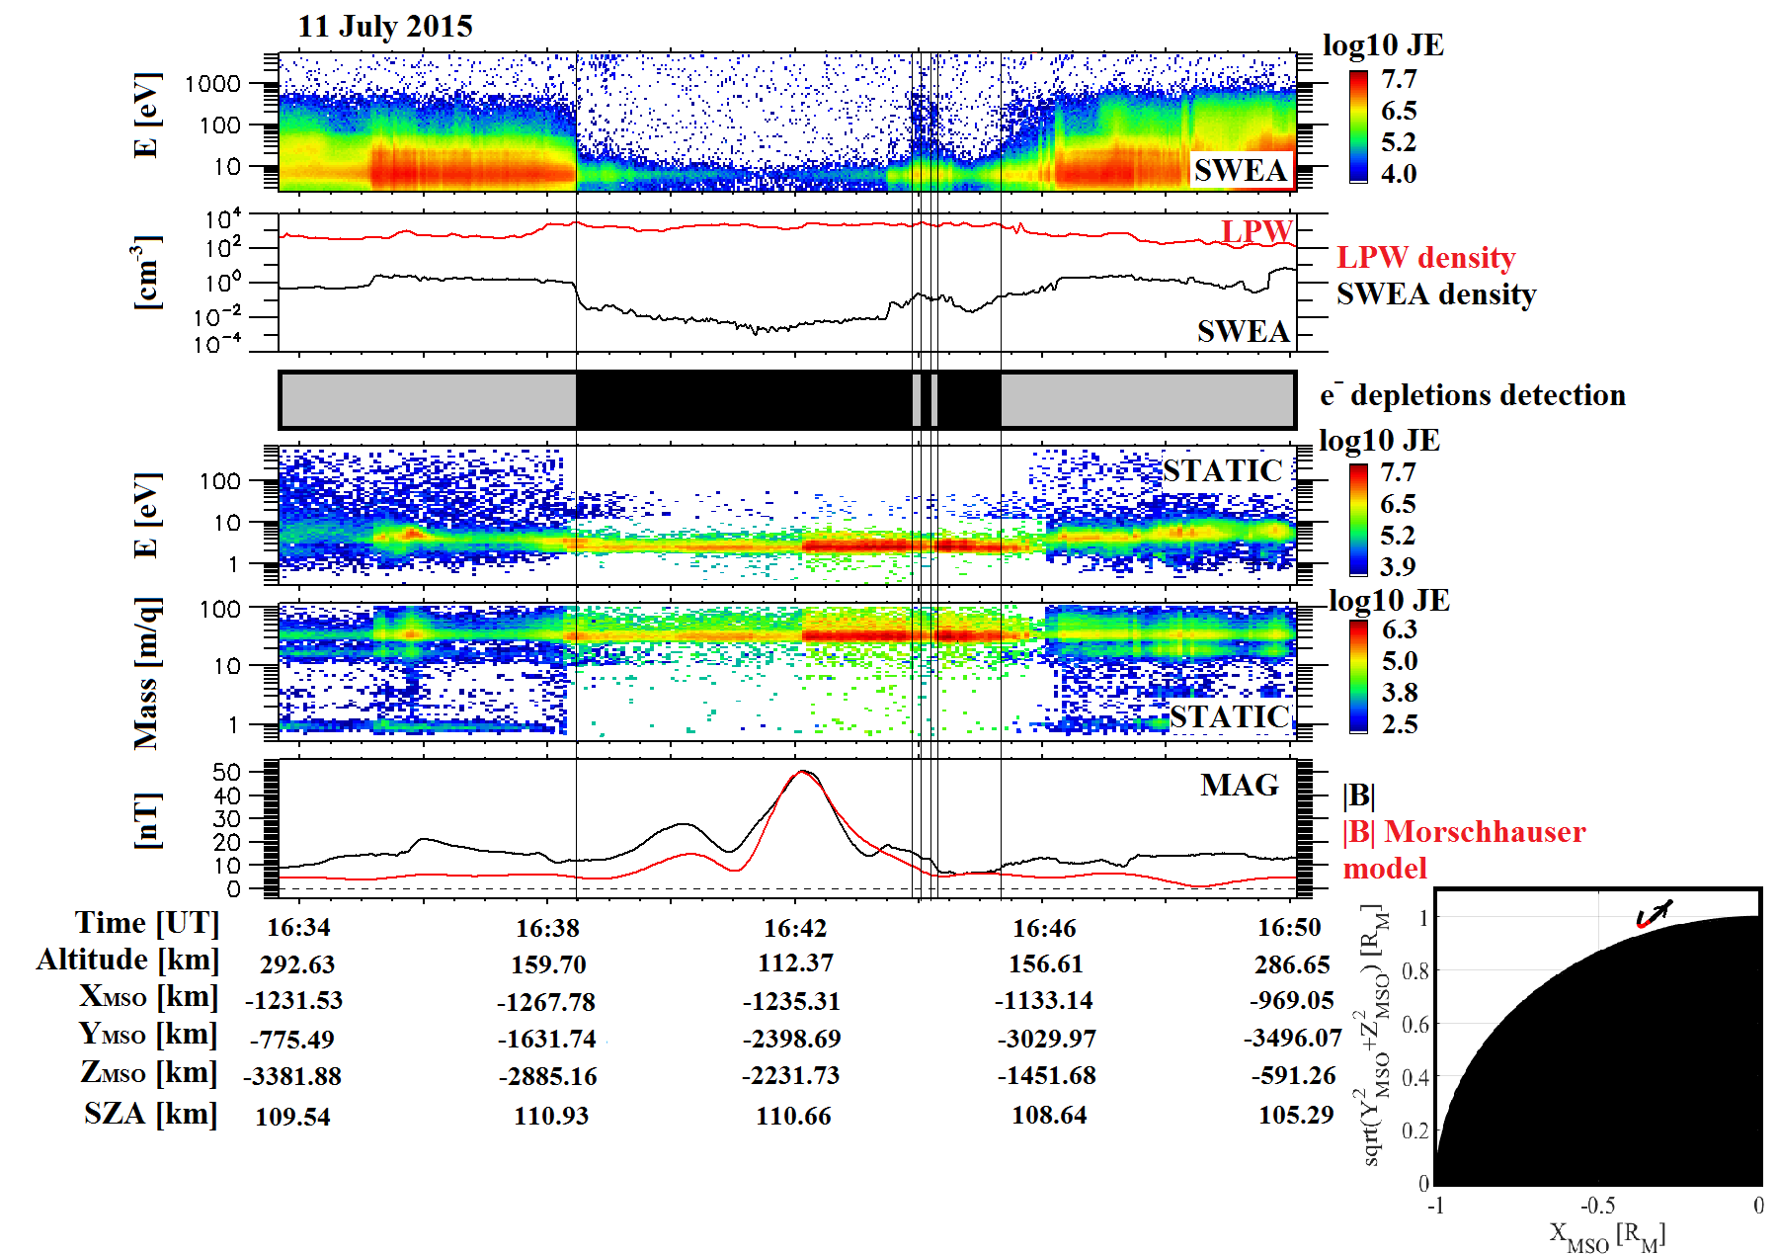

**Figure 3**. Example of electron depletion observed with MAVEN. First panel: SWEA energy-time spectrogram of omnidirectional electron energy flux (ENGY mode) corrected for the potential measured with LPW. Second panel: Electron density calculated with SWEA (black) superimposed with the density calculated with LPW (red). Third panel: Detection of electron depletions by criterion (1) (black boxes). See section 3 for more details. The shadow corresponds to the nightside. Fourth panel: STATIC energy-time spectrogram of omnidirectional ion energy flux (C0 mode). Fifth panel: STATIC mass-time spectrogram of omnidirectional ion energy flux (C6 mode). Sixth panel: Magnetic field intensity (measured by MAG in black and calculated from the model of Morschhauser in red). Seventh panel (bottom right): MAVEN orbital trajectory in a cylindrically symmetric MSO coordinates frame. The location of the electron depletions detected have been highlighted in red.

|  |  |  |  |
| --- | --- | --- | --- |
|  | **MGS** | **MEX** | **MAVEN** |
| **Number of orbits under study** | 42 048 | 9 983 | 2 138 |
| **Number of depletions detected** | 116 278 | 14 517 | 3 698 |
| **Number of orbits containing depletions** | 29 460 | 2 197 | 899 |
| **Median number of depletions per orbit** | 4 | 5 | 4 |

**Table 2**. For each mission are reported here the number of orbits under study (for MEX it corresponds to the number of time intervals longer than one hour when ELS was in the survey mode. It corresponds approximately to the number of orbits studied), the number of depletions detected by criterion (3) for MGS, criterion (2) for MEX and criterion (1) for MAVEN, the number of orbits containing depletions and the median number of depletions per orbit.

## **Global properties of suprathermal electron depletions: statistical properties**

# **Determination of the origins of suprathermal electron depletions**

# **Physical processes: Interaction plasma/neutrals**

# **Conclusions**

# **Conclusions**

# **Table of figures**

Figure 1. Illustration of the Parker spiral. 8

Figure 2. M-B diagram [Barabash et al., 2012]. 10

Figure 3. Illustration of the general features of the interaction of the solar wind with the Earth magnetic field [Luhmann et al., 1991]. Superimposed in dotted lines are the main features of the Mars-solar wind interaction. The sizes of the planet has been normalized for the purpose of comparison. 11

Figure 4. Illustration of two different interactions of the solar wind with unmagnetized planetary obstacles [Luhmann et al., 2004]. On the left, the Moon interacts only weakly with the solar wind, providing mainly an absorber. On the right, in the case of Venus, the presence of a substantial ionosphere produces a relatively impenetrable obstacle. 12

Figure 5. Illustration of the steps leading to the formation of an ionospheric obstacle in the solar wind flow. Adapted from Kivelson and Russel [1995]. 13

Figure 6. Neutral profiles obtained with the NGIMS instrument on MAVEN [Mahaffy et al., 2015]. 17

Figure 7. Altitude profiles of the averaged density of ionospheric ions measured by NGIMS at a solar zenith angle of 60° at altitudes between 150 and 500 km Benna et al. [2015]. The vertical profile of the total ion density $Ni$ is also plotted in black. 18

Figure 8. Cross section for the photoionization of atomic oxygen and carbon dioxide from Huebner et al., [1979, 1992, 2015]. 19

Figure 9. Illustration of the measurement of the crustal magnetic field by MGS [Acuña et al., 1998]. 21

Figure 10. Map of the magnetic field of Mars observed by the Mars Global Surveyor satellite at a nominal 400 km altitude. 22

Figure 11. Phase diagram of water 24

Figure 12. Vertical component of the MF6 model crustal magnetic field at the Earth surface, overlain with the isochrones of an ocean-age model inferred from independent marine and aeromagnetic data by Muller et al., [2007] and plate boundaries by Bird et al., [2003], http://geomag.org/models/MF6.html 25

Figure 13. Schematic of contemporary escape processes (rectangular boxes) relevant for atmospheric neutrals and ions, presented in a ‘decision tree’. Solar inputs shown at the lower right contribute to the energization of atmospheric particles [Brain et al., 2014]. 27

Figure 14. Schematic of the Martian plasma interaction regions [Brain et al., 2014]. 30

Figure 15. Example of a MAVEN passage in the plasma environment of Mars with a periapsis on the dayside. 31

Figure 16. Electron energy spectra measured by SWEA in the **solar wind**, **magnetosheath**, **ionosphere** and the **lobe** on the orbit showed on Figure 1‑15. 33

Figure 17. All MPB and bow shock crossings found from the pre-mapping phase of MGS plotted as dots and plus signs, respectively, in 4° aberrated cylindrical MSO coordinates [Edberg et al., 2008]. Also shown, as a comparison, are the best fit conic section from Edberg et al., [2008] (solid line), the best fit from Vignes et al., [2000] (dashed line), and the best fit from Trotignon et al. [2006] (dashed-dotted). 34

Figure 18. Plasma and magnetic field environment of Mars according to the multi-fluid magnetohydrodynamic simulation of Dong et al., [2014]. Upper left panel is a meridian plane projection of the magnitude (color) and direction (arrows) of plasma velocity near Mars. Lower left panel shows the simulated magnetic field lines and magnetic field magnitude (colors) in meridian plane direction. Large field magnitudes very near the planet’s surface are due to strong crustal magnetic fields, especially in the Southern hemisphere. However, strong fields due to the solar wind interaction with Mars are also observed at high altitude on the dayside. Right panels illustrate flow velocity (upper) and magnetic field magnitude (lower) in greater detail and unencumbered by flow and field vectors. 40

Figure 19. Left. Possible magnetic field topologies [Brain et al., 2007]. The Mars Global Surveyor Magnetometer and Electron Reflectometer (MGS MAG/ER) measures the local vector magnetic field near 400 km altitudes (arrows). Electron pitch angle distributions can be used to help identify whether the field angle is closed (curve a), open (curve b) or draped (curve c) in the ionosphere/atmosphere, or draped above the ionosphere/atmosphere (curve d). Right. Plane projection of the magnetic field geometry above the intensely magnetized southern highlands [Connerney et al., 2015] based on the crustal magnetic field model of Connerney et al. [1999]. This figure illustrates the field geometry that would be encountered during periapsis passes along a line of constant longitude (near 150° East) and centered at 50°S. Similar ‘mini-magnetosphere’ may be encountered above much of the magnetized crust, depending on spacecraft altitude and solar wind conditions. 41

Figure 20. Illustration (not to scale) of how the interplanetary magnetic field may penetrate into the Martian ionosphere (stippled). The stream lines of plasma flow are those that are diverted around the planetary obstacle, while the cross-flow lines are magnetic field lines. 43

Figure 21. Example of a MAVEN passage in the plasma environment of Mars with a periapsis on the nightside. 46

Figure 22. First photograph made by the lander Viking 1 of the Martian surface 47

Figure 23. Summary of all the missions ever sent toward Mars. 49

Figure 24. MGS orbit period during its aerobreaking phase. [Albee et al., 2001] 51

Figure 25. Global view of the MGS spacecraft showing the main components and instruments [Albee et al., 2001] 54

Figure 26. Orbit of MGS, MEX and Phobos on March 10, 2005 in the ($XMSO$; $YMSO$) plane. Created with 3D view. 57

Figure 27. Exploded view of the MEX orbiter, revealing the arrangement of the scientific instruments. 59

Figure 28. 3D picture of the Gale crater obtained with HRSC 60

Figure 29. Overall timeline of MAVEN mission, from launch through end of primary mission and into a possible extended mission [Jakosky et al., 2015] 62

Figure 30. Precession of the MAVEN orbit for the primary mission and the first extension (left) and for the second extension (right). Location of the spacecraft at periapsis is shown as in geographical coordinates [Jakosky et al., 2016]. 63

Figure 31. Orbit of MAVEN, MEX and Phobos on March 10, 2016 in the ($XMSO$; $YMSO$) plane. Created with 3D view. 63

Figure 32. Instrument accommodation. It shows the locations of the science instruments on the body of the spacecraft and on the APP [Jakosky et al., 2015]. 64

Figure 33. Schematic of the Electron Reflectometer showing the concentric hemispherical deflection plates, the microchannel plate (MCP) and the position-sensing resistive anode. Adapted from Mitchell et al. [2001]. 67

Figure 34. Electron energy spectra corresponding to the instrument background. Adapted from Mitchell et al. [2001]. 68

Figure 35. Electron and magnetic field observed by MGS. Panel 1: Electron fluxes (in units of $cm-2s-1sr-1eV-1$) measured by ER are shown as a color spectrogram. Panel 2: Magnetic field amplitude measured by MAG. Vertical lines indicate the position of the bow shock (BS), of the MPB, of the ionopause (IP), and of the ionospheric main peak ($Nm$). Adapted from [Acuña et al., 1998]. 68

Figure 36. a) The ELS sensor b) Cross section of the IMA sensor c) The ASPERA-3 mechanical model during vibration testing [adapted from Barabash et al., 2004]. 69

Figure 37. Panel 1: Energy-time spectrogram of the electron fluxes with the imposed curve of the magnetic field value. Panel 2: Energy-time spectrogram of the ion fluxes. Two different ion populations (solar wind and planetary plasmas) are mixed in the magnetic barrier region. Adapted from Dubinin et al. [2008b]. 71

Figure 38. MAVEN science instruments. Adapted from Jakosky et al. [2015]. 72

Figure 39. 73

Figure 40. 74

Figure 41. Left: Cross-sectional view of SWEA, defining the instrument frame regarding the payload (PL) frame. Right: Top view of the anodes. Simulated electron trajectories (blue) are shown for a deflection of $θ=-45°$. Adapted from [Mitchell et al., 2016] 76

Figure 42. Left: SWEA is on the end of a 1.5-meter boom, with its symmetry axis ($ZSWEA$) aligned with the spacecraft Z axis ($ZPL$). SWEA has a FOV (blue shading indicates the instruments blind spots). Middle: SWEA’s field of view at all energies below 2 keV, mapped in SWEA coordinates over the full sky with an Aitoff projection. The FOV is subdivided into 96 angular bins (16 azimuths 6 deflections). SWEA’s blind spots are two oppositely directed cones. Ten of the angular bin, shown in white, are blocked by the spacecraft. Right: SWEA’s field of view at an energy of 4.6 keV. At this energy, four angular bins are blocked by the spacecraft. Adapted from [Mitchell et al., 2016] 76

# **Table of tables**

Table 1. Observed properties of the solar wind at the orbit of the Earth [Kivelson and Russel, 1995] and at the orbit of Mars [Brain, 2006; Fränz et al., 2007] 9

Table 2. Spacecraft mission to Mars that have provided measurements relevant for describing the plasma environment of Mars [Brain et al., 2014]. 60

Table 3. Summary of the characteristics of the magnetometer, electron spectrometer, ion spectrometer and Langmuir probe onboard MGS, MEX and MAVEN [Steckiewicz et al., 2016]. 77

# **Bibliography**

Acuña, M. H., J. E. P. Connerney, P. Walilewski, R. P. Lin, K. A. Anderson, C. W. Carlson, J. McFadden, D. W. Curtis, H. Rème, A. Cros, J. L. Médale, J. A. Sauvaud, C. d'Uston, S. J. Bauer, P. Cloutier, M. Mayhew, and N. F. Ness (1992), Mars Observer Magnetic Fields Investigation, *Journal of Geophysical Research,* 97, n° E5, 7799-7814, doi: 10.1029/92JE00344

Acuña, M. H., et al. (1998), Magnetic field and plasma observations at Mars : Initial results of the Mars Global Surveyor mission, *Science,* vol. 279, issue 5357, pp. 1676-1680, doi: 10.1126/science.279.5357.1676

Acuña, M. H., J. E. P. Connerney, N. F. Ness, R. P. Lin, D. Mitchell, C. W. Carlson, J. McFadden, K. A. Anderson, H. Rème, C. Mazelle, D. Vignes, P. Wasilewski, and P. Cloutier (1999), Global distribution of crustal magnetization discovered by the Mars Global Surveyor MAG/ER Experiment, *Science*, 284: 790-793, doi: 10.1126/science.284.5415.790

Acuña, M. H., J. E. P. Connerney, P. Wasilewski, R. P. Lin, D. Mitchell, K. A. Anderson, J. McFadden, H. Rème, C. Mazelle, D. Vignes, S. J. Bauer, P. Cloutier, and N. F. Ness (2001), Magnetic field of Mars: Summary of results from the aerobreaking and mapping orbits, *Journal of Geophysical Research,* 106, E10, pp: 23403-23417, doi: 10.1029/2000JE001404

Albee, A. L., R. E. Arvidson, F. Palluconi and T. Thorpe (2001), Overview of the Mars Global Surveyor mission, *Journal of Geophysical Research,* 106, n° E10, 23291-23316, doi: 10.1029/2000JE001306

Andersson, L., R. E. Ergun, G. T. Delory, A. I. Eriksson, J. Westfall, H. Reed, J. McCauly, D. Summers, and D. Meyers (2015), The Langmuir Probe and Waves instrument for MAVEN, *Space Sci. Rev., 195*: 173-198, doi: 10.1007/s11214-015-0194-3

Anderson, D. E. Jr, and C. W. Hord (1971), Mariner 6 and 7 ultraviolet spectrometer experiment: Analysis of hydrogen Lyman-alpha data, *Journal of Geophysical Research,* vol. 76, no. 28, doi: 10.1029/JA076i028p06666

Barabash, S., Lundin, R., & Andersson, H. et al. (2004), ASPERA-3: Analyser of Space Plasmas and Energetic Ions for Mars Express, Mars Express: the Scientific Payload (ESA SP-1240), ed. A. Wilson & A. Chicarro (Noordwijk: ESA), 121

Barabash, S. (2012), Classes of the solar wind interactions in the solar system, *Earth Planets Space*, 64, 57-59, doi: 10.5047/eps.2012.01.005

Benna, M., P. R.Mahaffy, J. M. Grebowsky, J. L. Fox, R. V. Yelle, and B. M. Jakosky (2015), First measurements of composition and dynamics of the Martian ionosphere by MAVEN’s Neutral Gas and Ion Mass Spectrometer, *Geophys. Res. Lett.*, 42, 8958–8965, doi: 10.1002/2015GL066146

Bertaux, J.-L., et al. (2004), SPICAM: Studying the Global Structure and Composition of the Martian Atmosphere, *Planetary Missions Division, Research & Scientific Support Department, ESA/ESTEC, PO box 299, 2200 AG Noordwijk, The Netherlands*

Bertucci, C., C. Mazelle, D. H. Crider, D. Vignes, M. H. Acuña, D. L. Mitchell, R. P. Lin, J. E. P. Connerney, H. Rème, P. A. Cloutier, N. F. Ness, and D. Winterhalter (2003), Magnetic field draping enhancement at the Martian magnetic pileup boundary from Mars Global Surveyor observations, *Geophysical Research Letters,* 30, 2, doi: 10.1029/2002GL015713

Bertucci, C., C. Mazelle, D. H. Crider, D. L. Mitchell, K. Sauer, M. H. Acuña, J. E. P. Connerney, R. P. Lin, N. F. Ness, and D. Winterhalter (2004), MGS MAG/ER observations at the magnetic pileup boundary of Mars: draping enhancement and low frequency waves, *Advances in Space Research*, 33, 11, pp. 1938-1944, doi: 10.1016/j.asr.2003.04.054

Bertucci, C., F. Duru, N. Edberg, M. Fraenz, C. Martinecz, K. Szego, and O. Vaisberg (2011), The induced magnetospheres of Mars, Venus, and Titan, *Space Sci. Rev.*, 162:113-171, doi: 10.1007/s1124-011-9845-1

Bibring, J-P., et al. (2004), OMEGA: Observatoire pour la Minéralogie, l’Eau, les Glaces et l’Activité, *Planetary Missions Division, Research & Scientific Support Department, ESA/ESTEC, PO box 299, 2200 AG Noordwijk, The Netherlands*

Bougher, S. W. (1995), Comparative thermospheres: Venus and Mars, *Adv. Space Res.*, 15 (4), 21–25, doi: 10.1016/0273-1177(94)00062-6

Bougher, S. W., Engel, S., Roble, R. G., and Foster, B. (2000), Comparative terrestrial planet thermospheres 3. Solar cycle variation of global structure and winds at solstices, *J. Geophys. Res.*, 105, 17669–17692, doi: 10.1029/1999JE001232.

Bougher, S. W., McDunn, T. M., Zoldak, K. A., and Forbes, J. M. (2009), Solar cycle variability of Mars dayside exospheric temperatures: Model evaluation of underlying thermal balances, *Geophys. Res. Lett.*, 36, L05201, doi: 10.1029/2008GL036376.

Bougher, S. W., Brain, D. A., Fox, J. L., Gonzalez-Galindo, F., Simon-Wedlund, C., and Withers, P. G. (2014), Upper Neutral Atmosphere and Ionosphere, *in Mars Book II* (Cambridge University Press, Cambridge, 2014), Chap. 14

Bougher, S. et al., (2015), Early MAVEN Deep Dip Campaigns: First Results and Implications, *Sciences, Vol. 350, Issue 6261,* doi: 10.1126/science.aad0459

Brain, D. A., and B. M. Jakosky (1998), Atmospheric loss since the onset of the Martian geologic record: Combined role of impact erosion and sputtering, *Journal of Geophysical Research,* vol. 103, no. E10, 22689-22694, doi: 10.1029/98JE02074

Brain, D. A., F. Bagenal, M. H. Acuña, and J. E. P. Connerney (2003), Martian magnetic morphology: Contributions from the solar wind and crust, *Journal of Geophysical Research*, 108(A12), 1424, doi: 10.1029/2002JA009482

Brain, D. A. (2006), Mars Global Surveyor measurements of the Martian Solar wind interaction, *Space Science Review,* 126: 77-112, doi: 10.1007/s11214-006-9122-x

Brain, D. A., R. J. Lillis, D. L. Mitchell, J. S. Halekas, and R. P. Lin (2007), Electron pitch angle distributions as indicators of magnetic field topology near Mars, *Journal of Geophysical Research,* 112(A09201), doi: 10.1029/2007JA012435

Brain, D. A., S. Barabash, S. W. bougher, F. Duru, B. M. Jakosky and R. Modolo (2014), Solar wind interaction and atmospheric escape (Chapter 15), *in Atmosphere and Climate of Mars*, eds. R. Haberle, T. Clancy, F. Forget, M. Smith, R. Zurek (Cambridge University Press, 2014)

Brecht, S. H., and S. A. Ledvina (2006), The Solar Wind Interaction With the Martian Ionosphere/Atmosphere, *Space Sci. Rev.*, 126(1), 15–38, doi:10.1007/s11214-006-9084-z

Breus, T. K., A. M. Krymskii, R. Lundin, E. M. Dubinin, J. G. Luhmann, Ye G. Yeroshenko, S. V. Barabash, V. Ya Mitnitskii, N. F. Pissarenko, and V. A. Styashkin (1991), The solar wind interaction with Mars: Consideration of Phobos 2 mission observations of an ion composition boundary on the dayside, *Journal of Geophysical Research,* 96(A7), 11165-11174, doi: 10.1029/91JA01131

Chicarro, A., P. Martin, and R. Trautner (2004), The Mars Express Mission: An overview, *Planetary Missions Division, Research & Scientific Support Department, ESA/ESTEC, PO box 299, 2200 AG Noordwijk, The Netherlands*

Christensen, P. R., et al., Thermal EmissionS pectrometer experiment: The Mars Observer mission, *Journal of Geophysical Research, 97*, 7719-7734, doi: 10.1029/92JE00453

Connerney, J. E. P., M. H. Acuña, P. J. Wasilewski, N. F. Ness, H. Rème, C. Mazelle, D. Vignes, R. P. Lin, D. L. Mitchell, and P. A. Cloutier (1999), Magnetic lineations in the Ancient crust of Mars, *Nature*, 284, 5415, pp. 794-798, doi: 10.1126/sience.284.5415.794

Connerney, J. E. P., M. H. Acuña, N. F. Ness, G. Kletetschka, D.L. Mitchell, R. P. Lin, and H. Rème (2005), Tectonic implications of Mars crustal magnetism, *PNAS,* 102, 42, doi: 10.1073/pnas.0507469102

Connerney, J. E. P., J. Espley, P. Lawton, S. Murphy, J. Odom, R. Oliverson, and D. Sheppard (2015), The MAVEN magnetic field investigation, *Space Sci. Rev.*, doi:10.1007/s11214-015-0169-4

Crider, D. H. et al. (2002), Observations of the latitude dependence of the location of the Martian magnetic pileup boundary, *Geophys. Res. Lett.*, 29(8), 11–1, doi: 10.1029/2001GL013860.

Crider, D. H., D. A. Brain, M. H. Acuña, D. Vignes, C. Mazelle, and C. Bertucci (2004), Mars Global Surveyor Observations of Solar Wind Magnetic Field Draping Around Mars, *Space Sci. Rev.*, 111(1), 203–221, doi:10.1023/B:SPAC.0000032714.66124.4e

Dolginov, Sh. Sh., Ye. G. Yeroshenko, and L. N. Zhuzgov (1973), Magnetic field in the very close neighborhood of Mars according to data from the Mars 2 and Mars 3 spacecraft, *Journal of Geophysical Research,* 78, 22, doi: 10.1029/JA078i022p04779

Dolginov, Sh. Sh., and L. N. Zhuzgov (1991), The magnetic field and the magnetosphere of the planet Mars, *Planet. Space Sci.*, vol. 39, no. 11, pp. 1493-1510, doi: 10.1016/0032-0633(91)90077-N

Dong, C. F., S. W. Bougher, Y. J. Ma, G. Toth, A. F. Nagy, and D. Najib (2014), Solar wind interaction with Mars upper atmosphere: Results from the one-way coupling between the multi-fluid MHD model and the MTGCM model, *Geophys. Res. Lett.*, doi: 10.1002/2014GL059515

Dubinin, E., K. Sauer, M. Delva, and A. Skalsky (1998), The IMF bending upstream of the Martian bow shock, *Earth, Planets and Space*, doi: 10.1186/BF03352116

Dubinin, E, R. Lundin, O. Norberg, and N. Pissarenko (1993), Ion acceleration in the Martian tail: Phobos observations, *Journal of Geophysical Research,* 98(A3), pp. 3991-3997, doi: 10.1029/92JA02233

Dubinin, E., M. Fränz, J. Woch, E. Roussos, S. Barabash, R. Lundin, J. D. Winningham, R. A. Frahm, and M. Acuña (2006), Plasma morphology at Mars. Aspera-3 observations, *Space Science Reviews,* 126: 209-238, doi: 10.1007/s11214-006-9039-4

Dubinin, E., et al. (2008a), Structure and dynamics of the solar wind/ionosphere interface on Mars: MEX-ASPERA-3 and MEX-MARSIS observations, *Geophys. Res. Lett., 35(1),* 11103, doi: 10.1029/2008GL033730

Dubinin, E., et al. (2008b), Plasma environment of Mars as observed by simultaneous MEX-ASPERA-3 and MEX-MARSIS observations, *Journal of Geophysical Research*, 113(A10217), doi: 10.1029/2008JA013355

Duru, F., D. A. Gurnett, J. D. Winningham, R. Frahm, and R. Modolo (2010), A plasma flow velocity boundary at Mars from the disappearance of electron plasma oscillations, *Icarus*, 206(1), 74–82, doi: 10.1016/j.icarus.2009.04.012.

Edberg, N. J. T., M. Lester, S. W. H. Cowley, and A. I. Eriksson (2008), Statistical analysis of the location of the Martian magnetic pileup boundary and bow shock and the influence of crustal magnetic fields, *Journal of Geophysical Research,* 113, A08206, doi: 10.1029/2008JA013096

Edberg, N. J. T., D. A. Brain, M. Lester, S. W. H. Cowley, R. Modolo, M. Fränz, and S. Barabash (2009), Plasma boundary variability at Mars as observed by Mars Global Surveyor and Mars Express, *Ann Geophys-Germany*, 27(9), 3537–3550, doi: 10.5194/angeo-27-3537-2009

Eparvier, F. G., P. C. Chamberlin, T. N. Woods, E. M. B. Thiemann (2015), The Solar Extreme Ultraviolet Monitor for MAVEN, *Space Science Reviews*, 195(1), pp. 293-301, doi: 10.1007/s11214-015-0195-2

Fang, X., M. W. Liemohn, A. F. Nagy, J. G. Luhmann, and Y. Ma (2010), Escape probability of Martian atmospheric ions: Controlling effects of the electromagnetic fields, *J. Geophys. Res.*, 115(A), 04308, doi: 10.1029/2009JA014929

Fillingim, M. O., L. M. PetiColas, R. J. Lillis, D. A. Brain, J. S. Halekas, D. Lummerzheim, and S. W. Bougher (2010), Localized ionization patches in the nighttime ionosphere of Mars and their electrodynamic consequences, *Icarus*, 206, 112–119, doi: 10.1016/j.icarus.2009.03.005

Formissano, V., et al. (2004), The Planetary Fourier Spectrometer (PFS) onboard the European Mars Express mission, *Planetary Missions Division, Research & Scientific Support Department, ESA/ESTEC, PO box 299, 2200 AG Noordwijk, The Netherlands*

Frahm, R. A., et al. (2006), Locations of atmospheric photoelectron energy peaks within the Mars environment, *Space Science Reviews,* 126 : 389-402, doi : 10.1007/s11214-006-9119-5

Fränz, M., E. Dubinin, E. Roussos, J. Woch, J. D. Winningham, R. Frahm, A. J. Coates, A. Fedorov, S. Barabash, and R. Lundin (2006), Plasma Moments in the Environment of Mars, *Space Sci Rev*, *126*(1-4), 165–207, doi:10.1007/s11214-006-9115-9.

Fränz, M., E. Dubinin, E. Nielsen, J. Woch, S. Barabash, R. Lundin, and A. Fedorov (2010), Transterminator ion flow in the Martian ionosphere, *Planet. Space Sci.*, 58, 1442–1454, doi: 10.1016/j.pss.2010.06.009

Gringauz, K. I. (1976), Interaction of Solar wind with Mars as seen by charged particle traps on Mars 2, 3 and 5 satellites, *Reviews of geophysics and space physics,* 14, 3, doi: 10.1029/RG014i003p00391

Gringauz, K. I., Verigin, M., Luhmann, J., Russell, C. T. and Mihalov, J. D. (1993), On the Compressibility of the Magnetic Tails of Mars and Venus, in *Plasma Environments of Non-magnetic Planets*, Pergammon, New York, pp. 265–270

Halekas, J. S., D. A. Brain, R. J. Lillis, M. O. Fillingim, D. L. Mitchell, and R. P. Lin (2006), Current sheets at low altitudes in the Martian magnetotail, *Geophysical Research Letter,* 33(L13101), doi: 10.1029/2006GL026229

Halekas, J. S., E. R. Taylor, G. Dalton, G. Johnson, D. W. Curtis, J. P. McFadden, D. L. Mitchell, R. P. Lin, and B. M. Jakosky (2013), The Solar Wind Ion Analyzer for MAVEN, Space Sci. Rev., 1-27, doi: 10.1007/s11214-013-0029-z

Hall, B. E. S., M. Lester, J. D. Nichols, B. Sànchez-Cano, D. J. Andrews, H. J. Opgenoorth, and M. Fränz (2016), A survey of suprathermal electron flux depressions, or ‘electron holes’, within the illuminated Martian induced magnetosphere, *Journal of Geophysical Research,* 121(5), pp. 4835-4857, doi: 10.1002/2015JA021866

Harnett, E. M., and R. M. Winglee (2006), Three-dimensional multifluid simulations of ionospheric loss at Mars from nominal solar wind conditions to magnetic cloud events, *J. Geophys. Res.*, 111(A), 09213, doi: 10.1029/2006JA011724

Huebner, W. F., Carpenter, C. W. (1979) Solar Photo Rate Coefficients, *Los Alamos Scientific Laboratory report,* LA-8085-MS

Huebner, W. F., Keady, J. J., Lyon, S. P. (1992), Solar Photo Rates for Planetary Atmospheres and atmospheric pollutants, *Astrophys. Space Sci.,* 195, 1-294

Huebner, W. F., Mukherjee, J. (2015), Photoionization and photodissociation rates in solar and blackbody radiation fields, *Planetary and Space Science,* <http://dx.doi.org/10.1016/j.pss.2014.11.022>

Jakosky, B. M., and R. J. Phillips (2001), Mars’ volatile and climate history, *Nature*, 412, 6843, pp. 237-244

Jakosky, B. M., et al. (2015), The Mars Atmosphere and Volatile Evolution (MAVEN) mission, *Space Sci. Rev.*, 195:3-48, doi: 10.1007/s11214-015-0139-x

Jakosky, B. M., J. M. Grebowsky, J. G. Luhmann, and D. A. Brain (2017), The MAVEN mission to Mars at the end of one Mars year of science observations, *J. Geophys. Res.*, (to be submitted)

Jakosky, B. M., J. M. Grebowsky, J. G. Luhmann, and D. A. Brain (2015), Initial results from the MAVEN mission to Mars, *Geophys. Res. Lett.*, *42* 8791-8802, doi: 10.1002/2015GL065271

Kallio, E., R. A. Frahm, Y. Futaana, A. Fedorov, and P. Janhunen (2008), Morphology of the magnetic field near Mars and the role of the magnetic crustal anomalies: Dayside region, *Planetary and Space Science*, 56(6), 852–855, doi: 10.1016/j.pss.2007.12.002.

Kivelson, M. G., and C. T. Russel (1995), Introduction to space physics, *Cambridge University Press*.

Krasnopolsky, V. A. (1993), Solar cycle variations of the hydrogen escape rate and the CO mixing ratio on Mars, *Icarus (ISSN 0019-1035)*, *101*, 33–41, doi: 10.1006/icar.1993.1003.

Krymskii, A. M., T. K. Breus, N. F. Ness, M. H. Acuña, J. E. P. Connerney, D. H. Crider, D. L. Mitchell, and S. Bauer (2002), Structure of the magnetic field fluxes connected with crustal magnetization and topside ionosphere at Mars, *Journal of Geophysical Research,* *107(*A9), 1245, doi: 10.1029/2001JA000239

Kotova, G. et al. (1997), Study of the solar wind deceleration upstream of the Martian terminator bow shock, *J. Geophys. Res.*, *102*(A), 2165–2174, doi: 10.1029/96JA01533.

Larson, D. E., et al. (2015), The MAVEN Solar Energetic Particle Investigation, *Space Science Reviews*, 195(1), pp. 153-172, doi: 10.1007/s11214-015-0218-z

Lillis, R. J., H. V. Frey, and M. Manga (2008), Rapid decrease in Martian crustal magnetization in the Noachian era: implications for the dynamo and climate of early Mars, *Geophysical Research Letter,* 35, L14203, doi: 10.1029/2008GL034338

Lillis, R. J., M. O. Fillingim, and D. A. Brain (2011), Three-dimensional structure of the Martian nightside ionosphere: Predicted rates of impact ionization from Mars Global Surveyor magnetometer and Electron Reflectometer measurements of precipitating electrons, *J. Geophys. Res.*, 116, A12317, doi: 10.1029/2011JA016982.

Lillis, R. J., S. Robbins, M. Manga, J. S. Halekas and H. V. Frey (2013a), Time history of the Martian dynamo from crater magnetic field analysis, *Journal of Geophysical Research,* 118, 1488-1511, doi: 10.1002/jgre.20105

Lillis, R. J., and D. A. Brain (2013b), Nightside electron precipitation at Mars: Geographic variability and dependence on solar wind conditions, *J. Geophys. Res. Space Physics*, 118, 3546–3556, doi: 10.1002/jgra.50171.

Luhmann, J. G. and L. H. Brace (1991), Near-Mars space, *Review of Geophysics,* 29, 2, pages 121-140, doi: 10.1029/91RG00066

Luhmann, J. G. (1992), Comparative studies of the solar wind interaction with weakly magnetized planets, *Adv. Space Res.*, 12, 9, pp. (9)191-(9)203, doi: 10.1016/0273-1177(92)90331-Q

Luhmann, J. G. (1995), Plasma interactions with unmagnetized bodies, in Introduction to Space Physics, *Cambridge University Press*.

Luhmann, J. G., S. A. Ledvina, and C. T. Russell, (2004), Induced magnetosphere, *Advances in Space Reasearch,* doi: 10.1016/j.asr.1003.03.031

Lundin, R., A. Zakharov, R. Pellinen, H. Borg, B. Hultqvist, N. Pissarenko, E. M. Dubinin, S. W. Barabash, I. Liede, and H. Koskinen (1989), First measurements of the ionospheric plasma escape from Mars, *Nature,*341, 609-612, doi: 10.1038/341609a0

Ma, Y., A. F. Nagy, K. C. Hansen, D. L. DeZeeuw, T. I. Gombosi, and K. G. Powell (2002), Three-dimensional multispecies MHD studies of the solar wind interaction with Mars in the presence of crustal fields, *Journal of Geophysical Research-Space*, 107(A), 1282, doi:10.1029/2002JA009293

Ma, Y.-J., and A. F. Nagy (2007), Ion escape fluxes from Mars, *Geophys. Res. Lett.*, 34(8), 08201, doi: 10.1029/2006GL029208

Mahaffy, P. R., et al. (2015), The Neutral Gas and Ion Mass Spectrometer on the Mars Atmosphere and Volatile Evolution Mission, *Space Sci. Rev.*, 195:49-73, doi: 10.1007/s11214-014-0091-1

Mahaffy, P. R., M. Benna, M. Elrod, R. V. Yelle, S. W. Bougher, S. W. Stone, and B. M. Jakosky (2015), Structure and composition of the neutral upper atmosphere of Mars from the MAVEN NGIMS investigation, *Geophysical Research Letter, 42*, 8951-8957, doi:10.1002/2015GL065329

Malin, M. C., G.E. Danielson, A. P. Ingersoll, H. Masursky, J. Veverka, M. A. Ravine, and T. A. Soulanille (1992), Mars Observer Camera, *Journal of Geophysical Research,* 97, n° E5, 7699-7718, doi: 10.1029/92JE00340

Martin-Torres, F. J., et al. (2015), Transient liquid water and water activity at Gale crater on Mars, *Nature Geoscience*, 8, 357-361, doi: 10.1038/ngeo2412

McClintock, W. E., et al. (2014), The Imaging Ultraviolet Spectrograph (IUVS) for the MAVEN mission, 195(1), pp. 75-124, doi: 10.1007/s11214-014-0098-7

McFadden, J. P., et al. (2015), MAVEN SuparThermal and Thermal Ion Composition (STATIC) Instrument, *Space Sci. Rev., 195(1-4)* 199-256, doi: 10.1007/s11214-015-0175-6

Melosh, H. J., and A. M. Vickery (1989), Impact erosion of the primordial atmosphere of Mars, *Nature (ISSN 0028-0836)*, *338*, 487–489, doi: 10.1038/338487a0

Mitchell, D. L., R. P. Lin, H. Rème, D. H. Crider, P. A. Cloutier, J. E. P. Connerney, M. H. Acuña, and N. F. Ness (2000), Oxygen Auger electrons observed in Mars’ ionosphere, *Geophysical Research Letter,* 27, 13, pp. 1871-1874, doi: 10.1029/1999GL010754

Mitchell, D. L., R. P. Lin, C. Mazelle, H. Rème, P. A. Cloutier, J. E. P. Connerney, M. H. Acuña, and N. F. Ness (2001), Probing Mars’ crustal magnetic field and ionosphere with the MGS Electron Reflectometer

Mitchell, D. L., et al. (2016), The MAVEN Solar Wind Electron Analyzer, *Space Sci. Rev.,*1-34doi: 10.1007/s11214-015-0232-1

Modolo, R., G. M. Chanteur, E. Dubinin, and A. P. Matthews (2005), Influence of the solar EUV flux on the Martian plasma environment, *Ann Geophys-Germany*, 23(2), 433–444, doi: 10.5194/angeo-23-433-2005

Modolo, R., G. M. Chanteur, E. Dubinin, and A. P. Matthews (2006), Simulated solar wind plasma interaction with the Martian exosphere: influence of the solar EUV flux on the bow shock and the magnetic pile-up boundary, *Ann Geophys-Germany*, 24(12), 3403–3410

Modolo, R., G. M. Chanteur, and E. Dubinin (2012), Dynamic Martian magnetosphere: Transient twist induced by a rotation of the IMF, *Geophys. Res. Lett.*, 39(1), 01106, doi:10.1029/2011GL049895

Möhlmann, D., W. Riedler, J. Rustenbach, K. Schwingenschuh, J. Kurths, U. Motschmann, T. Roatsch, K. Sauer, and H. T. M. Lichtenegger (1991), The question of an internal Martian magnetic field, *Planetary and Space Science,* 39 (1-2), pp. 83-88, doi: 10.1016/0032-0633(91)90130-3

Morschhauser, A., V. Lesur, and M. Grott (2014), A spherical harmonic model of the lithospheric magnetic field of Mars, *Journal of Geophysical Research: Planets*, *119*, 1162-1188, doi: 10.1002/2013JE004555

Nagy, A. F., M. W. Liemohn, J. L. Fox, and J. Kim (2001), Hot carbon densities in the exosphere of Mars, *J. Geophys. Res.*, *106*(A), 21565–21568, doi:10.1029/2001JA000007

Nagy, A. F., D. Winterhalter, K. Sauer, T. E. Cravens, S. Brecht, C. Mazelle, D. Crider, E. Kallio, A. Zakharov, E. Dubinin, M. Verigin, G. Kotova, W. I. Axford, C. Bertucci, and J. G. Trotignon (2004), The plasma environment of Mars, *Space Science Reviews,* 111: 33-114, doi: 10.1023/B:SPAC.0000032718.47512.92

Najib, D., A. F. Nagy, G. Tóth, and Y. Ma (2011), Three-dimensional, multifluid, high spatial resolution MHD model studies of the solar wind interaction with Mars, *J. Geophys. Res.-Space*, 116(A), –, doi: 10.1029/2010JA016272

Neukum, G., et al. (2004), HRSC: the High Resolution Stereo Camera of Mars Express, *Planetary Missions Division, Research & Scientific Support Department, ESA/ESTEC, PO box 299, 2200 AG Noordwijk, The Netherlands*

Nier, A. O., and M. B. McElroy (1976), Structure of the Neutral upper atmosphere of Mars: results from Viking 1 and Viking 2, *Science,* vol. 194, issue 4271, pp. 1298-1300, doi: 10.1126/science.194.4271.1298

Nier, A. O., W. B. Hanson, A. Seiff, M. B. McElroy, N. W. Spencer, R. J. Duckett, T. C. D. Knight, and W. S. Cook (1976), Composition and Structure of the Martian atmosphere: Preliminary results from Viking 1, *Science,* vol. 193, issue 4255, pp. 786-788, doi: 10.1126/science.193.4255.786

Pätzold, M., et al. (2004), MaRS: Mars Express Orbiter Radio Science, *Planetary Missions Division, Research & Scientific Support Department, ESA/ESTEC, PO box 299, 2200 AG Noordwijk, The Netherlands*

Parker, E. N. (1958), Dynamics of the interplanetary gas and magnetic fields, *Astrophysical Journal*, vol. 128, p. 664, doi:10.1086/146579

Phillips, J. L., J. G. Luhmann, W. C. Knudsen, and L. H. Brace (1988), Asymmetries in the location of the Venus ionopause, *Journal of Geophysical Research (ISSN 0148-0227)*, *93*, 3927–3941, doi:10.1029/JA093iA05p03927

Picardi, G., et al. (2004), MARSIS: Mars Advanced Radar for Subsurface and Ionosphere Sounding, *Planetary Missions Division, Research & Scientific Support Department, ESA/ESTEC, PO box 299, 2200 AG Noordwijk, The Netherlands*

Riedler, W., et al. (1989), Magnetic fields near Mars: first results, *Nature*, 341, 604-607, doi: 10.1038/341604a0

Rosenbauer, H., et al. (1989), Ions of Martian origin and plasma sheet in the Martian magnetosphere: initial results of the TAUS experiment, *Nature*, 341, 612-614, doi: 10.1038/341612a0

Russell, C. T., J. G. Luhmann, J. R. Spreiter, and S. S. Stahara (1984), The magnetic field of Mars: Implications from gas dynamic modeling, *Journal of geophysical research,* 89 (A5), pp. 2997-3003, doi: 10.1029/JA089iA05p02997

Russell, C. T., T. Mulligan, M. Delva, T. L. Zhang, and K. Schwingenschuh (1995), A simple test of the induced nature of the Martian tail, *Advances in Space Research,* 16 (6), pp. 69-73, doi: 10.1016/0273-1177(95)00251-9

Sauer, K., A. Bogdanov, and K. Baumgärtel (1994), Evidence of an ion composition boundary (protonopause) in bi-ion fluid simulations of solar wind mass loading, *Geophysical Research Letter*, 21, 20, pp. 2255-2258, doi: 10.1029/94GL01691

Sauvaud, J.-A., D. Larson, C. Aoustin, J.-L. Médale, A. Fedorov, J. Rouzaud, J. G. Luhmann, T. Moreau, P. Schröder, P. Louarn, I. Dandouras, E. Penou (2008), The IMPACT Solar Wind Electron Analyzer (SWEA), *Space Science Reviews*, 136(1), pp. 227-239, doi: 10.1007/s11214-007-9174-6

Slavin, J. A., K. Schwingenschuh, W. Riedler, and Ye. Yeroshenko (1991), The solar wind interaction with Mars: Mariner 4, Mars 2, Mars 3, Mars 5, and Phobos 2 observations of bow shock position and shape, *Journal of Geophys. Research,* 96, A7, pp 11235-11241, doi: 10.1029/91JA00439

Smith, E. J., L. Davis Jr, P. J. Coleman Jr, and D. E. Jones (1965), Magnetic field measurements near Mars, *Science,* vol. 149, issue 3689, pp. 1241-1242, doi: 10.1126/science.149.3689.1241

Smith, D. E., et al. (2001), Mars Orbiter Laser Altimeter: Experiment summary after the first year of global mapping of Mars, *Journal of Geophysical Research,* 106(E10), 23689-23722, doi: 10.1029/2000JE001364

Steckiewicz, M., et al. (2015), Altitude dependence of nightside Martian suprathermal electron depletions as revealed by MAVEN observations, *Geophysical Research Letters,* *42*, 8877-8884, doi: 10.1002/2015GL065257

Steckiewicz, M., et al. (2016), Comparative study of the Martian suprathermal electron depletions based on Mars Global Surveyor, Mars Express and the Mars Atmosphere and Volatile Evolution mission observations, *Journal of Geophysical Research: Space Physics*, *121*, doi: 10.1002/2016JA023205

Stewart, A. I. F. (1987) Revised time dependent model of the martian atmosphere for use in orbit lifetime and sustenance studies, *LASP-JPL Internal Report*, NQ-802429, Jet Propulsion Lab, Pasadena, California

Trotignon, J. G., E. Dubinin, R. Grard, S. Barabash, and R. Lundin (1996), Martian planetopause as seen by the plasma wave system onboard Phobos 2, *Journal of Geophysical Research,* 101(A11), 24965-24977, doi: 10.1029/96JA01898

Trotignon, J. G., C. Mazelle, C. Bertucci, and M. H. Acuña (2006), Martian shock and magnetic pile-up boundary positions and shpaes determined from Phobos 2 and Mars Global Surveyor data sets, *Planetary and Space Science*, 54, 357-369, doi: 10.1016/j.pss.2006.01.003

Ulusen, D., and I. R. Linscott (2008), Low-energy electron current in the Martian tail due to reconnection of draped interplanetary magnetic field and crustal magnetic fields, *J. Geophys. Res.*, 113, E06001, doi: 10.1029/2007JE002916

Vaisberg, O. L., A. V. Bogdanov, N. F. Borodin, A. A. Zertzalov, B. V. Polenov, and S. Romanov (1973), Solar Plasma Interaction with Mars: Preliminary results, *Icarus*, 18, 59-63, doi: 10.1016/0019-1035(73)90172-3

Vaisberg, O. L. (1992), The solar wind interaction with Mars: a review of results from previous soviet missions to Mars, *Adv. Space Res.*, 12, 9, pp. (9)137-(9)161, doi: 10.1016/0273-1177(92)90328-U

Vignes, D., C. Mazelle, H. Rème, M. H. Acuña, J. E. P. Connerney, R. P. Lin, D. L. Mitchell, P. Cloutier, D. H. Crider, and N. F. Ness (2000), The solar wind interaction with Mars: locations and shapes of the bow shock and the magnetic pile-up boundary from the observations of the MAG/ER experiment onboard Mars Global Surveyor, *Geophysical Research Letter,* 27, 1, pp. 49-52, doi: 10.1029/1999GL010703

Vignes, D., M. H. Acuña, J. E. P. Connerney, D. H. Crider, H. Rème, and C. Mazelle (2002), Factors controlling the location of the bow shock at Mars, *Geophysical Research Letters,* 29, 9, 1328, doi: 10.1029/2001GL014513

Verigin, M. I., N. M. Shuttle, A. A. Galeev, K. I. Gringauz, G. A. Kotova, and A. P. Reminoz (1991), Ions of planetary origin in the Martian magnetosphere (Phobos 2/TAUS experiment), *Planetary and Space Science,* 39 (1-2), pp. 131-137, doi: 10.1016/0032-0633(91)90135-W

Xu, S., D. L. Mitchell, M. Liemohn, X. Fang, Y. Ma, J. G. Luhmann, D. Brain, M. Steckiewicz, C. Mazelle, J. E. P. Connerney, and B. M. Jakosky (2016), Martian low-altitude magnetic topology deduced from MAVEN/SWEA observations, *Journal of Geophysical Research Space Physics*, *122*, doi: 10.1002/2016JA023467

Yeroshenko, Y., W. Riedler, K. Schwingenschuh, J. G. Luhmann, and M. Ong (1990), The magnetotail of Mars - PHOBOS observations, *Geophysical Research Letters (ISSN 0094-8276)*, *17*, 885–888, doi:10.1029/GL017i006p00885

Zahnle, K. J., and J. F. Kasting (1986), Mass fractionation during transonic escape and implications for loss of water from Mars and Venus, *Icarus (ISSN 0019-1035)*, *68*, 462–480, doi: 10.1016/0019-1035(86)90051-5

Zuber, M. T., D. E. Smith, S.C. Solomon, D. O. Muhleman, J. W. Head, J. B. Garvin, J. B. Abshire, and J. L. Bufton (1992), The Mars Observer Laser Altimeter investigation, *Journal of Geophysical Research,97*, 7781-7798, doi: 10.1029/92JE00341